Hospital Appointment System

System Testing

# System Testing

In this section, you will see the three levels of testing I have used to ensure that the “Hospital Appointment” program operates as required.

Three Levels of Testing

The three levels are as follows:

**Unit Testing** - This involves the testing of the individual elements of the system.

Examples of what I will be testing include the following and more: Validation checks, Password Entry, Menu Selection, subroutines and functions etc.

**Integration Testing** - This involves testing the system as a whole e.g. Full procedure such as generating the appropriate letter for an appointment.

Examples of what I will be testing include the following and more: Correct summary report generated, appropriate letter generated, dates do not conflict with other appointments, new patients can be added to the system etc.

**End User Testing** – This involves testing the data supplied by you.

The testing results for this section will be base on which data you wish to test.

Data Types

I will be using the following data types:

**Erroneous** – This is data that is deliberately incorrect to see how the system copes with the data.

**Typical** – This is data that wold typically be entered into the system/data it is designed to handle.

**Extreme** – This is data that tests the boundaries of the system e.g. password length. This will mostly be used for validation testing.

# Unit Testing

**This section will cover the following**:

* **General System Functions -**  This will test the functions which are present in all of the forms and previous record
* **Logging In -** This section will cover the validation testing of the login procedure.
* **Data Validation -** This will test if all the forms only accept the right data inside them to minimalize incorrect data entry and more
* **Navigation -** Different from the general system functions testing, this will test if the main menu’s tabs navigate to the correct form/report. It will also test if forms are open when a button is clicked.
* **Adding Attachments -** This will test if attachments can be added and displayed.
* **Sorting Records -** This will test if records can be sorted by fields in ascending or descending order

# Integration Testing

**This section will cover the following**:

* **Appointment -**  This will test complex functions of the system such as generating an appropriate appointment letter for an appointment with details of the patient already added as well as checking if specific dates are available
* **Holidays/Leaves -** This section will cover if Holidays for doctors can be added correctly and stored
* **Main menu -** This will test the functions present in the main menu such as the backup function and test if the modules correctly work.
* **Adding/Editing/Deleting Records -** This will test if all the forms can have records added/edited/deleted
* **Advanced Patient Search -** This will test if the advanced multi search function will work and display the most relevant records
* **Summary Report -** This will test if an accurate summary of all the data can be collected and displayed/printed in a report

# Unit Testing – General System Functions (GSF)

This section will cover functions which are present throughout the system such as the navigation buttons and the save and close buttons.

I will only be displaying one test for each for demonstration purposes and I will test all the other navigation buttons myself.

**Test No. : 1**

**Purpose of Test**: To test if the navigation buttons navigates to the correct records

**Test Data**: I will be using Form “Clinic Records” to test if the record goes to the next and previous clinic record

**Expected Result**: Form navigates to the next record or previous record depending on which button is pressed

**Actual Result**: (GSF) Previous: Navigates to previous record (Clinic ID = 1 from 2) - Success

(GSF) Next: Navigates to next record (Clinic ID = 3 from 2) - Success

(GSF) Navigation: Original/Initial Screen

Clinic ID = 2

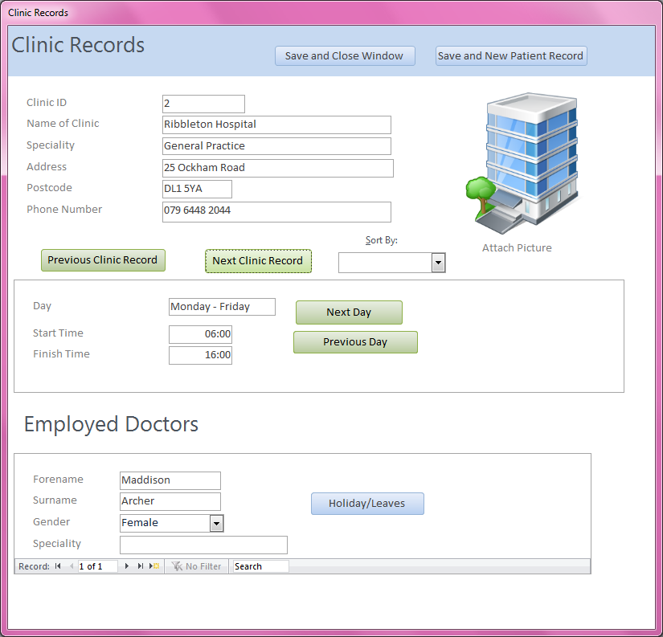

## Unit Testing – General System Functions (GSF)

(GSF) Previous

Clinic ID = 1

Previous Button pressed

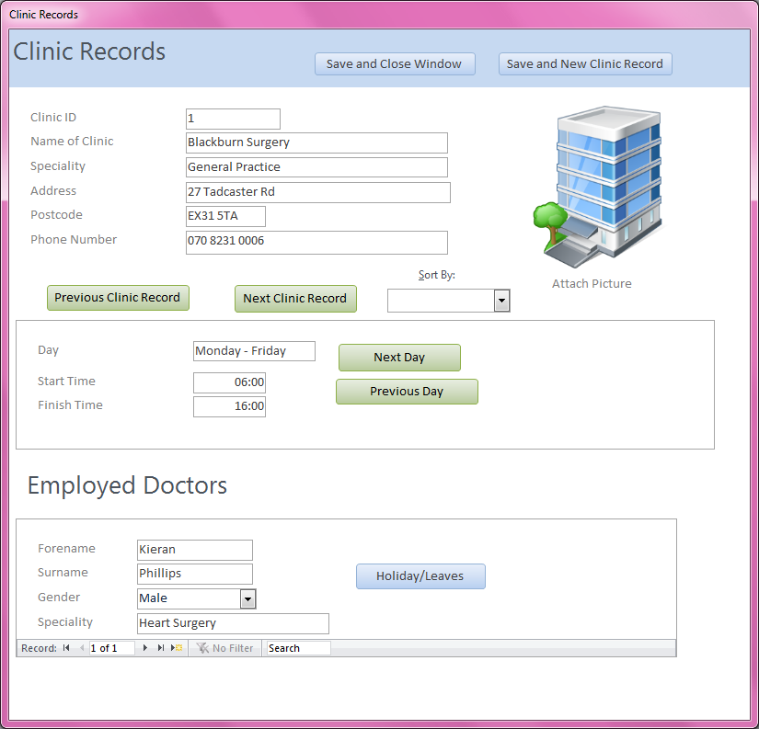

To the left is a screenshot showing what has happened after the “Previous Clinic Record” button was pressed. The Clinic ID has changed from 2 to 1 indicating that the form has navigated to a previous record. The button completed the task successfully.

Previous Button pressed

(GSF) Next

Next Button pressed

Clinic ID = 3

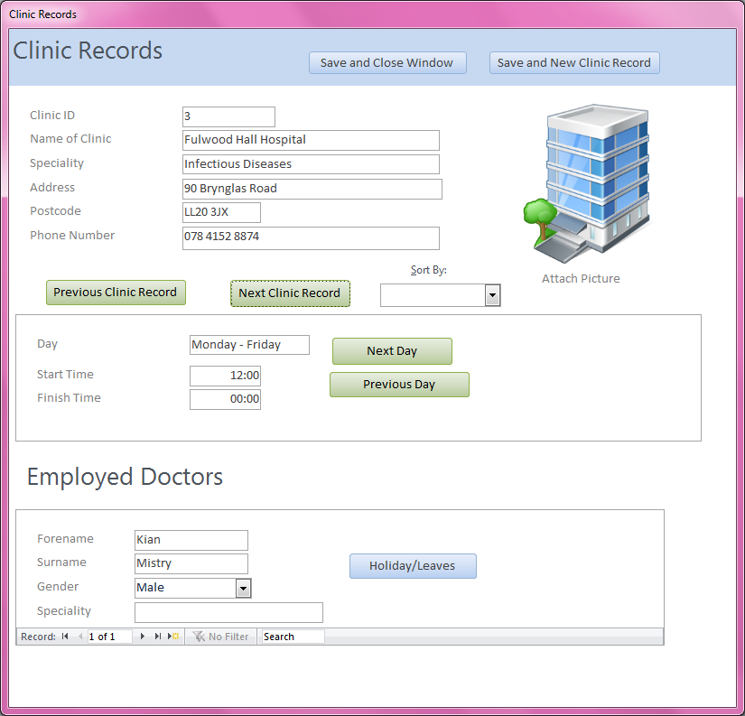

To the left is a screenshot showing what has happened after the “Next Clinic Record” button was pressed. The Clinic ID has changed from 2 to 3 indicating that the form has navigated to the next record. The button completed the task successfully.

## Unit Testing – General System Functions (GSF)

**Test No. 2**

**Purpose of Test**: To test if the “Save and New Clinic Record” saves the current record and allows you to produce a new record

**Test Data**: I will be using Form “Clinic Records” and will press the “Save and New Clinic Record” button

**Expected Result**: Form pops up message with “Record Saved” if the record is changed and then turns all fields blank

**Actual Result**: (GSF) Save and New Clinic Record - Success

(GSF) Save and New Clinic Record: Initial Screen

“Save and New Clinic Record” button pressed

Clinic ID = 1

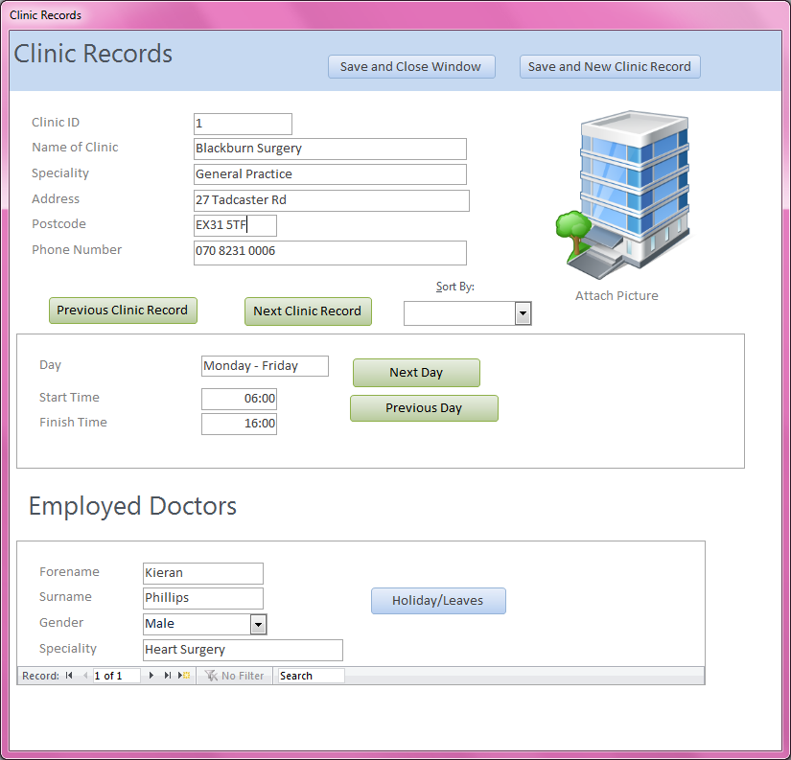

Postcode = “EX21 5TF”

## Unit Testing – General System Functions (GSF)

(GSF) Save and New Clinic Record: Record Saved

Clinic ID = 1

Postcode Changed to “EX21 5TA”

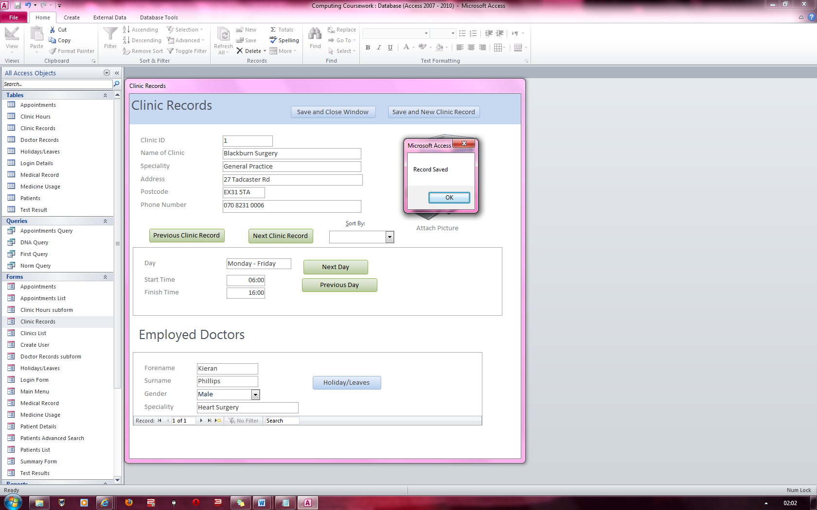

To the left is a screen shot of the original record having its postcode changed to “EX31 5TA” from “EX31 5TF”. This prompts the “Record Saved” message as the record was changed.

“Record Saved” Message box appears.

(GSF) Save and New Clinic Record: Blank Fields

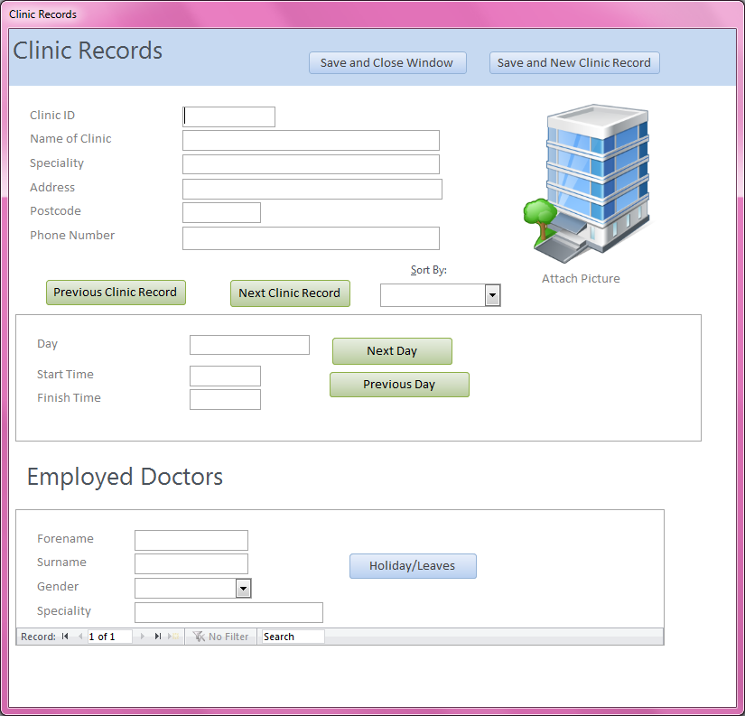

After the record has been saved, all the fields turn blank which produces a new record where data can be entered into.

All fields blank

## Unit Testing – General System Functions (GSF)

**Test No. 3**

**Purpose of Test**: To test if the “Save and Close Window” produces a save prompt and then closes the window.

**Test Data**: I will be using Form “Clinic Records” and will press the “Save and Close Window” button

**Expected Result**: Form pops up message with the “Record Saved” message and the form then closes

**Actual Result**: (GSF) Save and Close Window - Success

(GSF) Save and Close Window

Save Messaged Appeared and “Save and Close Window” button pressed



After “OK” is pressed on the dialog box, the form exits.

This covers the General System Functions for the system. All general system functions have been tested and all perform their designated task.

# Unit Testing – Logging In

|  |  |  |  |  |  |
| --- | --- | --- | --- | --- | --- |
| Test  No | Purpose of Test | Test Data | Data Type | Expected Result | Actual Result (reference) |
| 4 | Test that the program prevents logging in if no security code is entered | Login = “Admin”  Password = “Admins5”  Usergroup = “Admin” | Erroneous | Error message box given | Pass  Fig 1 |
| 5 | Test that the program prevents logging in if security code is too short | Sec Code = “1111-1111-1111-1111”  (Sec code is 1 character short)  Login = “Admin”  Password = “Admins5”  Usergroup = “Admin” | Erroneous | Error message box given | Pass  Fig 2 and Fig 3 |
| 6 | Test that the program prevents logging in if text box “login” is blank.  (Same for Create user form) | Sec Code = “1111-1111-1111-11117”  Login is empty  Password = “Admins5”  Usergroup = “Admin” | Erroneous | Error message box given | Pass  Fig 4, Fig 5, Fig 6  and Fig 7 |
| 7 | Test that the program prevents logging in unless a user account is selected.  (Same for Create user form) | Sec Code = “1111-1111-1111-11117”  Login = “Admin”  Password = “Admins5”  Usergroup is not selected | Erroneous | Error message box given | Pass  Fig 8 and Fig 9, |
| 8 | Test that the program prevents logging in if text box “Password” is blank.  (Same for Create user form) | Sec Code = “1111-1111-1111-11117”  Login = “Admin”  Password is empty  Usergroup = “Admin” | Erroneous | Error message box given | Pass  Fig 10, Fig 11  and Fig 12 |

## Unit Testing – Login Form and Create User Form

|  |  |  |  |  |  |
| --- | --- | --- | --- | --- | --- |
| Test  No | Purpose of Test | Test Data | Data Type | Expected Result | Actual Result (reference) |
| 9 | Test that the program prevents logging in if text box “Password” is less than 6 characters  (Same for Create user form) | Sec Code = “1111-1111-1111-11117”  Login = “Admin1”  Password (Length 5) = “Admin”  Usergroup = “Admin” | Erroneous | Error message box given | Pass  Fig 13, Fig 14  and Fig 15 |
| 10 | Test that the program prevents logging in if text box “Password” is more than 24 characters  (Same for Create user form) | Sec Code = “1111-1111-1111-11117”  Login = “Admin2”  Password (Length 26) = “thisismyreallylongpassword”  Usergroup = “Admin” | Erroneous | Error message box given | Pass  Fig 16, Fig 17  And Fig 18 |
| 11 | Test that the program prevents logging in if the password and login combination is correct but the incorrect user group is selected | Sec Code = “1111-1111-1111-11117”  Login = “Admin”  Password = “Admins5”  Usergoup = “Doctor” | Erroneous | Error message box given | Pass  Fig 19 |
| 12 | Test that the program allows exactly 6 characters for the password | Sec Code = “1111-1111-1111-11117”  Login = “Doctor”  Password = “Doctor”  Usergoup = “Doctor” | Extreme  (boundary) | Welcome Doctor Message given a | Pass  Fig 20 |
| 13 | Test that the program allows exactly 24 characters for the password | Sec Code = “1111-1111-1111-11117”  Login = “Admin2”  Password (length 24) = “thisismybigadminpassword”  Usergoup = “Admin” | Extreme  (boundary) | Welcome Admin  Message given | Pass  Fig 21 |

## Unit Testing – Login Form and Create User Form

|  |  |  |  |  |  |
| --- | --- | --- | --- | --- | --- |
| Test  No | Purpose of Test | Test Data | Data Type | Expected Result | Actual Result (reference) |
| 14 | Test that an account a Doctor account can be created | New User Name = “Anna”  New User Password = “Oranges”  User Group = “Doctor”  Admin Login = “Admin”  Admin Password = “Admins5” | Typical | Message that doctor account was created  Record created in  “Login Details” table | Pass  Fig 22 and Fig 23 |
| 15 | Test that an Admin account can be created | New User Name = “Fred”  New User Password = “Apples”  User Group = “Admin”  Admin Login = “Admin”  Admin Password = “Admins5” | Typical | Message that admin account was created  Record created in  “Login Details” table | Pass  Fig 24 and Fig 25 |
| 16 | Test that another account cannot be created with the same name | New User Name = “Anna”  New User Password = “Bananas”  User Group = “Doctor”  Admin Login = “Admin”  Admin Password = “Admins5” | Erroneous | Error Message | Pass  Fig 26 and Fig 27 |

# Unit Testing – Data Validation

|  |  |  |  |  |  |
| --- | --- | --- | --- | --- | --- |
| Test  No | Purpose of Test | Test Data | Data Type | Expected Result | Actual Result (reference) |
| 17 | Test to see if you can’t leave the “Forename” textbox blank or enter a number into the field  (Same for Doctor Records) | Forename is empty  Forename = 52 | Erroneous | Error Messages | Pass  Fig 28,29,30,31 |
| 18 | Test to see if you can’t leave the “Surname” textbox blank or enter a number into the field  (Same for Doctor Records) | Surname is empty  Surname = 52 | Erroneous | Error Messages | Pass  Fig 32,33,34,35 |
| 19 | Test to see if you can’t leave the “City” textbox blank or enter a number into the field | City is empty  City = 52 | Erroneous | Error Messages | Pass  Fig 36 |
| 20 | Test to see if you can’t leave the “Gender” textbox blank or enter a number into the field  (Same for Doctor Records) | Gender is empty  Gender = 23 | Erroneous | Error Messages | Pass - Demo  Fig 37,38 |
| 21 | Test to see if you can’t leave the  “Phone Number” textbox blank and that you can only put numbers in it.  (Same with Patient Records) | Phone number is empty  Phone Number = cake | Erroneous | Error Messages | Pass - Demo  Fig 39,40 |
| 22 | Test to see if you can’t leave the “Mobile Phone Number” textbox blank and that you can only put numbers in it | Mobile Phone number is empty  Mobile Phone Number = cake | Erroneous | Error Messages | Pass - Demo  Fig 39,40 |
| 23 | Test to see if you can’t leave the “Address” textbox blank  (same with Clinic Records) | Address is empty | Erroneous | Error Messages | Pass - Demo  Fig 41 |

## Unit Testing – Data Validation

|  |  |  |  |  |  |
| --- | --- | --- | --- | --- | --- |
| Test  No | Purpose of Test | Test Data | Data Type | Expected Result | Actual Result (reference) |
| 24 | Test to see if you can’t leave the “Name of Clinic” textbox blank or enter a number into the field | Name of Clinic is Empty  Name of Clinic = 52 | Erroneous | Error Messages | Pass  Fig 42 |
| 25 | Test to see if you can’t leave the “Speciality” textbox blank or enter a number into the field  (Same for Clinic Records) | Speciality is empty  Speciality = 52 | Erroneous | Error Messages | Pass  Fig 43, 44 |
| 26 | Test to see if you can’t leave the “Postcode” textbox blank  (Same with Clinic Records) | Postcode is empty | Erroneous | Error Messages | Pass - Demo  Fig 45 |
| 27 | Test to see if you can’t leave the “Height” textbox blank and that you can only put numbers into it | Height is empty  Height = cake | Erroneous | Error Messages | Pass - Demo  Fig 46 |
| 28 | Test to see if you can’t leave the “Weight” textbox blank and that you can only put numbers into it | Weight is empty  Weight = cake | Erroneous | Error Messages | Pass - Demo  Fig 47 |
| 29 | Test to see if you can’t leave the “Blood Type” textbox blank or enter a number into the field | Blood Type is empty  Blood type = 23 | Erroneous | Error Messages | Pass  Fig 48,49 |
| 30 | Test to see if you can’t leave the “Disabilities” textbox blank | Disabilities is empty | Erroneous | Error Messages | Pass  Fig50 |
| 31 | Test to see if you can’t leave the “Past Major illnesses” textbox blank | Past major Illnesses is empty | Erroneous | Error Messages | Pass  Fig51 |
| 32 | Test to see if you can’t leave the “Past Surgeries” textbox blank | Past Surgeries is empty | Erroneous | Error Messages | Pass  Fig 51 |

## Unit Testing – Data Validation

|  |  |  |  |  |  |
| --- | --- | --- | --- | --- | --- |
| Test  No | Purpose of Test | Test Data | Data Type | Expected Result | Actual Result (reference) |
| 33 | Test to see if you can’t leave the Single Search textbox blank when searching. | Search box is empty | Erroneous | Error Messages | Pass  Fig 52 |
| 34 | Test to see you can’t leave the multi search text boxes blank when you have the respected fields checked | Forename check box is checked  Forename search is empty | Erroneous | Error Messages | Pass  Fig 53 |
| 35 | Test to see you can’t run a multi search if it is blank | No fields checked  Search box is empty | Erroneous | Error Messages | Pass  Fig 54 |
| 36 | Test to see you can’t run a search if the appropriate box is not checked | Forename is not checked  Forename search = Anna | Erroneous | Error Messages | Pass  Fig 55 |

# Unit Testing– Adding Attachments

|  |  |  |  |  |  |
| --- | --- | --- | --- | --- | --- |
| Test  No | Purpose of Test | Test Data | Data Type | Expected Result | Actual Result (reference) |
| 37 | Test if you can add multiple letter attachments to medical record | Shown in reference | Typical | Multiple letters added in list view | Pass  Fig 56,57,58 |
| 38 | Test if you can add a picture of a patient to patient details | Shown in reference | Typical | Picture uploaded successfully and displayed | Pass  Fig 59,60 |
| 39 | Test if you can add a picture of a clinic on clinic records | Shown in reference | Typical | Picture uploaded successfully and displayed | Pass  Fig 61,62 |

# Unit Testing – Navigation

|  |  |  |  |  |  |
| --- | --- | --- | --- | --- | --- |
| Test  No | Purpose of Test | Test Data | Data Type | Expected Result | Actual Result (reference) |
| 40 | Test if button to open Medical Record form works |  | Typical | Opens Medical Record Form | Pass – Visually Confirmed |
| 41 | Test if button to open Medical Usage form works |  | Typical | Opens Medical Usage Form | Pass – Visually Confirmed |
| 42 | Test if button to open Test Results form works |  | Typical | Opens Test Results Form | Pass – Visually Confirmed |
| 43 | Test if button to open Appointment form works |  | Typical | Opens Appointments Form | Pass – Visually Confirmed |
| 44 | Test to see if button to open Holidays/Leaves form works |  | Typical | Opens Holidays/Leaves Form | Pass – Visually Confirmed |
| 45 | Test to see if button to open Clinic Details form works |  | Typical | Opens Clinic Details Form | Pass – Visually Confirmed |
| 46 | Test to see if button to open Patient Details form works |  | Typical | Opens Patient Details Form | Pass – Visually Confirmed |
| 47 | Test to see if button to open Patient’s Advanced Search form works |  | Typical | Opens Patient’s Advanced Search Form | Pass – Visually Confirmed |
| 48 | Test to see if button to open summary report works |  | Typical | Opens Summary Report | Pass – Visually Confirmed |
| 49 | Test to see if changing tabs in the main menu changes the displayed form/report |  | Typical | Open’s the appropriate form/report | Pass – Visually Confirmed |

# Unit Testing – Sorting Records

|  |  |  |  |  |  |
| --- | --- | --- | --- | --- | --- |
| Test  No | Purpose of Test | Test Data | Data Type | Expected Result | Actual Result (reference) |
| 50 | Test if Patient records can be sorted in ascending order and descending order by “Forename” | Shown in reference | Typical | Ordered in ascending/descending order as appropriate | Pass  Fig 63,64 |
| 51 | Test if Patient records can be sorted in ascending order and descending order by “Surname” | Shown in reference | Typical | Ordered in ascending/descending order as appropriate | Pass – Demo  Fig 63,64 |
| 52 | Test if Clinc records can be sorted in ascending order and descending order by “Clinc ID” | Shown in reference | Typical | Ordered in ascending/descending order as appropriate | Pass  Fig 65,66 |
| 53 | Test if Clinc records can be sorted in ascending order and descending order by “Clinic Name” | Shown in reference | Typical | Ordered in ascending/descending order as appropriate | Pass – Demo  Fig 65,66 |

# Integration Testing – Adding, Amending and Deleting Records

|  |  |  |  |  |  |
| --- | --- | --- | --- | --- | --- |
| Test  No | Purpose of Test | Test Data | Data Type | Expected Result | Actual Result (reference) |
| 54 | Test if a new patient record can be added/edited/deleted | Shown in reference | Typical | Adds/Edits/Deletes the data | Pass  Fig 67,68,69,70,71,72,73 |
| 55 | Test if a new doctor record can be added/edited/deleted |  | Typical | Adds/Edits/Deletes the data | Pass – Demo  Fig 67,68,69,70,71,72,73 |
| 56 | Test if a new appointment record can be added/edited/deleted |  | Typical | Adds/Edits/Deletes the data | Pass – Demo  Fig 67,68,69,70,71,72,73 |
| 57 | Test if a new medical record can be added/edited/deleted |  | Typical | Adds/Edits/Deletes the data | Pass – Demo  Fig 67,68,69,70,71,72,73 |
| 58 | Test if a new test result record can be added/edited/deleted |  | Typical | Adds/Edits/Deletes the data | Pass – Demo  Fig 67,68,69,70,71,72,73 |
| 59 | Test if a new medical usage record can be added/edited/deleted |  | Typical | Adds/Edits/Deletes the data | Pass – Demo  Fig 67,68,69,70,71,72,73 |
| 60 | Test if a Holiday/Leave record can be added/edited/deleted |  | Typical | Adds/Edits/Deletes the data | Pass – Demo  Fig 67,68,69,70,71,72,73 |
| 61 | Test if a Clinic Record can be added/edited/deleted |  | Typical | Adds/Edits/Deletes the data | Pass – Demo  Fig 67,68,69,70,71,72,73 |

All of the above records can be added/edited/deleted similar to how the patient record was added/edited/deleted.

# Integration Testing – Appointments

|  |  |  |  |  |  |
| --- | --- | --- | --- | --- | --- |
| Test  No | Purpose of Test | Test Data | Data Type | Expected Result | Actual Result (reference) |
| 62 | Test that the Generate Referrence Number generates a random number |  | Typical | Generates a random reference number | Pass – Visual Confirmation |
| 63 | Test that the check valid date button checks if the date is valid and check if the correct end time is displayed | Appointment Time = 09:00  Duration = 60 minutes | Typical | Message about date being available with a certain clinic  End Time = 10:00 | Pass  Fig 74, Fig 75 |
| 64 | Test that the check valid date button checks if the date is invalid | Shown in reference | Erroneous | Message about appointment date already take with the clinic | Pass  Fig 76,77 |
| 65 | Test to see if valid date button is testing dates generally instead of it testing if a clinic is available at the specified date and time | Shown in reference | Erroneous | Message displaying time is available  Ie. It is dependent on the clinic as well as the date and time | Pass  Fig 78,79,80 |
| 66 | Check if an appointment date and time is valid if an appointment starts right after another ends with the same clinic | Shown in reference | Extreme  (boundary) | Message stating time and date is available at that time | Pass  Fig 81,82 |
| 67 | Test that that when checking the first appointment check box, the first appointment letter is generated with the patient’s appointment details | Shown in reference | Typical | First appointment letter generated with patient’s appointment details | Pass  Fig 83,84 |

## Integration Testing – Appointments

|  |  |  |  |  |  |
| --- | --- | --- | --- | --- | --- |
| Test  No | Purpose of Test | Test Data | Data Type | Expected Result | Actual Result (reference) |
| 68 | Test that that when checking the Did Not Attend check box, the Did not Attend appointment letter is generated with the patient’s appointment details | Shown in reference | Typical | Did not Attend letter generated with patient’s appointment details | Pass  Fig 85,86 |
| 69 | Test that that when not checking any check box the normal appointment letter is generated with the patient’s appointment details | Shown in reference | Typical | Normal letter generated with patient’s appointment details | Pass  Fig 87, 88 |
| 70 | Test that you cannot check both first appointment and did not attend check boxes | Shown in reference | Erroneous | Error message stating both checkboxes cannot be checked | Pass  Fig 89 |
| 71 | Test to see when clicking on generate letter label, it generates a letter label with the details of the patient’s who’s appointment it is. | Shown in reference | Typical | Report opens with letter label with print button | Pass  Fig 90 |

# Integration Testing – Adding Holidays/Leaves

|  |  |  |  |  |  |
| --- | --- | --- | --- | --- | --- |
| Test  No | Purpose of Test | Test Data | Data Type | Expected Result | Actual Result (reference) |
| 72 | Test if you can add holidays/leaves for a doctor | Shown in reference | Typical | holidays/leaves can be added | Pass  Fig 91. 92 |
| 73 | Test if you can add a holiday/leave before the current date | Shown in reference  Current Date = 15/03/2012 | Erroneous | Error Message stating it can’t be done | Fail – Fixed  Fig 93, 94, 95 |
| 74 | Test if you can view a doctor’s holiday/leave dates |  | Typical | Can view holidays/leaves | Pass – Visually Confirmed |

# Integration Testing – Patient’s Advanced Search

|  |  |  |  |  |  |
| --- | --- | --- | --- | --- | --- |
| Test  No | Purpose of Test | Test Data | Data Type | Expected Result | Actual Result (reference) |
| 75 | Test that the single search works | Forename = “Amber” | Typical | All records with  forename = “Amber” found | Pass  Fig 96,97,98 |
| 76 | Test for no record being found with data in multi search | Forename = “rabbits” | Erroneous | Error Message stating record does not exist | Fail – Fixed  Fig 99,100,101 |
| 77 | Test that multisearch brings up a valid record | Forename = “Ella”  Surname = “Steele” | Typical |  | Pass  Fig 102,103 |

# Integration Testing – Main Menu

|  |  |  |  |  |  |
| --- | --- | --- | --- | --- | --- |
| Test  No | Purpose of Test | Test Data | Data Type | Expected Result | Actual Result (reference) |
| 78 | Test if clicking backup starts the backup function |  | Typical | File Dialog box pops up | Pass - Visual Confirmation |
| 79 | Test if an error message pops up when no file is selected ie. Cancel is pressed  when clicking on the backup button | Cancel is pressed | Erroneous | Error Messages pop up | Pass  Fig 104,105,106 |
| 80 | Test to see if it the backup button creates the “backup” folder and saves the database in a folder with the correct date and time as the file name | Choose database  Backup file is generated  Database is saved inside a file with the current date and time as the file name. | Typical | Backup Successful Message pop up  Backup folder generated  Save file created with current date and time | Pass  Fig 107,108,109,110,111 |
| 81 | Test to see if it the backup button creates the saves the database in the already generated “backup “ in a folder with the correct date and time as the file name | Backup file is already created  New save file should have the same date but a different time. | Typical | Backup Successful  Message pop up  Save file created in the backup folder with the current date and time  (different to previous test) | Pass  Fig 112, 113, 114, 115 |
| 82 | Test if return to login screen button brings up login screen |  | Typical | Login screen pops up | Pass –Visually Confirmed  Login Screen Appears |
| 83 | Test if Exit button exits the main menu |  | Typical | Main Menu exits | Pass –Visually Confirmed The form closed |

# Integration Testing – Summary

|  |  |  |  |  |  |
| --- | --- | --- | --- | --- | --- |
| Test  No | Purpose of Test | Test Data | Data Type | Expected Result | Actual Result (reference) |
| 84 | Test if ratio’s and percentages are accurate | Shown in reference | Typical | Results are accurate | Pass  Fig 116, 117 |
| 85 | Test that the summary report generates the correct percentage when a normal appointment is removed | Temporarily removed a normal appointment | Typical | Total appointments = 6  Appointment Attendance percentage = 50% | Pass  Fig 118 |
| 86 | Test that the summary report generates the correct details if 5 doctor records are removed | Temporarily removed 5 doctor records | Typical | Ratio of patient to doctor turns to 1.1:1  Ratio of clinics to doctor turns to 1.1:1 | Pass  Fig 119 |

# End User Testing

|  |  |  |  |  |  |
| --- | --- | --- | --- | --- | --- |
| Test  No | Purpose of Test | Test Data | Data Type | Expected Result | Actual Result (reference) |
| 87 | Create Patient record | NHS Number = 324234  Date of Birth = “28/12/1963”  Forename = “Susan”  Surname = “Boyle”  Gender = Female  Phone number = 0324234  Mobile Phone Number = 73248234  Address = 32 Lossy street  Postcode = MM5 9HJ  City = Morecambe | Typical | Patient record created and saved | Pass  Fig 120,121 |
| 88 | Create Appointment for new patient | Appointment Date = 25/09/2012  Appointment Time = 05:00  Clinic = “Blackburn Surgery”  Treatment = “X-ray”  Duration = 30 minutes | Typical | Appointment record created and saved | Pass  Fig 122,123 |
| 89 | Generate the appropriate letter and label. | Shown in reference | Typical | Normal Appointment letter generated and letter label generated | Pass  Fig 124, 125 |
| 90 | Test if patient record shows up in patient list | Forename = Susan | Typical | Patient record shows up in Patient List | Pass  Fig 126 |
| 91 | Test if Appointment record shows up in Appointment list | Appointment ref number | Typical | Appointment record shows up in Appointment List | Pass  Fig 127 |
| 92 | Test if Clinic record shows up in Clinics list | Clinic = “Blackburn Surgery” | Typical | Clinic record shows up in Clinic List | Pass  Fig 128 |
| 93 | Test if the show record combo box displays the patient details | Forename = Susan” | Typical | Drop down combo box shows Susan and will navigate to it | Pass  Fig 129, 130 |

## End User Testing

|  |  |  |  |  |  |
| --- | --- | --- | --- | --- | --- |
| Test  No | Purpose of Test | Test Data | Data Type | Expected Result | Actual Result (reference) |
| 94 | Test to see if the timetable works for at least 1 doctor | Shown in Referrence | Typical | Appointment table pops up which is frozen on the clinic the doctor works for | Fig 131, 132 |
| 95 | Test to see if an appointment can be made when a clinic has no doctors available | Shown in reference | Erroneous | Error message stating when earliest doctor will be back. Forced to change appointment date or assigned clinic | Fig 132, 133, 134 |

# Appendix

This section will contain all the screenshots needed for the “Actual Results” column of my testing plan.

**Demo Definition:** To prevent repeating very similar tests which all have similar outcomes, I have produced a demo of some tests such that they represent what other similar tests would produce.

**Unit Testing**

1. Logging In
2. Data Validation
3. Navigation
4. Adding Attachments
5. Sorting Records

**Integration Testing**

1. Adding/Amending/Deleting Records
2. Appointments
3. Adding Holidays/Leaves and Patient’s Advanced Search
4. Main menu
5. Summary

**End User Testing**

1. Creating Patient and Appointment records & Generate Letter and Label
2. Check if Appointment shows up in Appointment list
3. Check if Patient record shows up in Patient list
4. Check if Clinic shows up in Clinic list
5. Check if the Patient record shows up in the “Show Record” combo box

### Figure 1

No Security Code has been entered

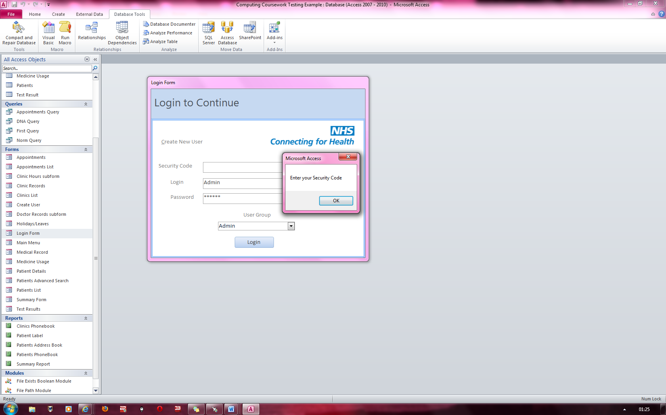

Error Message stating that a “Security Code” must be entered for the system to login.

### Figure 2& Figure 3

Security Code is 1 letter short from being complete.

Security code here is 16 characters long

(Security code is 17 characters long excluding the dashes)

Error Message stating that Security code is of an incorrect length which prevents the user from logging in

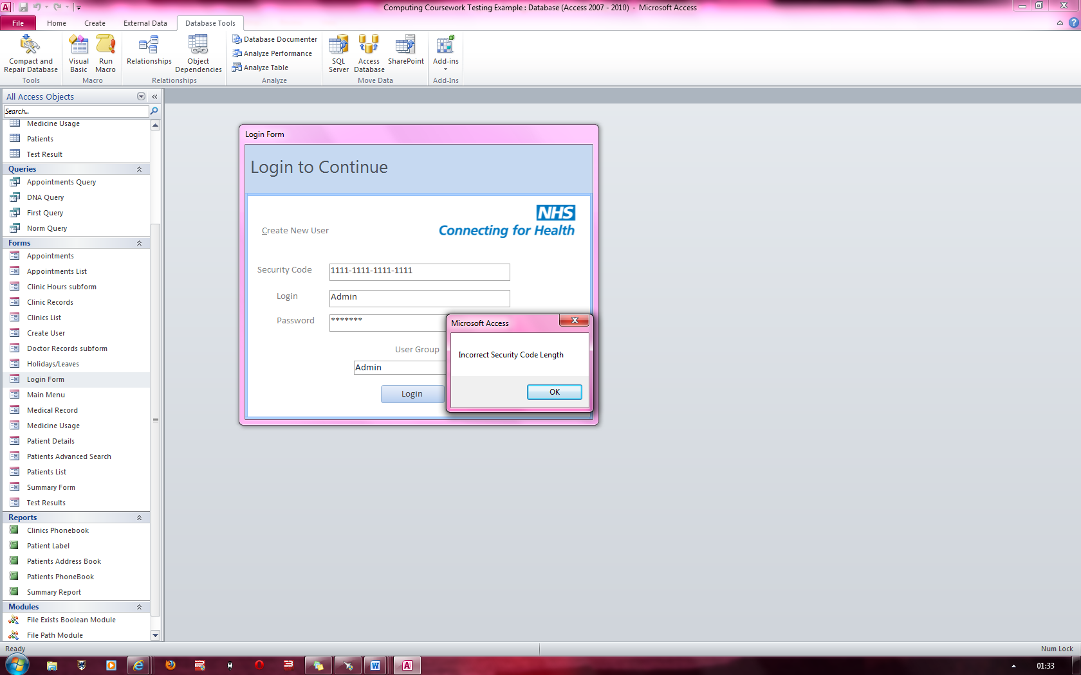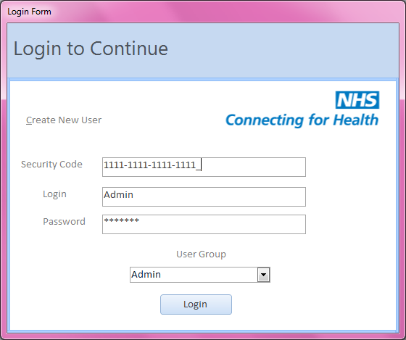**Fig 2: Fig 3:**

All other details are valid Login, Password and User Group combinations.

### Figure 4 & Figure 5

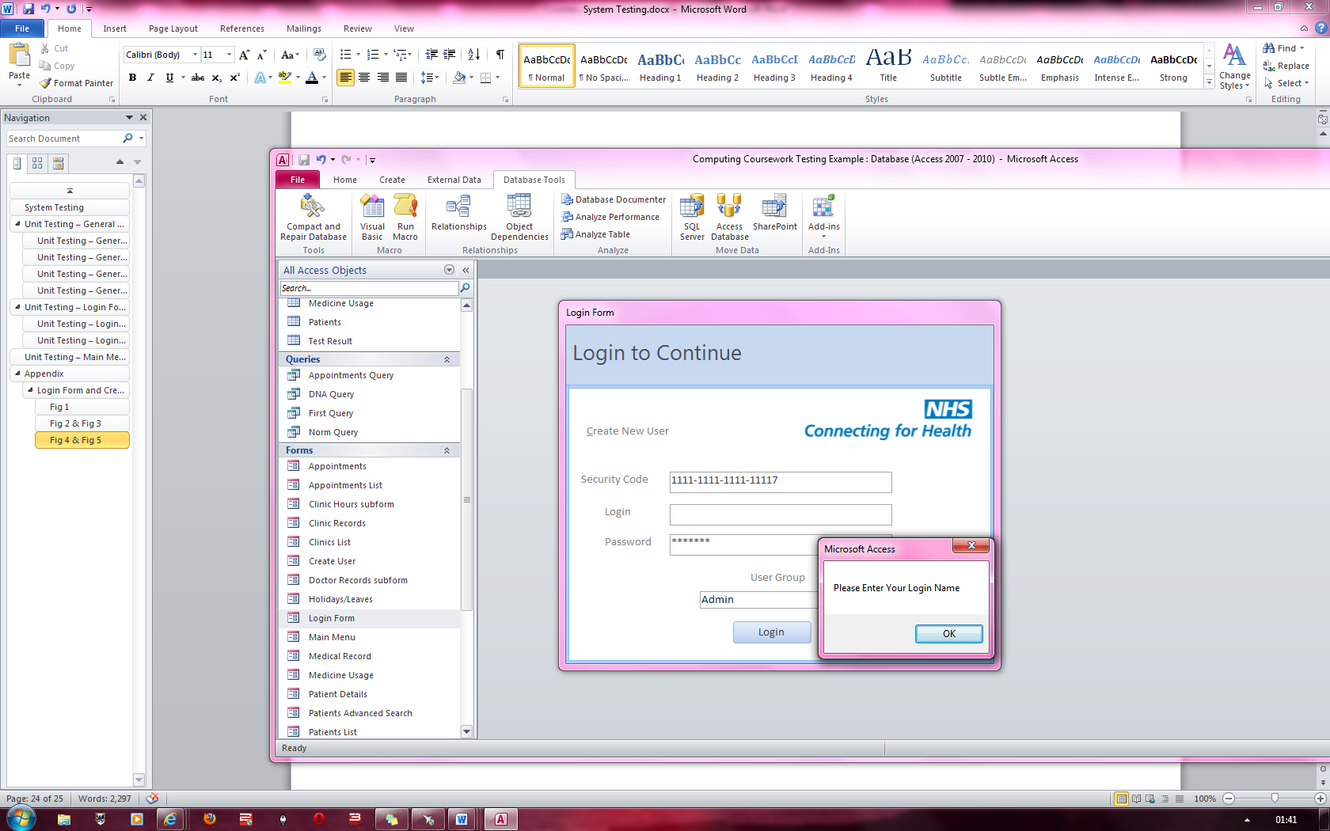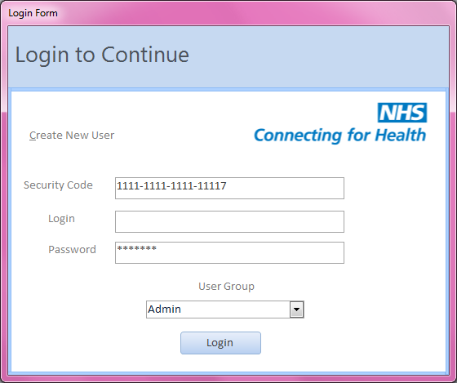**Fig 4:** **Fig 5:**

“Please Enter Your Login Name” error message appears which prevents the user logging in.

Login Name is empty

All other details are valid Security code, Password and User Group combinations.

### Figure 6 & Figure 7

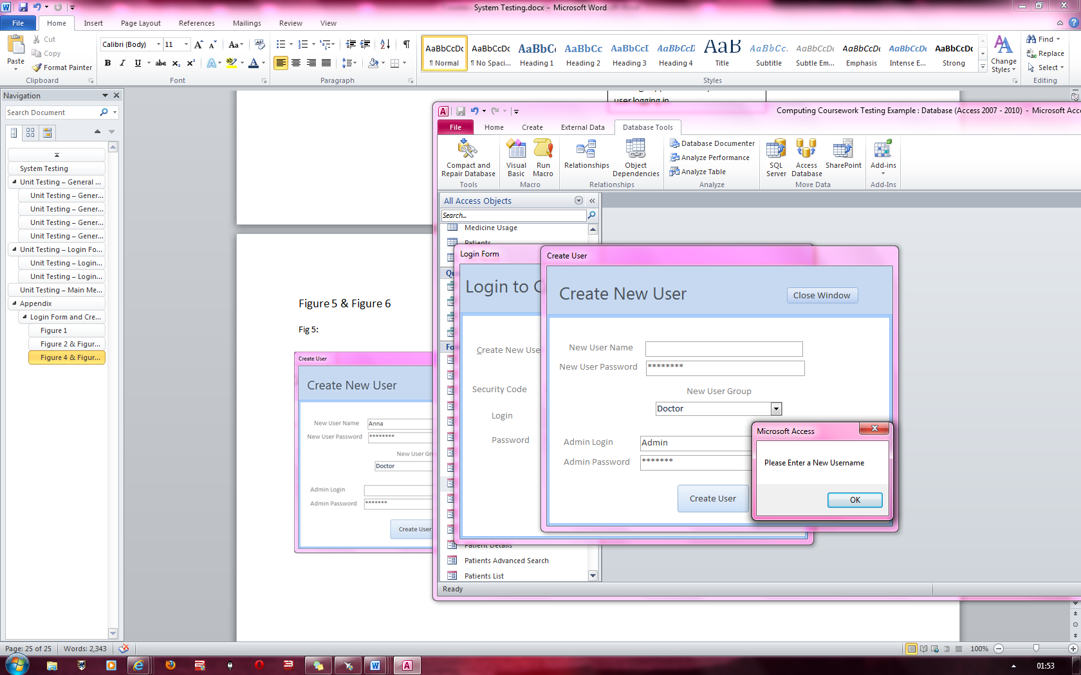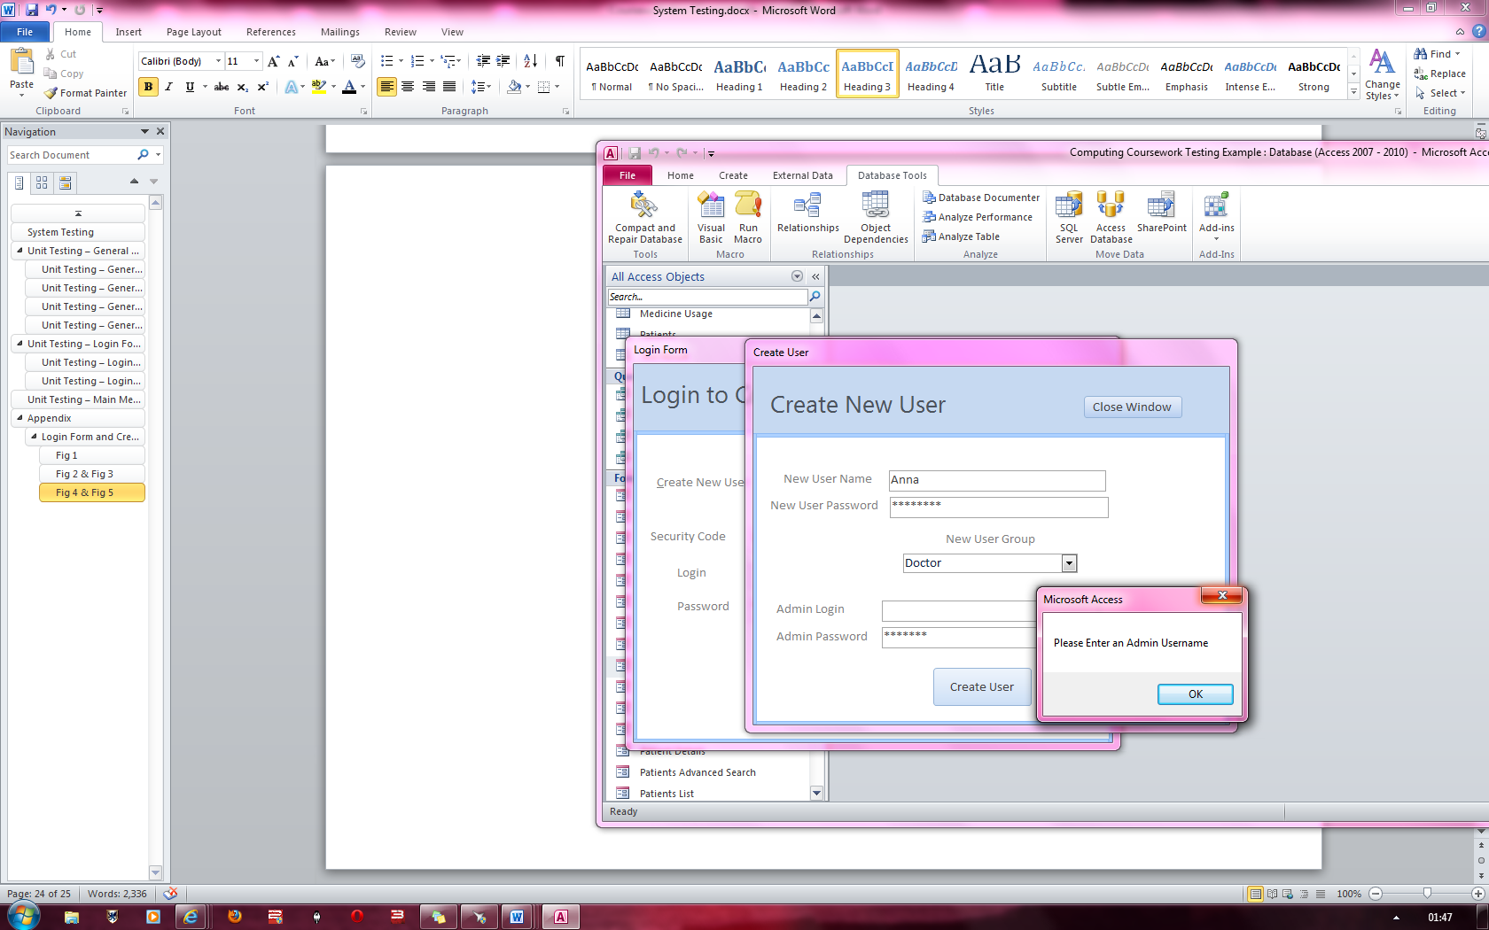**Fig 6**: **Fig 7:**

‘New User Name’ is empty

“Please Enter a New Username” error message appears which prevents the creation of the ‘Doctor account’

“Please Enter an Admin Username” error message appears which prevents the creation of the ‘Doctor account’

‘Admin Login’ is empty

### Figure 8 & Figure 9

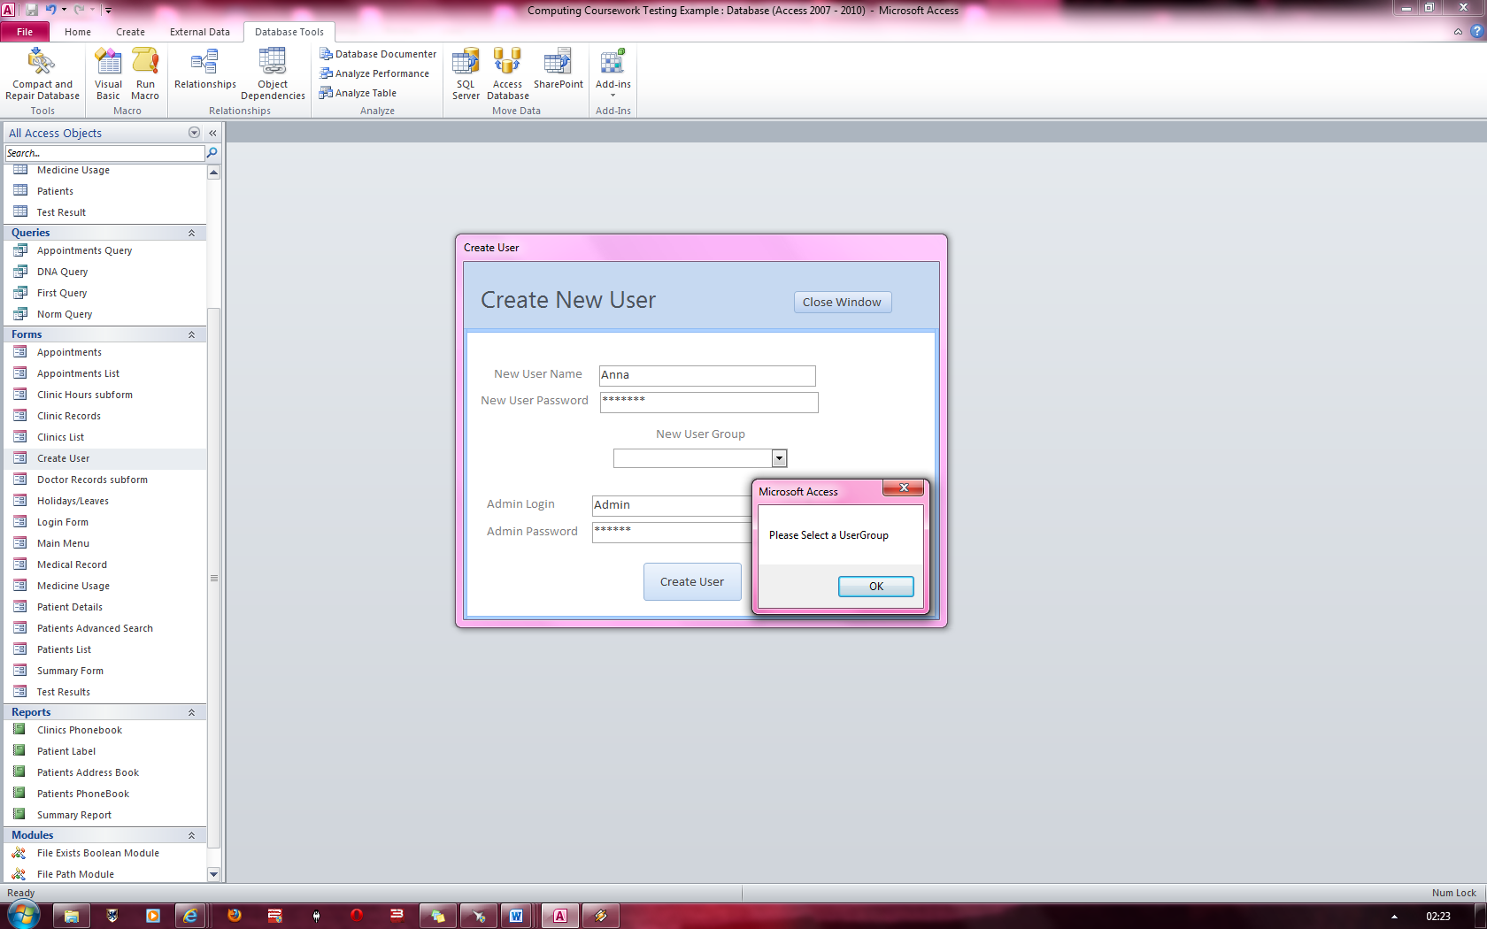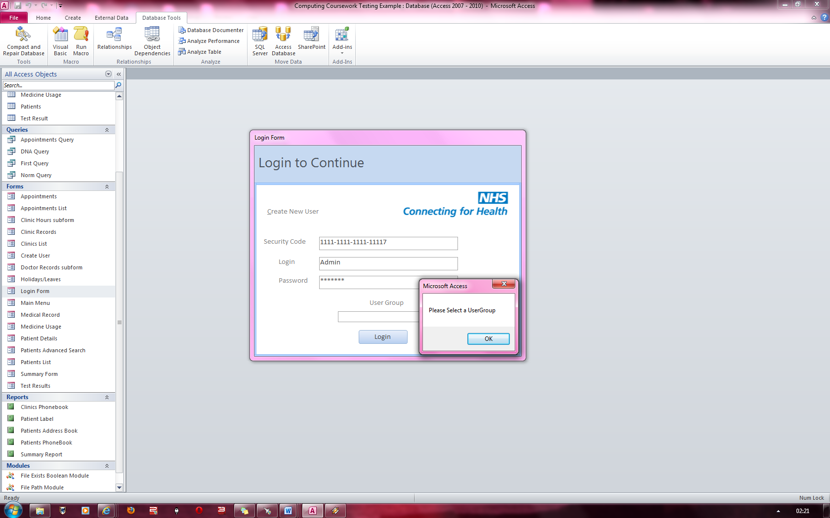 **Fig 8**: **Fig 9:**

‘New User group ‘is empty

“Please Select a UserGroup” error message appears which prevents the admin from creating a new account

‘User group ‘is empty

“Please Select a UserGroup” error message appears which prevents the user from logging in.

### Figure 10 & Figure 11

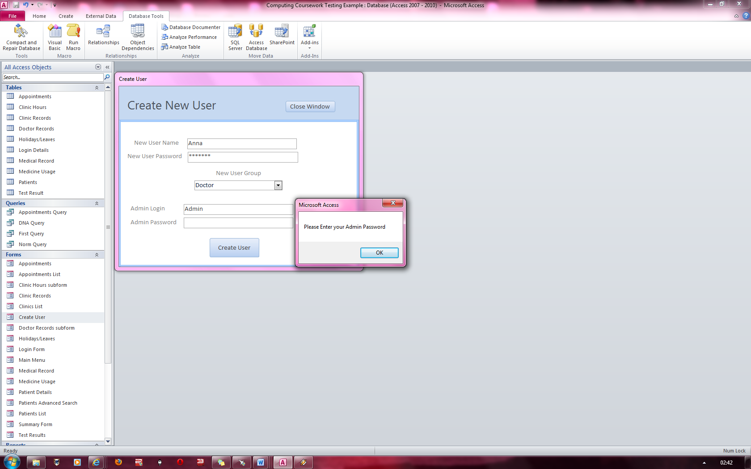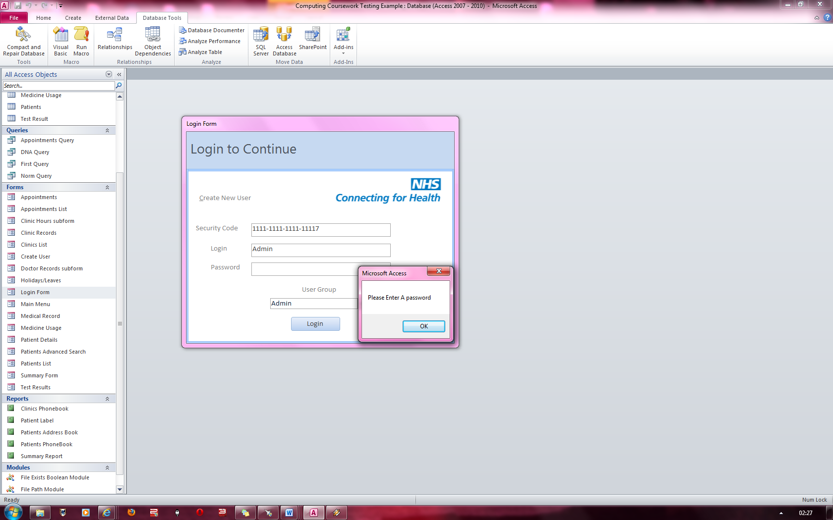**Fig 10**: **Fig 11**:

“Please Enter you Admin Password” error message appears which prevents the admin from creating the new account

‘Admin Password ‘is empty

‘Password ‘is empty

“Please Enter a Password” error message appears which prevents the user from logging in.

### Figure 12 & Figure 13

**Fig 12: Fig 13:**

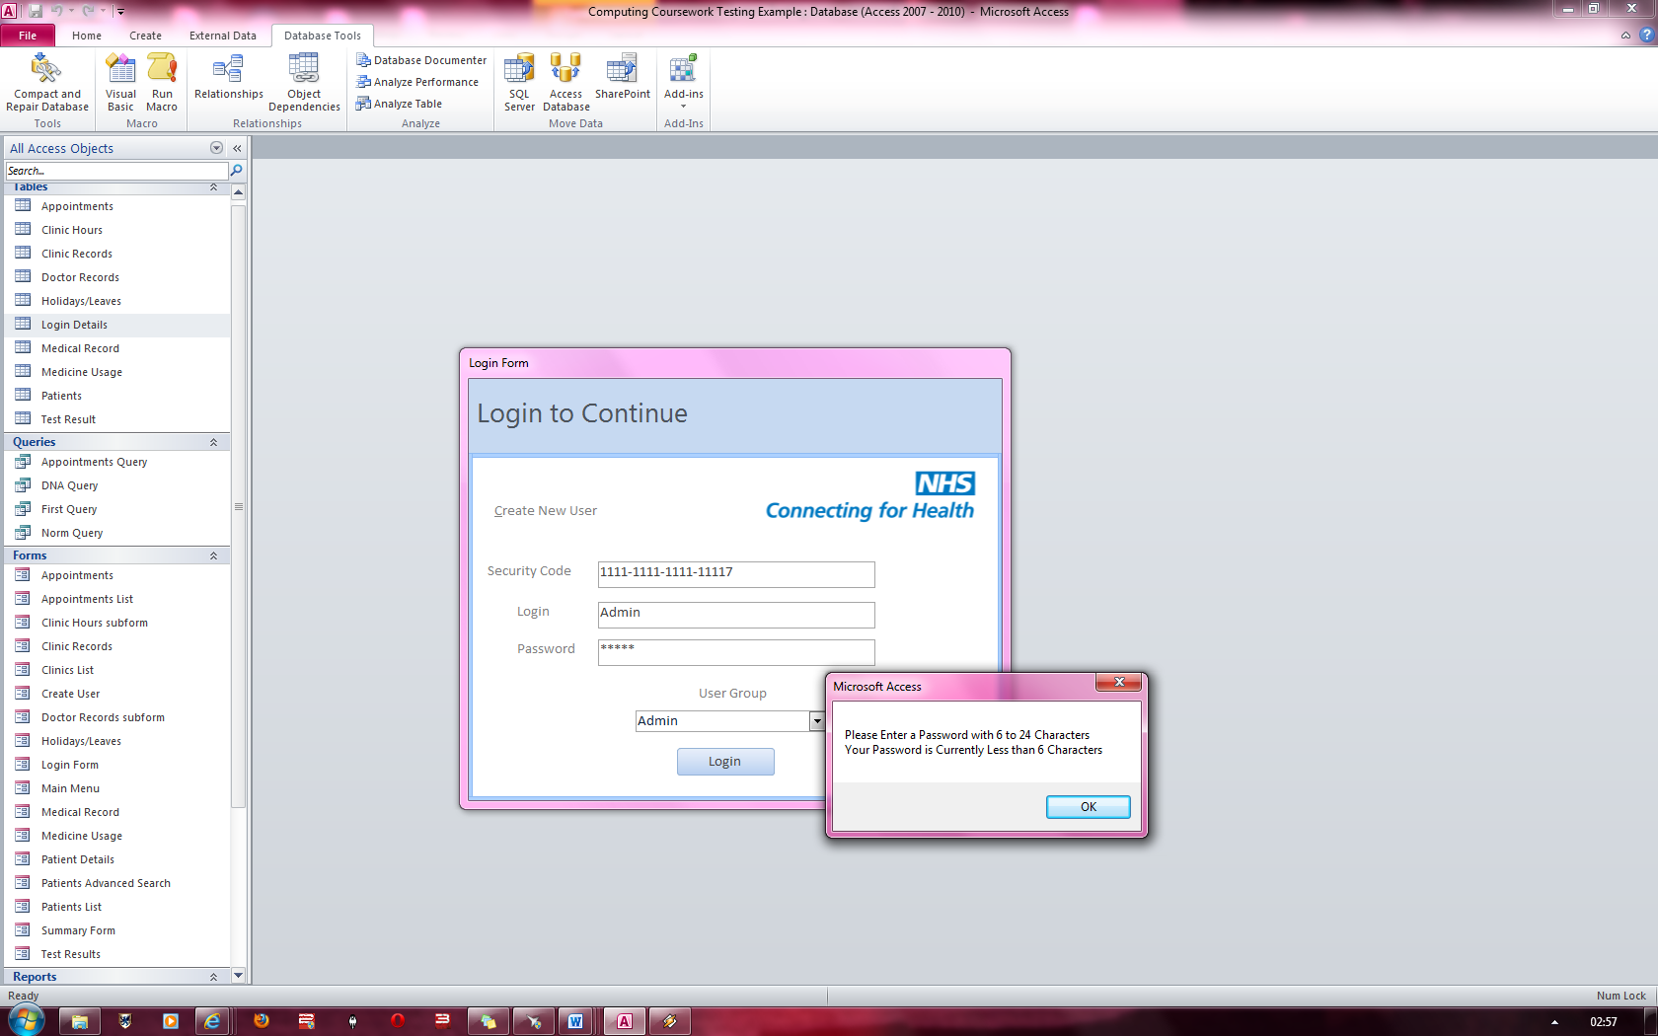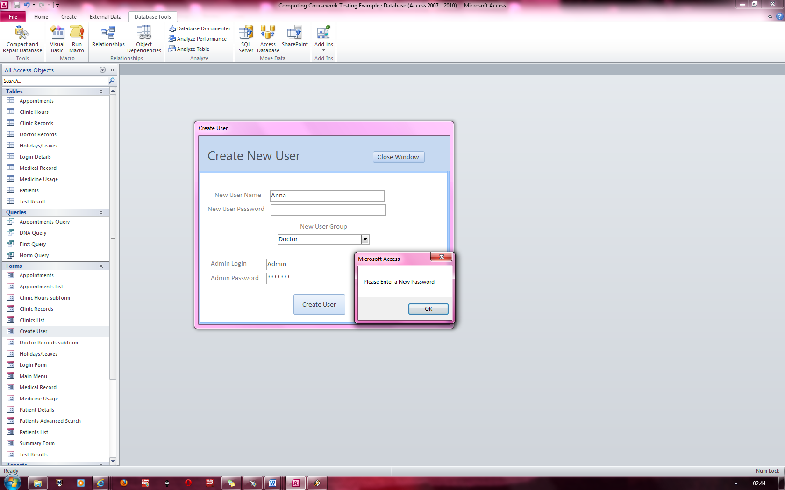

Error message stating that the password must be between 6 and 24 characters This prevents the user from logging in

‘Password ‘is 5 characters long

“Please Enter a New Password” error message appears which prevents the admin from creating the new account

‘New User Password ‘is empty

### Figure 14 & Figure 15

**Fig 14: Fig 15:**

‘New User Password ‘is 5 characters long

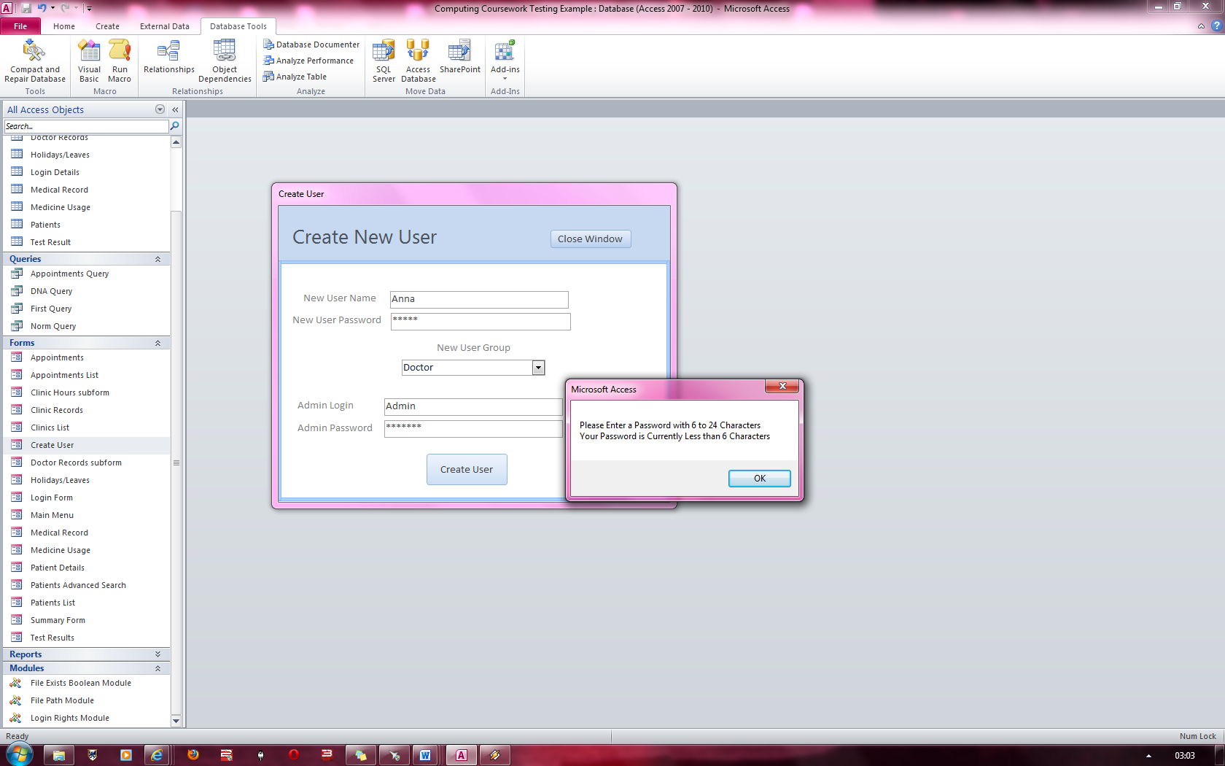

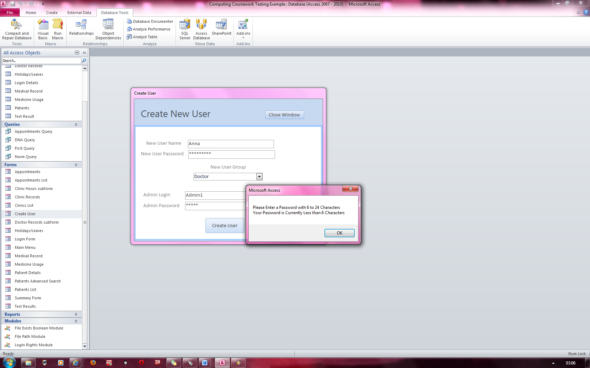

Error message stating that the New User password must be between 6 and 24 characters

This prevents the user from logging in

Error message stating that the Admin password must be between 6 and 24 characters

This prevents the user from logging in

‘Admin Password ‘is 5 characters long

### Figure 16 & Figure 17

‘New User Password ‘is 26 characters long

Error message stating that the New User password must be between 6 and 24 characters

This prevents the user from logging in

**Fig 16: Fig 17:**

‘Password ‘is 26 characters long

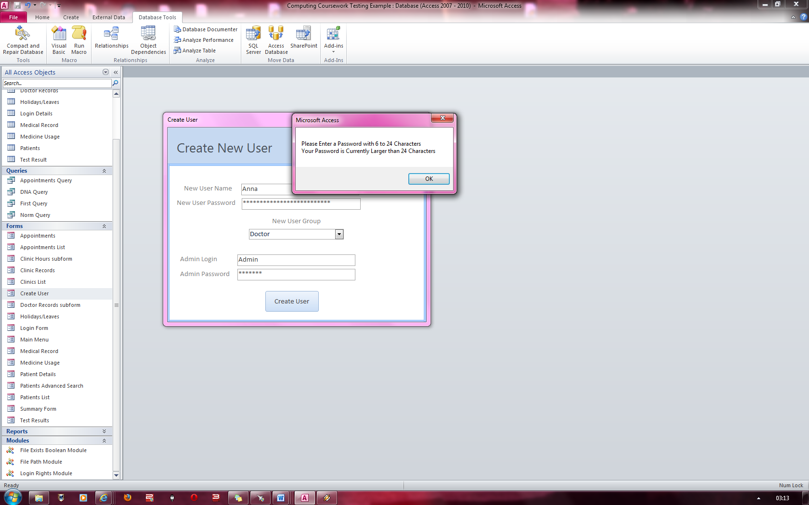

Error message stating that the password must be between 6 and 24 characters

This prevents the user from logging in

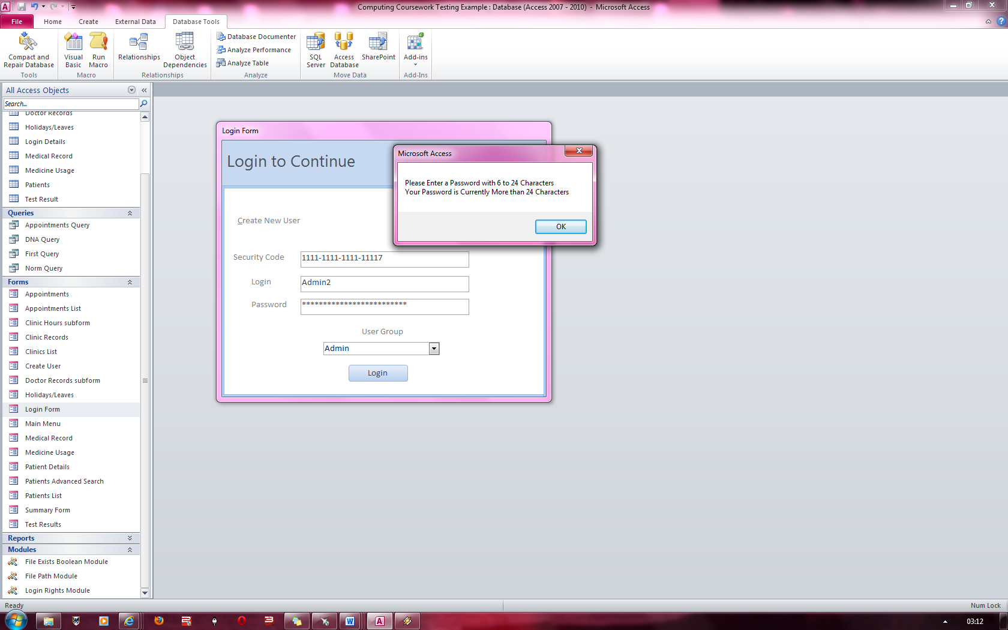

### Figure 18 & Figure 19

**Fig 18: Fig 19:**

Error message stating that the password must be between 6 and 24 characters

This prevents the user from logging in

‘Password ‘is 26 characters long

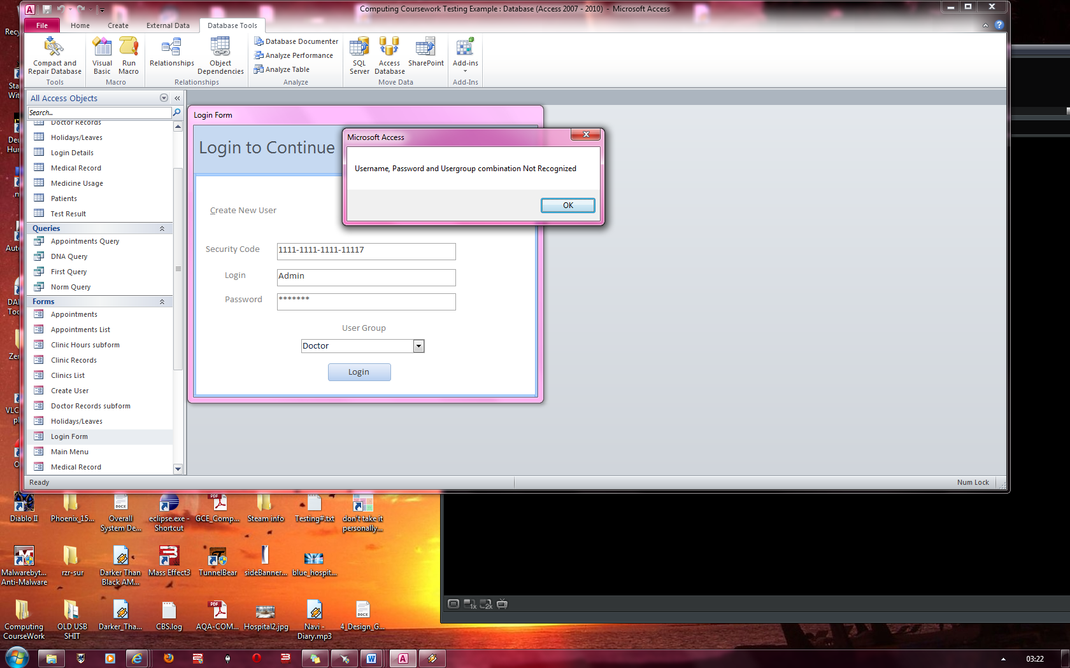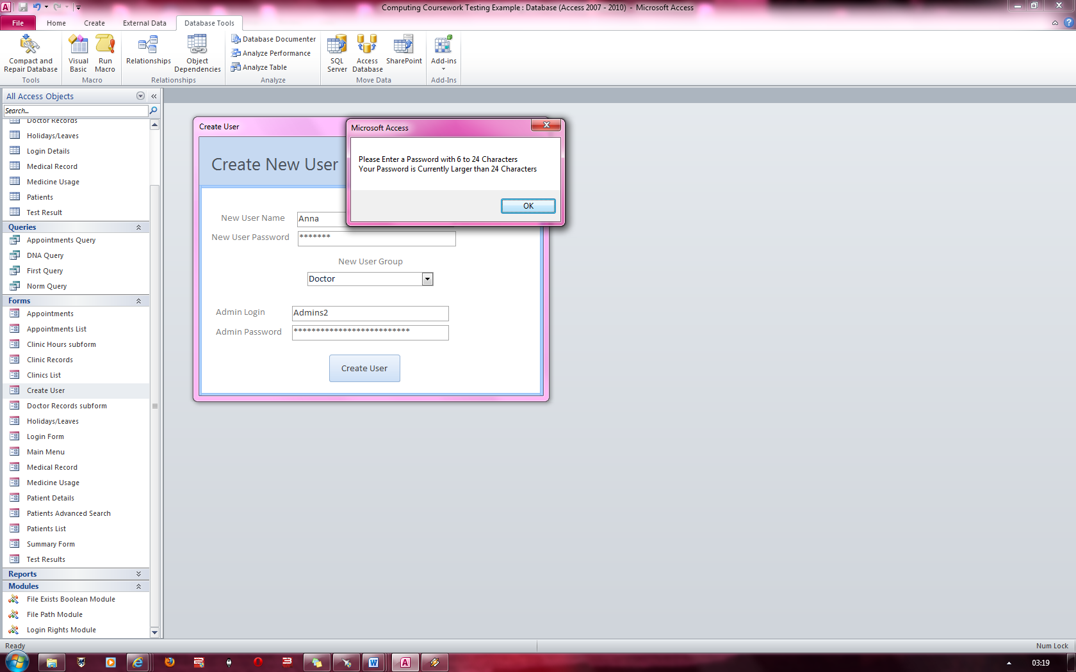

Security Code, Login and password contains a valid combination but the usergroup is invalid which prevents a login

### Figure 20 & Figure 21

**Fig 20: Fig 21:**

Successful login with all valid details for a doctor login

Successful login with all valid details for an admin login

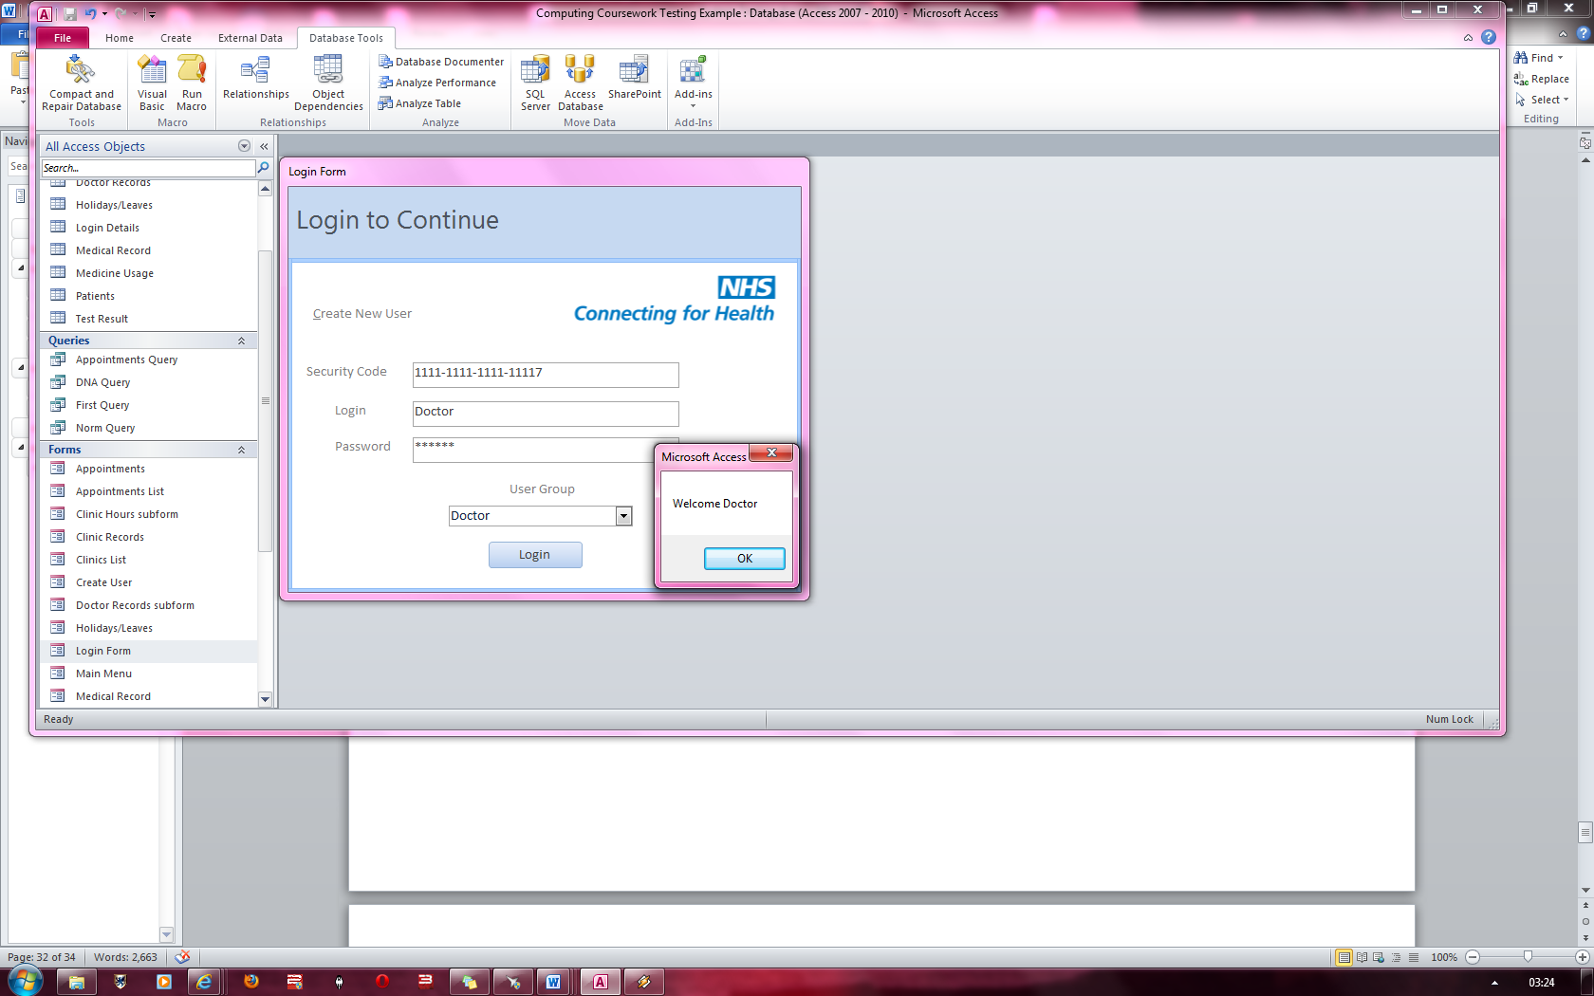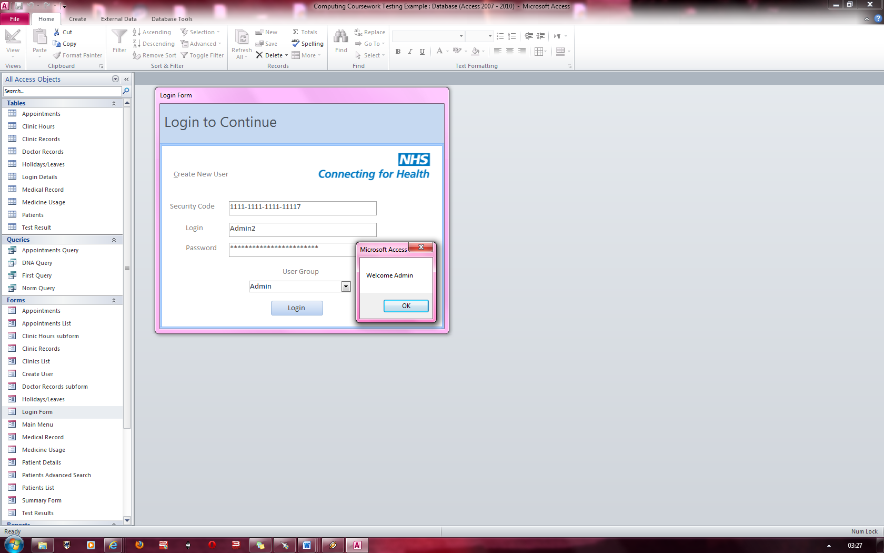

Message alerting doctor log in was successful

Message alerting admin log in was successful

### Figure 22 & Figure 23

**Fig 22: Fig 23:**

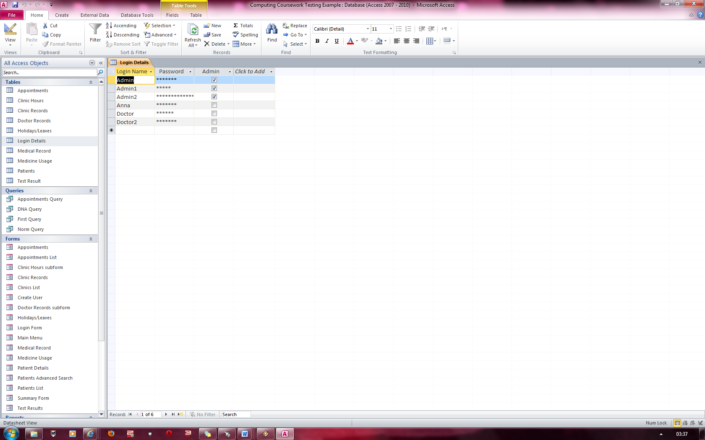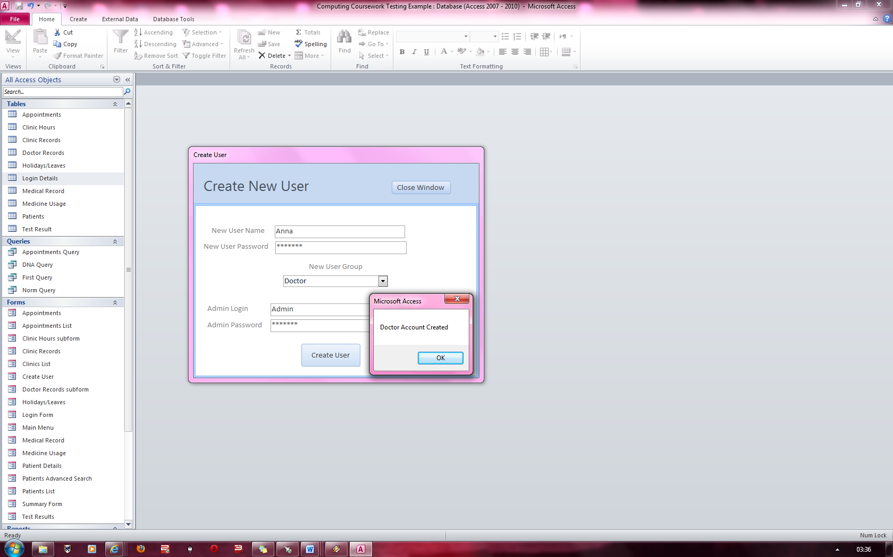

Proof that the Username and password have been added and that it is a doctor’s account

Message alerting admin that Doctor Account was created successfully

Successful doctor account creation with all valid details filled in.

### Figure 24 & Figure 25

**Fig 24: Fig 25:**

Proof that the Username and password have been added and that in is an admin’s account

Message alerting admin that an Admin Account was created successfully

Successful admin account creation with all valid details filled in.

### Figure 26 & Figure 27

**Fig 26: Fig 27:**

### Figure 28

Proof that another record has NOT been added

No two accounts can have the same username

Message alerting admin that they must choose a different username

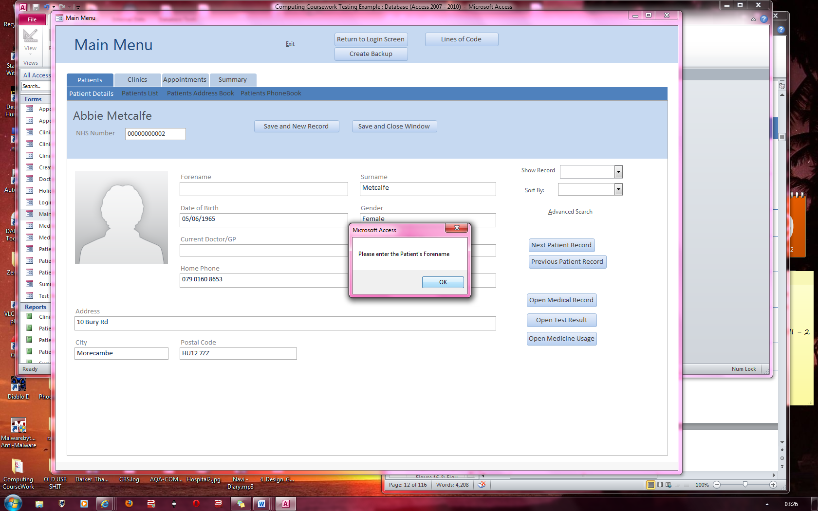

Message alerting the user that the Forename cannot be kept blank

### Figure 29

Message alerting the user that the Forename cannot contain numbers

### Figure 30 and 31

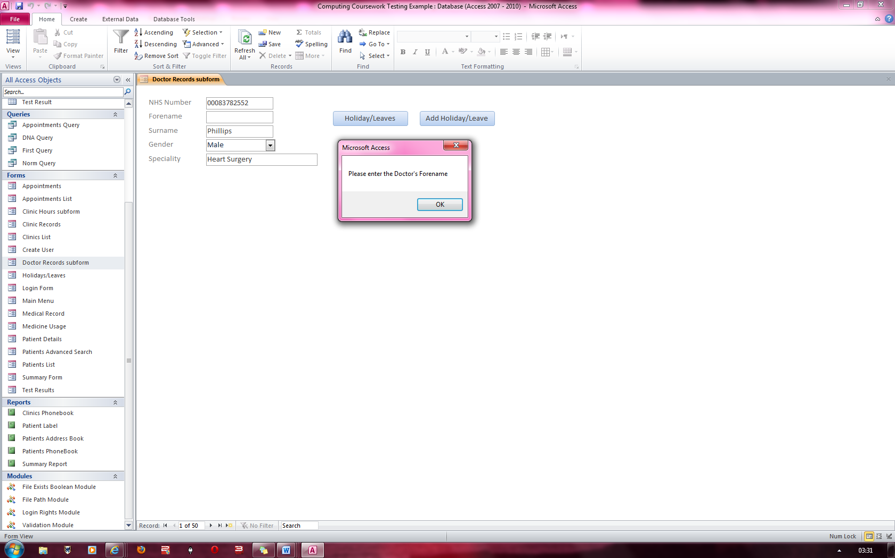

**Fig 30:**  Here is fig 30; the forename cannot be left blank as shown by the error message

**Fig 30**

**Fig 31:**  Here is fig 31; the forename cannot contain any numbers in the field as shown by the error message

**Fig 31**

### Figure 32

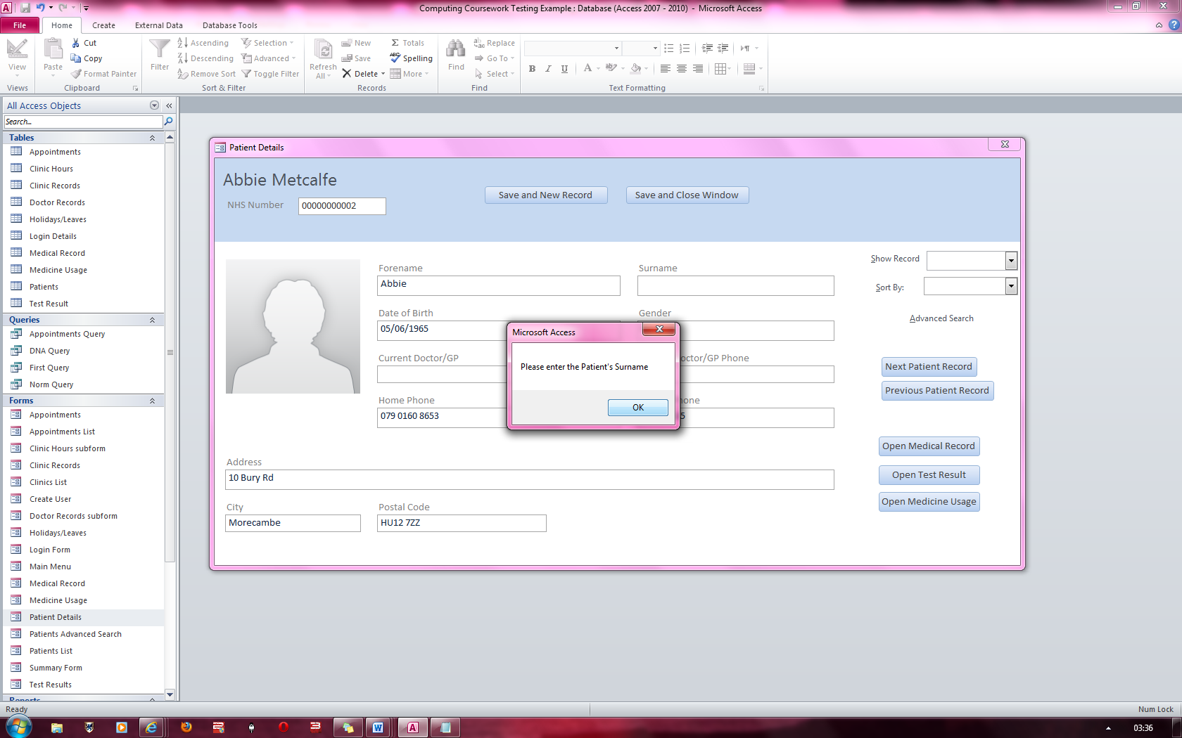

Here in figure 32, the Surname cannot be left blank or an error message appears as shown.

### Figure 33

Message alerting the user that the Surname cannot contain numbers

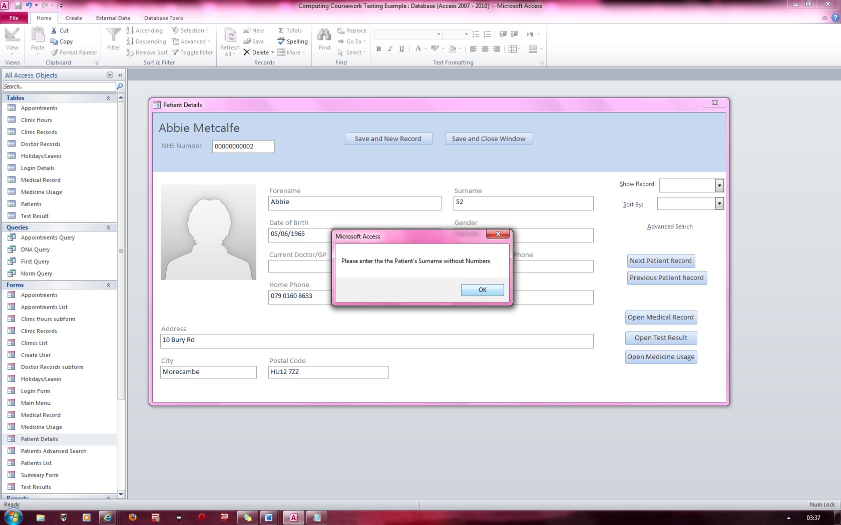

### Figure 34 & 35

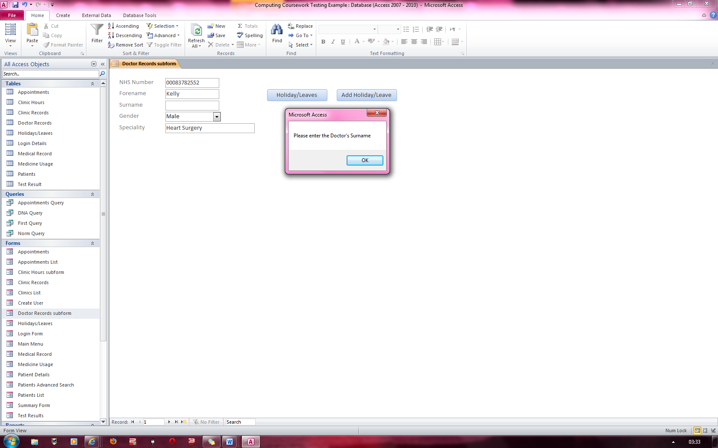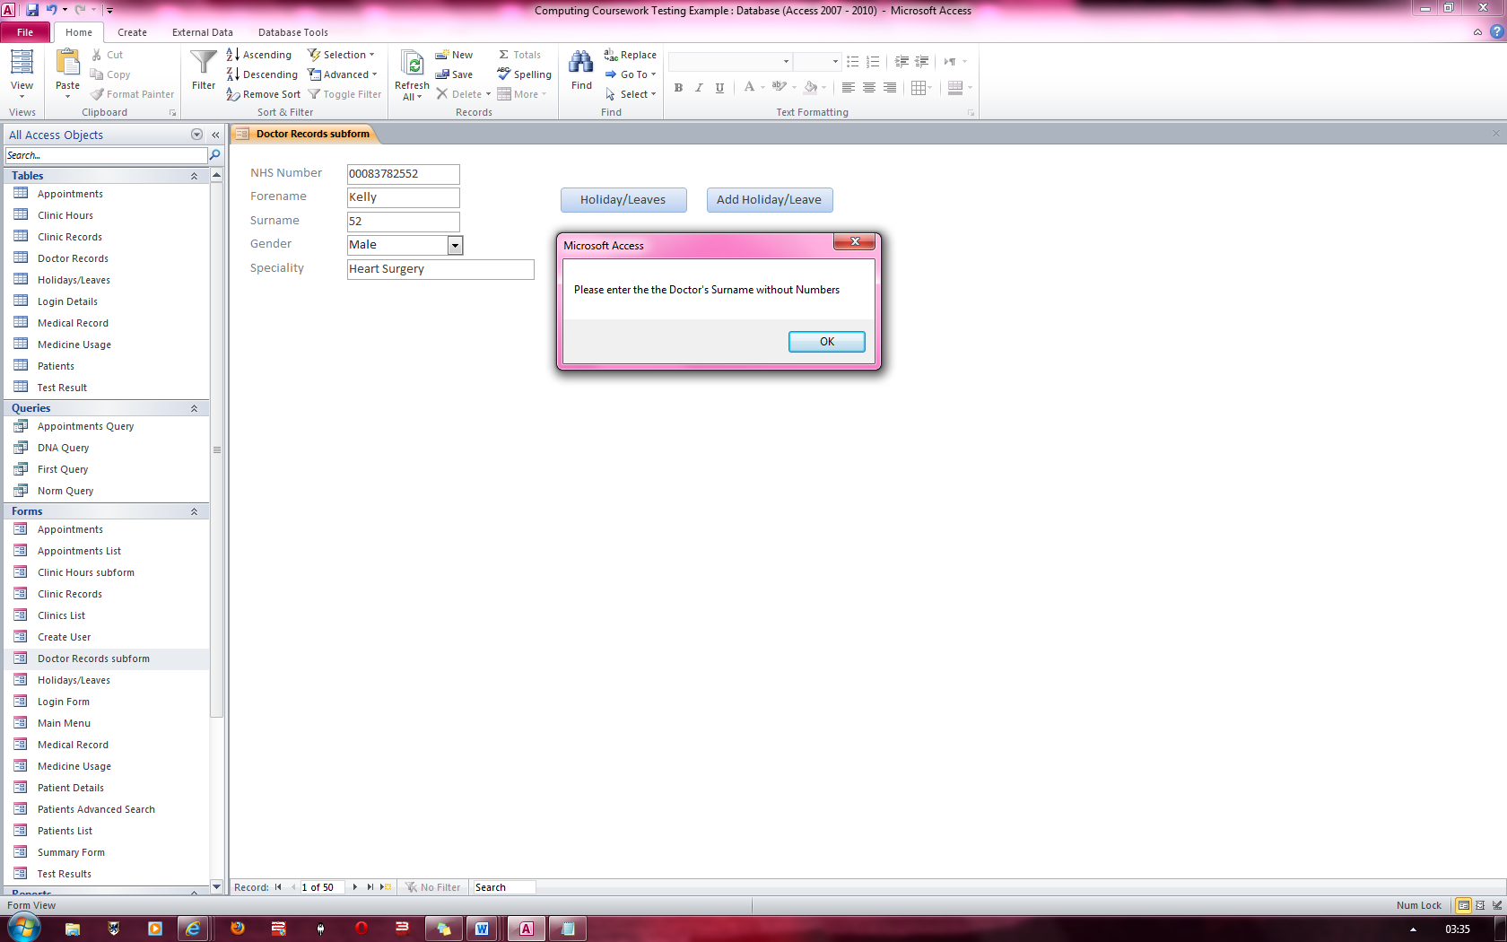

**Fig 35**

**Fig 34**

Message alerting the user that they must enter a Surname

Message alerting the user that the Surname cannot contain numbers

### Figure 36

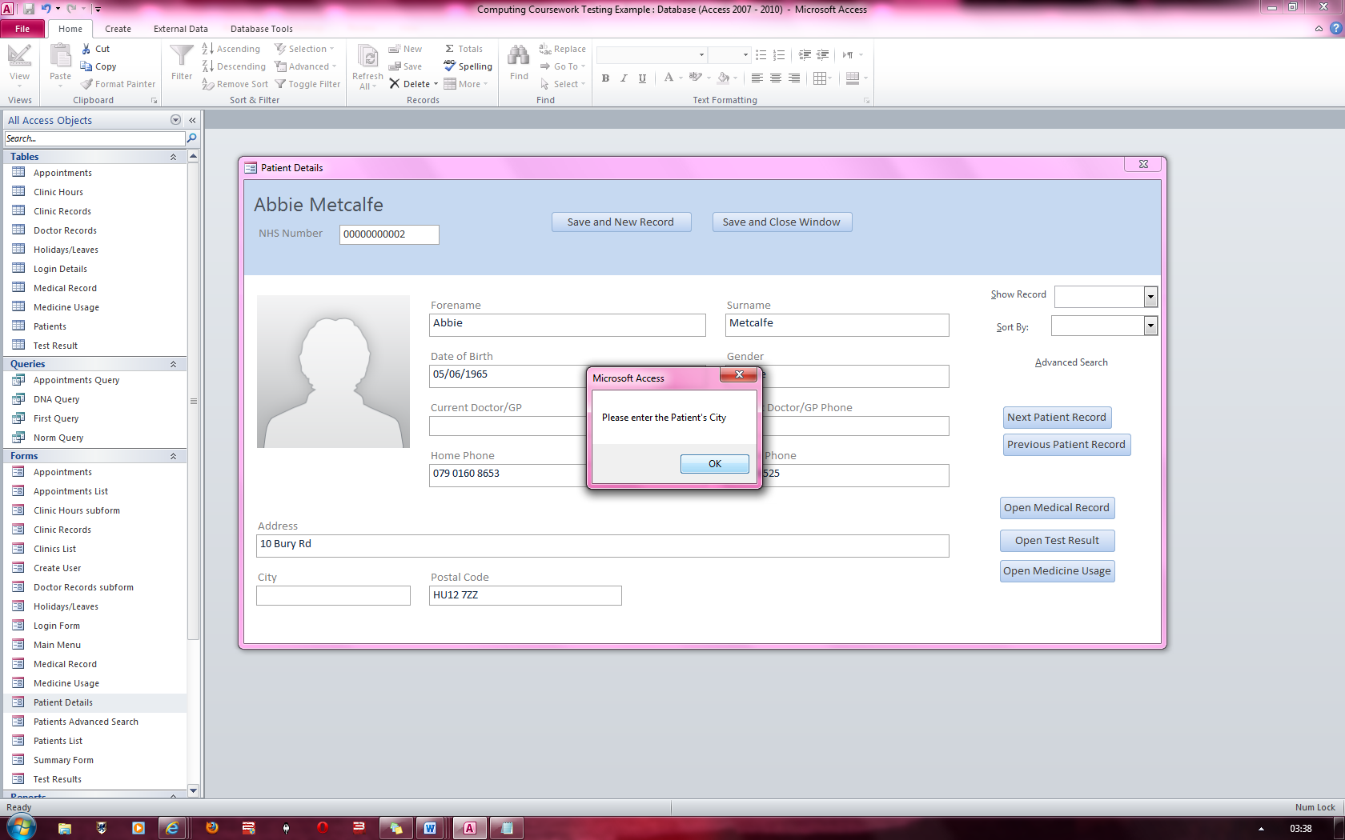

Message alerting the user that a city must be entered

### Figure 37

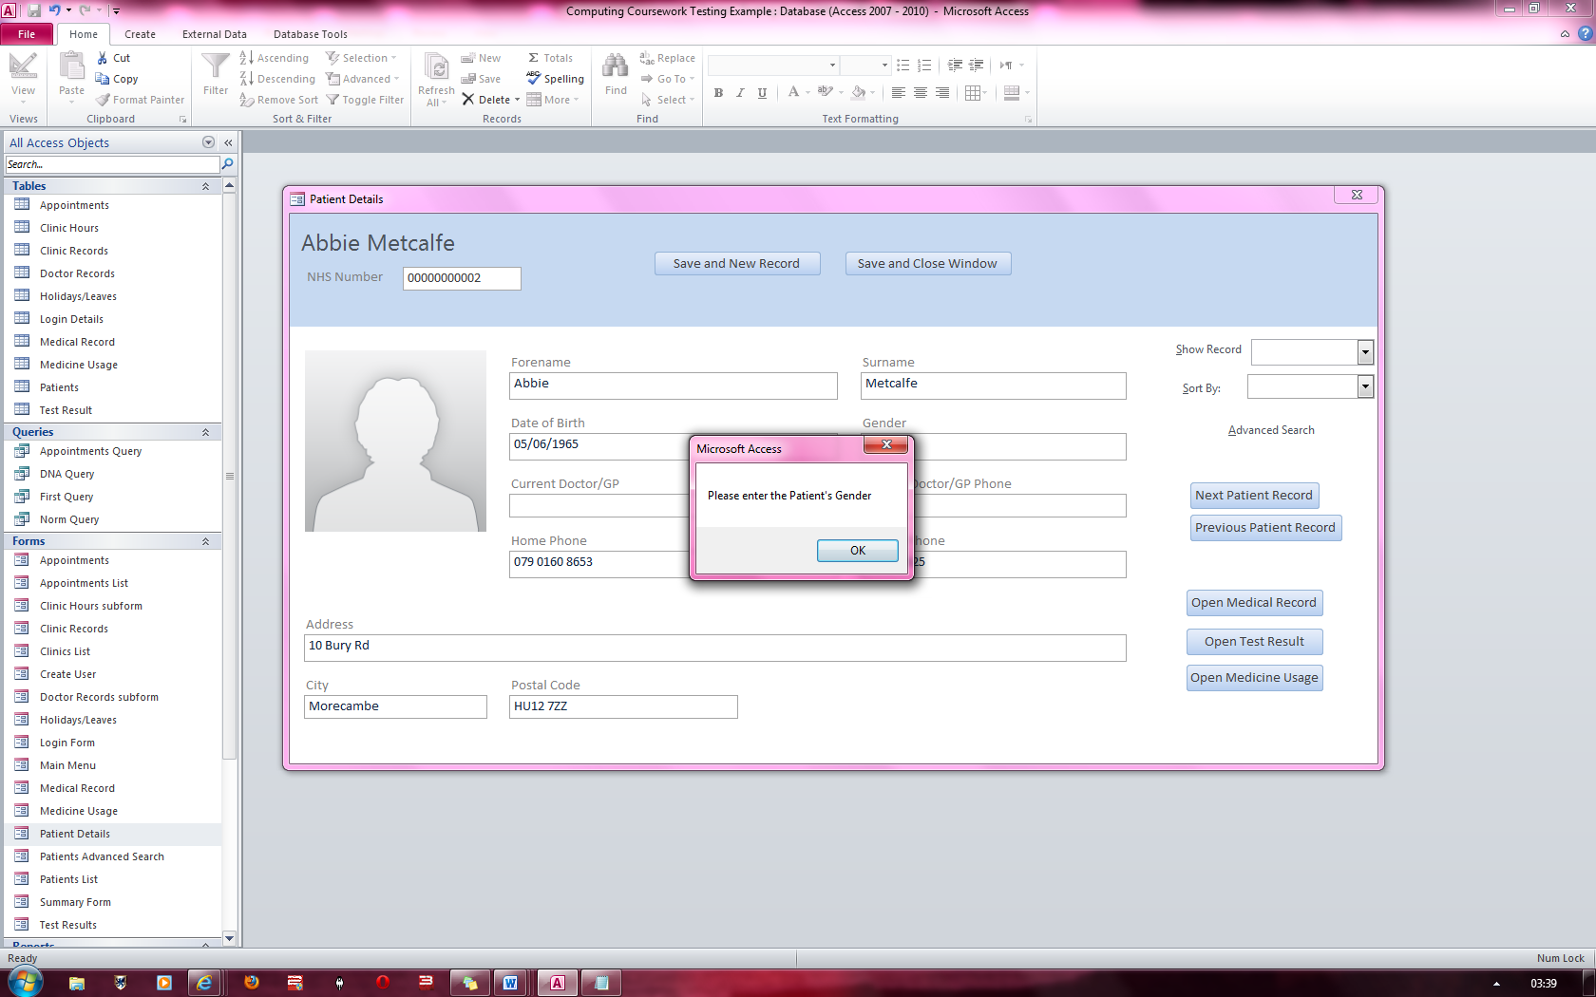

Message alerting the user that a Gender must be entered

### Figure 38

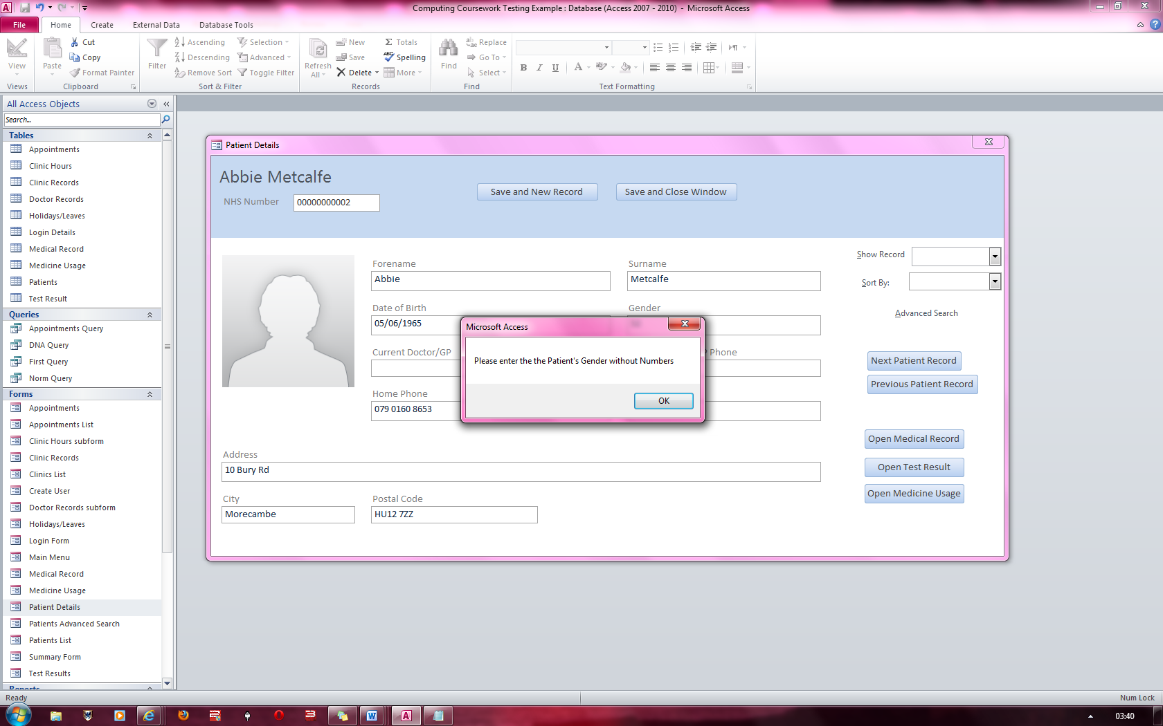

Similarly, when not entering a Gender in the Doctor’s record, a similar message pops up. The Gender is also checked if it contains numbers and if it does, it does not allow you to switch to another field unless you enter some valid date in the current field.

Message alerting the user that Gender cannot contain numbers

### Figure 39

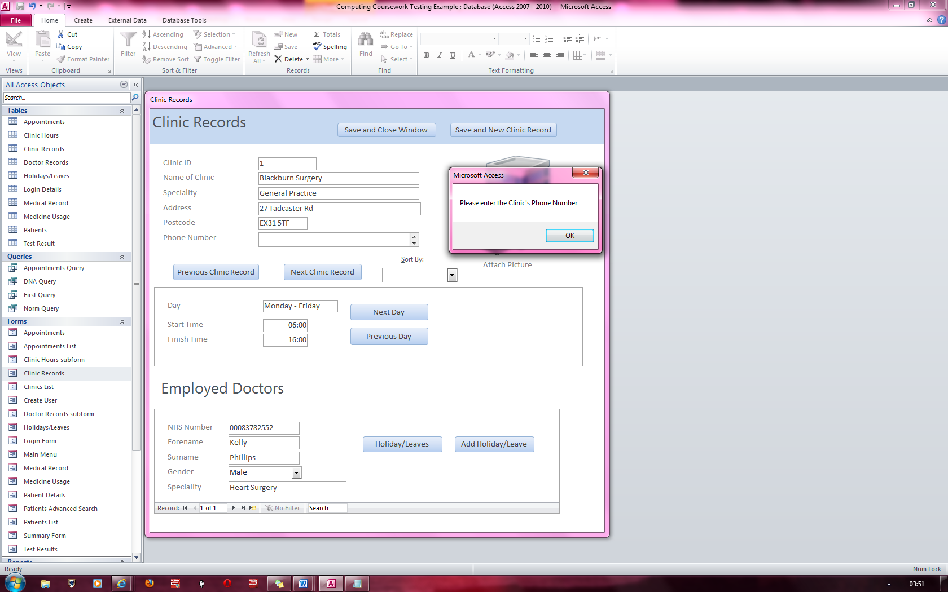

Message alerting the user that phone number must be entered

Similarly, when not entering a Phone Number or Mobile Phone Number in the Patient’s Details Form, a variation of this message pops up.

### Figure 40

Message telling the user that the phone number must contain numbers only

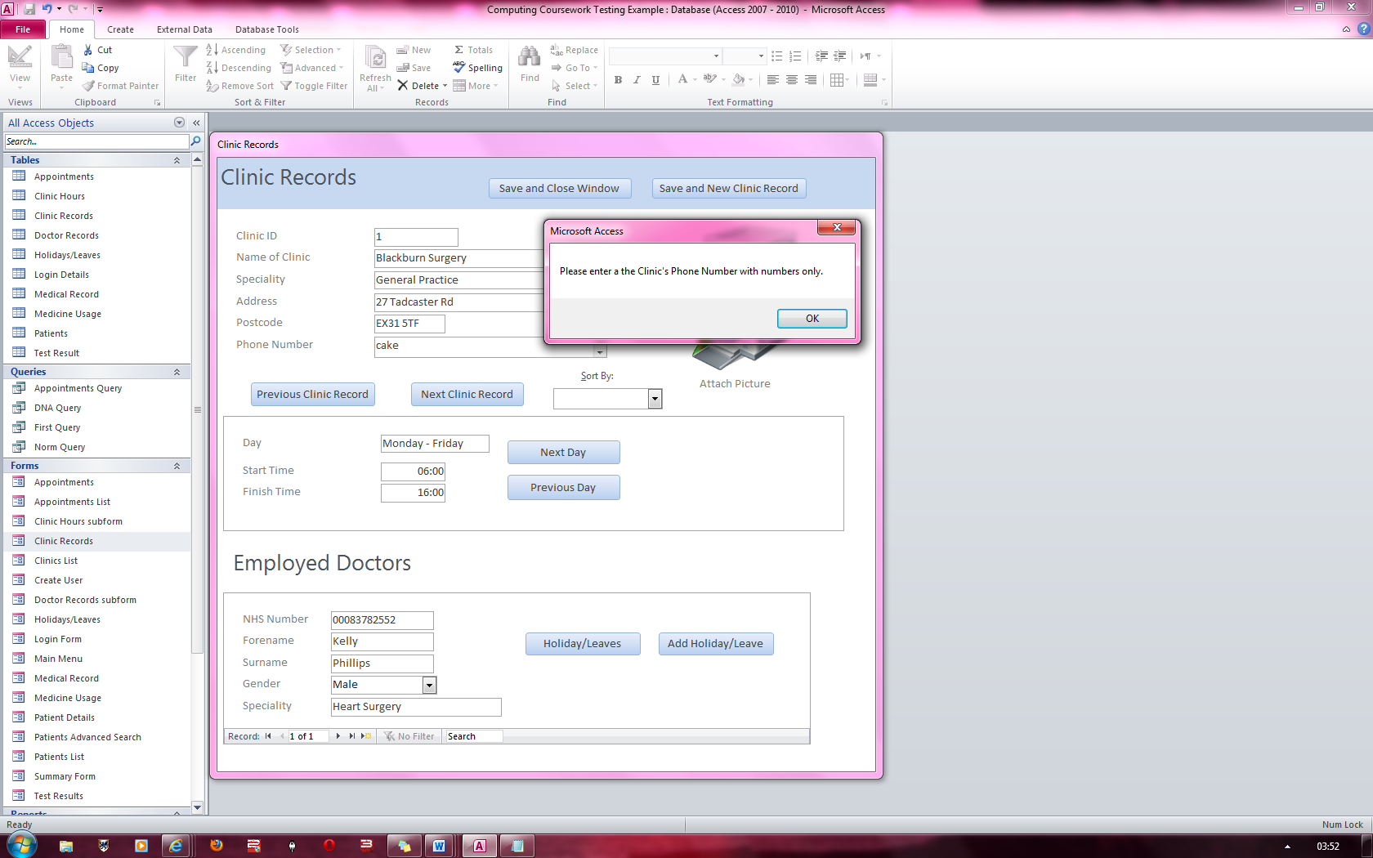

Similarly, when entering something other than numbers into the fields Phone Number or Mobile Phone Number in the Patient’s Details Form, a variation of this message pops up.

### Figure 41

Message alerting the user that the Address field must not be left blank

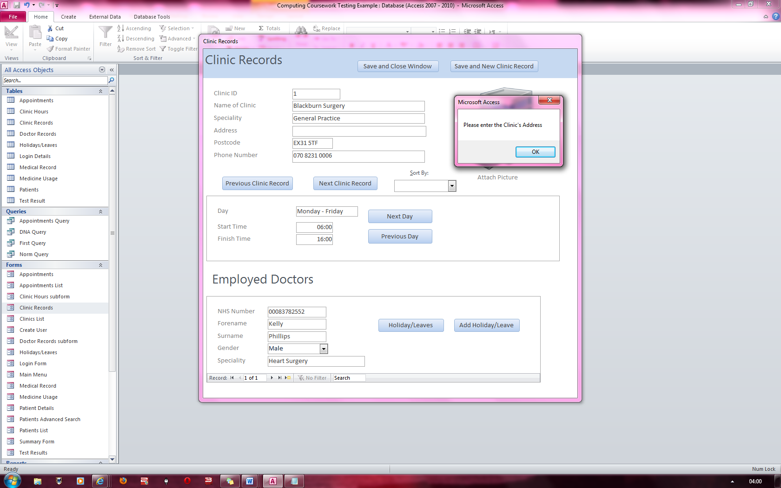

Similarly, when not entering an address in the Patient’s Details” Form, a variation of this message pops up.

### Figure 42

Message alerting the user that the Clinic Name field must not be left blank

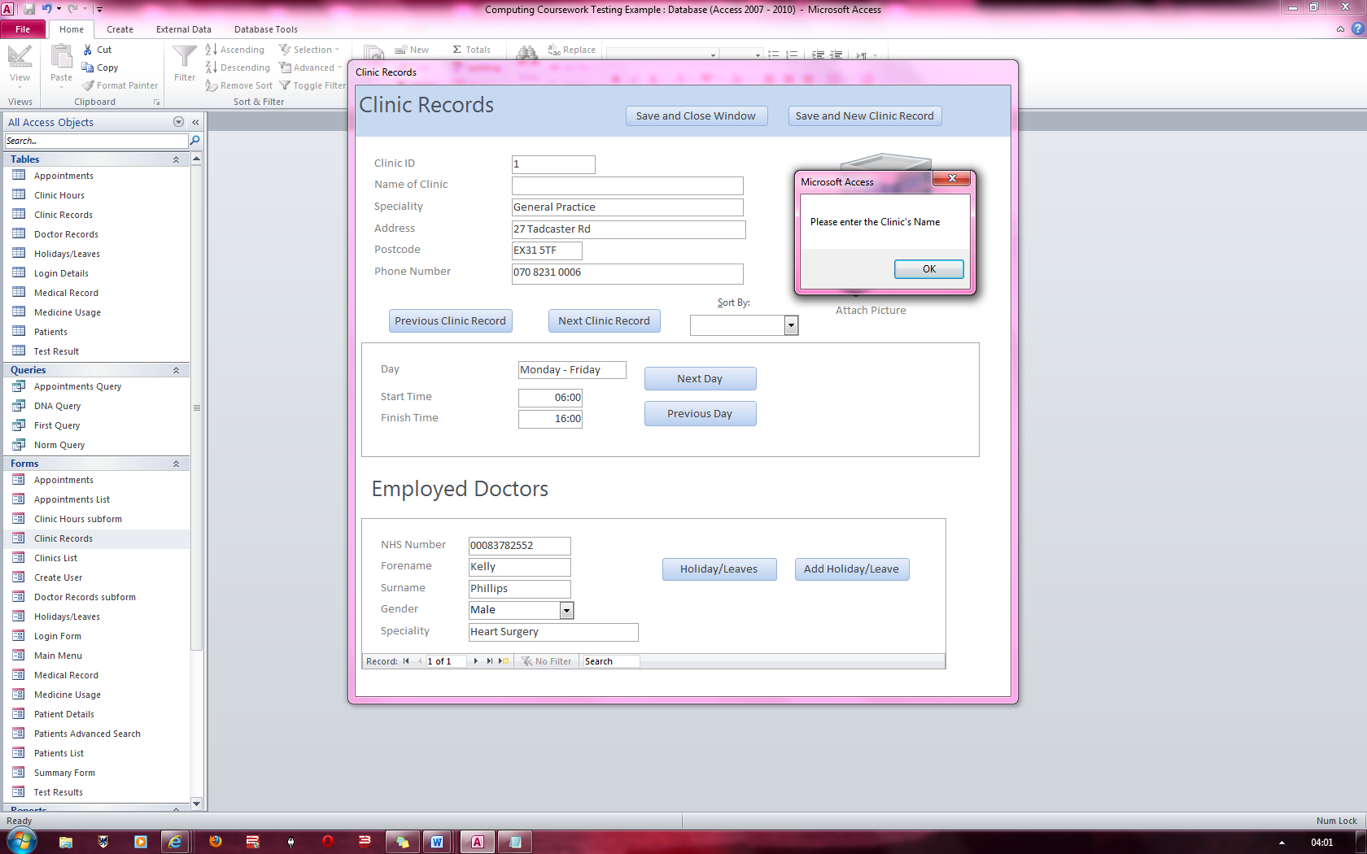

### Figure 43 & 44

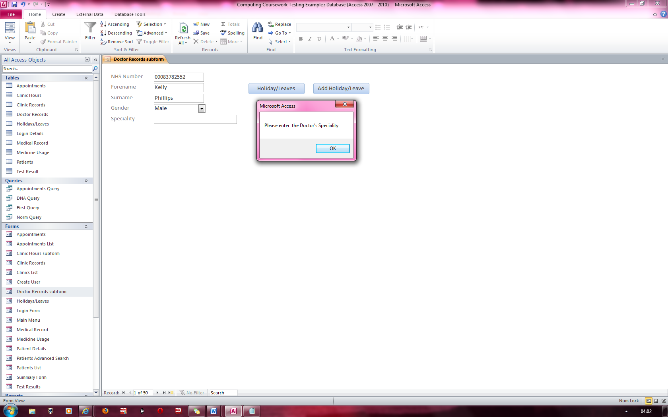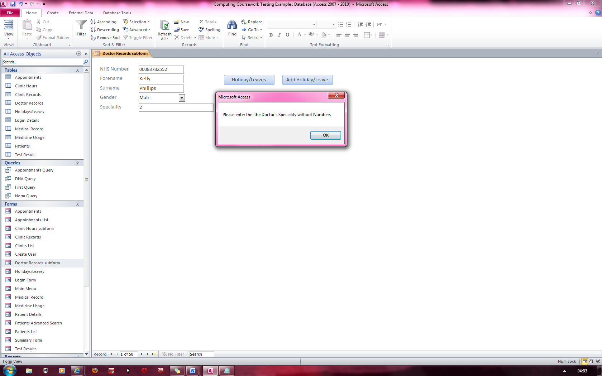

**Fig 53**

**Fig 52**

Similarly, when leaving Speciality blank in the Clinic Records form, a variation of this message pops up.

Similarly, when entering Specialty field in the Clinic Records Form, a variation of this message pops up

Message alerting the user that the Speciality field must not contain numbers

Message alerting the user that the Speciality field must not be left blank

### Figure 45

Similarly, when leaving Postcode blank in the Clinic Records form, a variation of this message pops up.

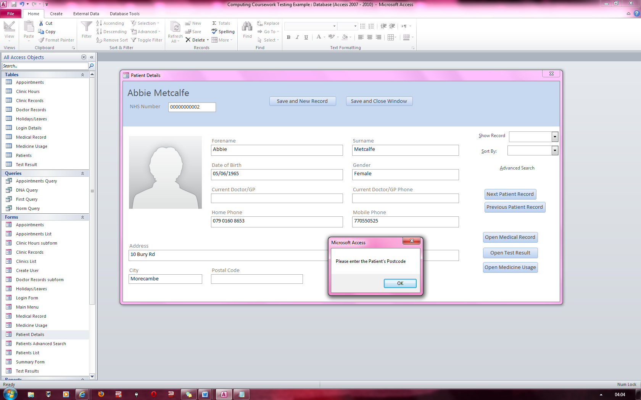

Message alerting the user that the postcode field cannot be left blank

### Figure 46

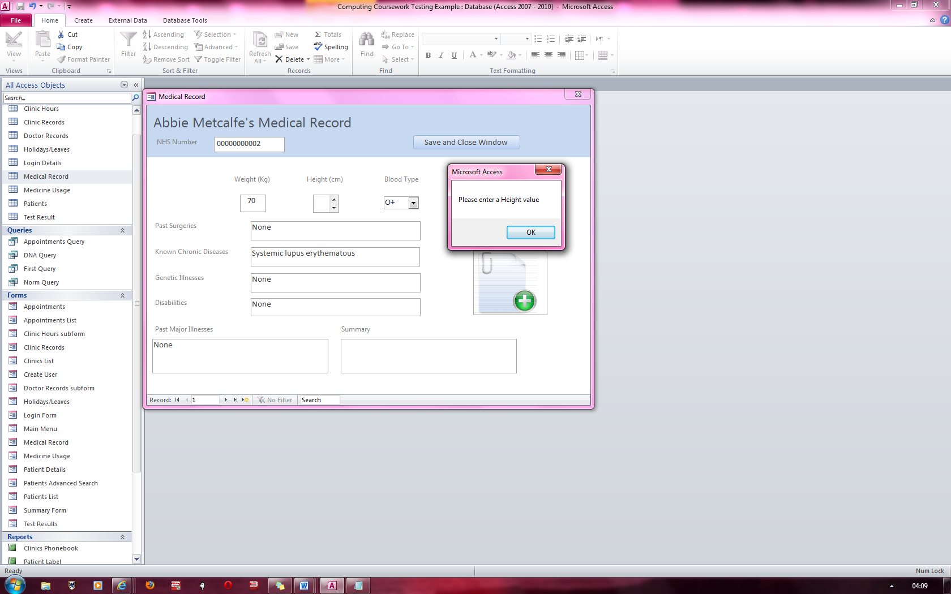

Message alerting the user that the Height cannot be left blank and it cannot contain anything but numbers either

Similar to figure 48

### Figure 47

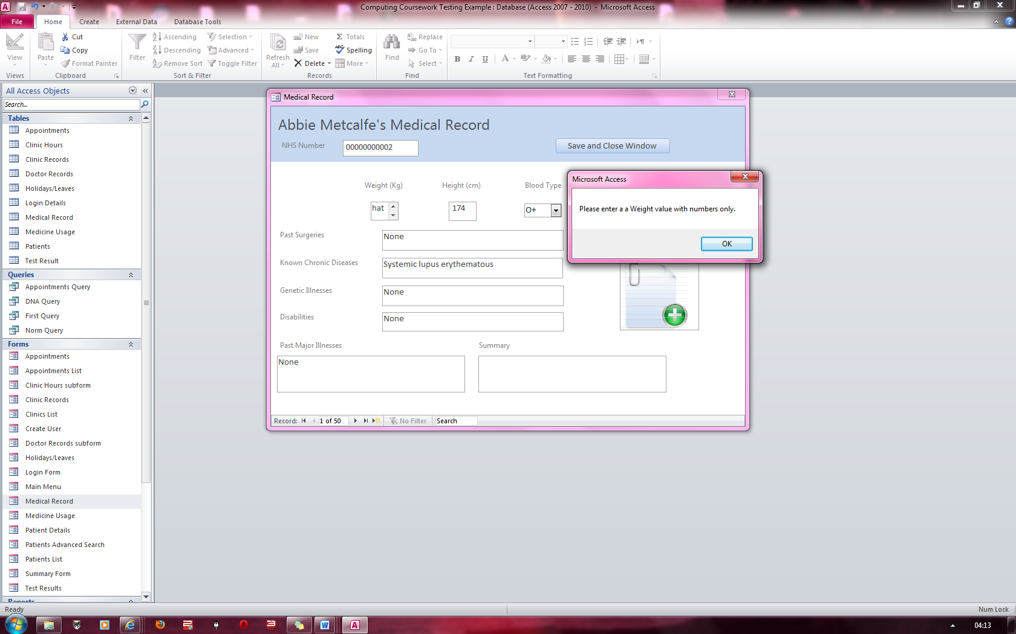

Message alerting the user that the Weight cannot be left blank and it cannot contain anything but numbers either

Similar to Figure 47

### Figure 48

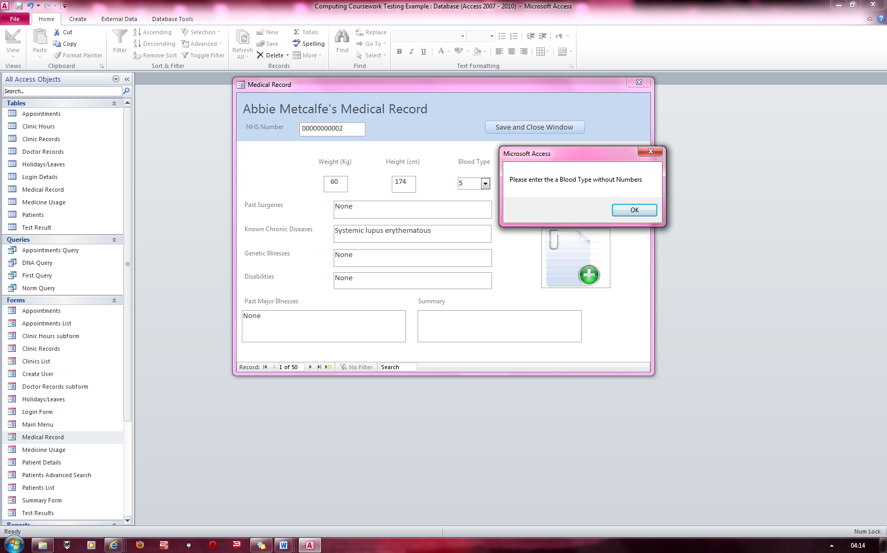

Message alerting the user cannot put in numbers for the bloodtype

### Figure 49

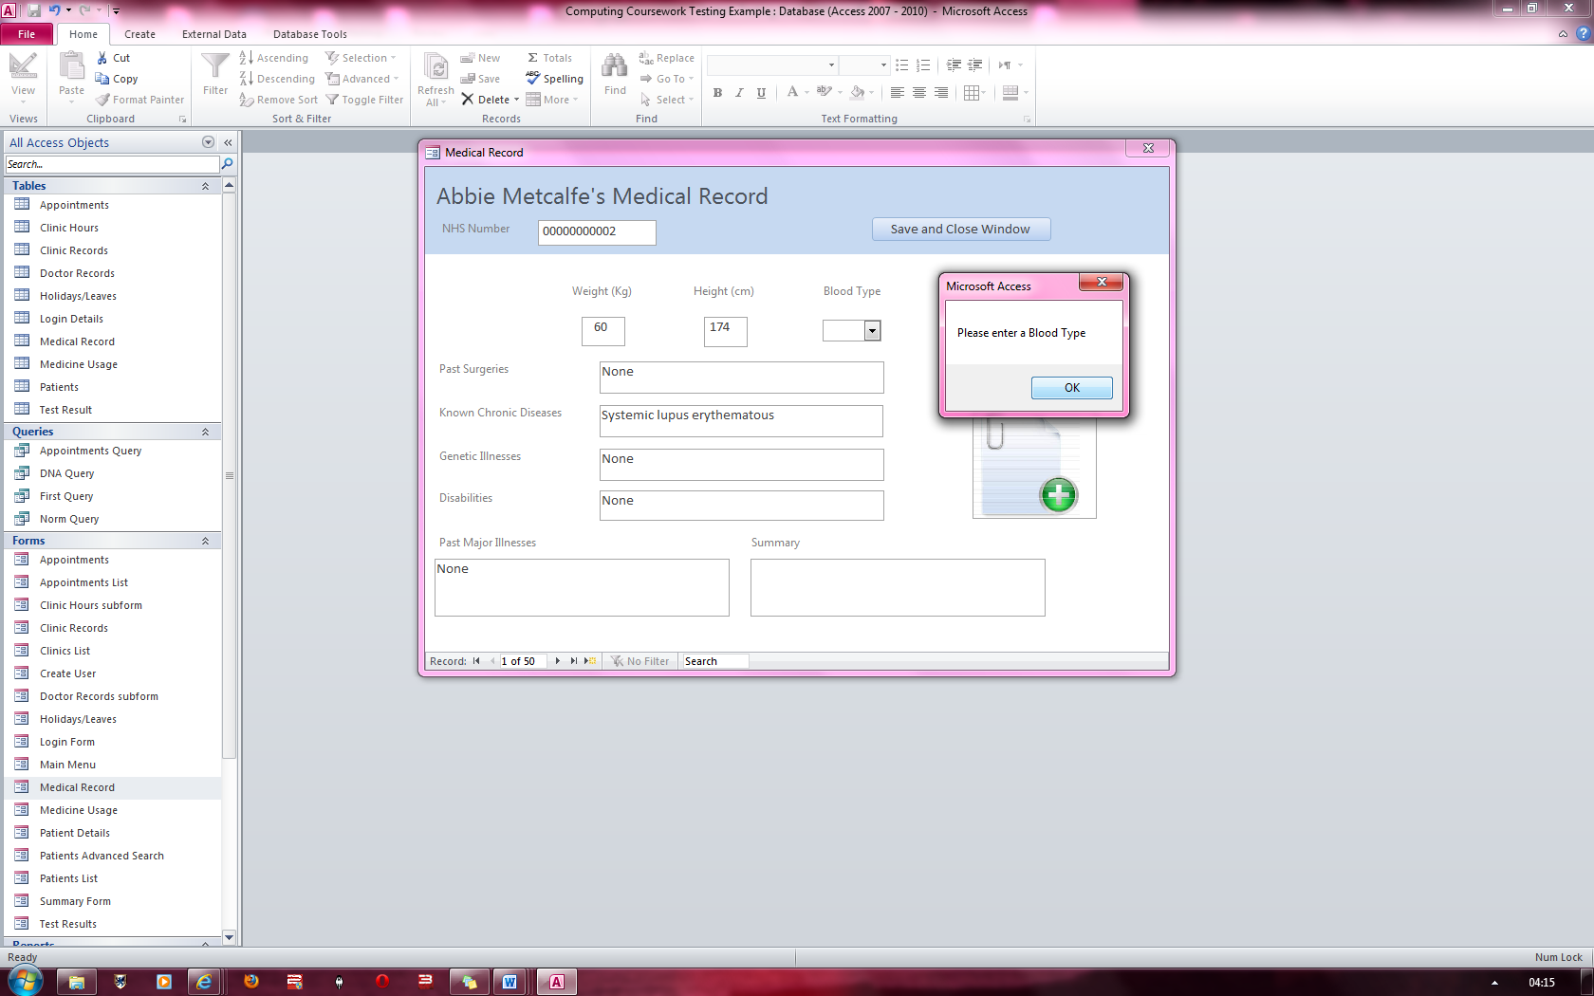

Message alerting the user cannot leave bloodtype blank

### Figure 50

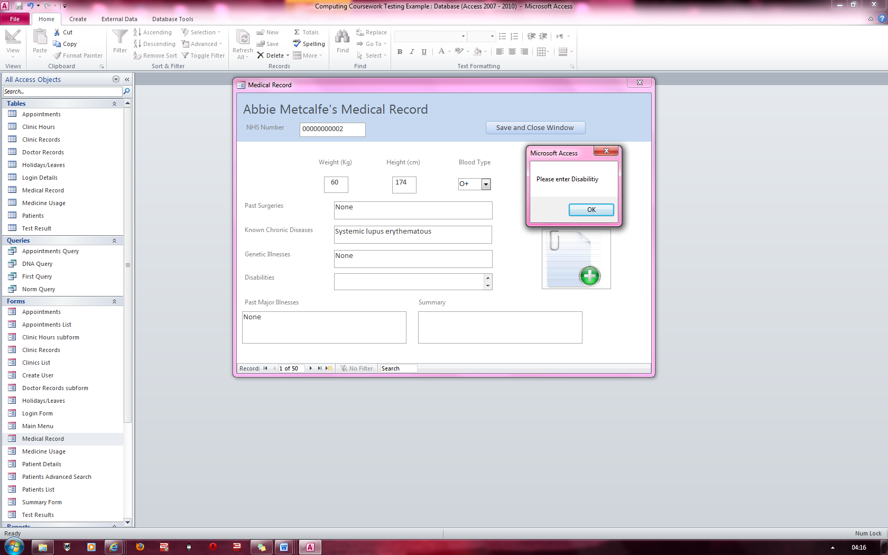

Similarly, a message would alert the user that they cannot leave the “Known Chronic Diseases” field empty

Message alerting the user cannot leave Disability blank

### Figure 51

Similarly, a message would alert the user that they cannot leave the “Past Surgeries” field empty

Message alerting the user cannot leave Past Major illnesses blank

### Figure 52 & 53

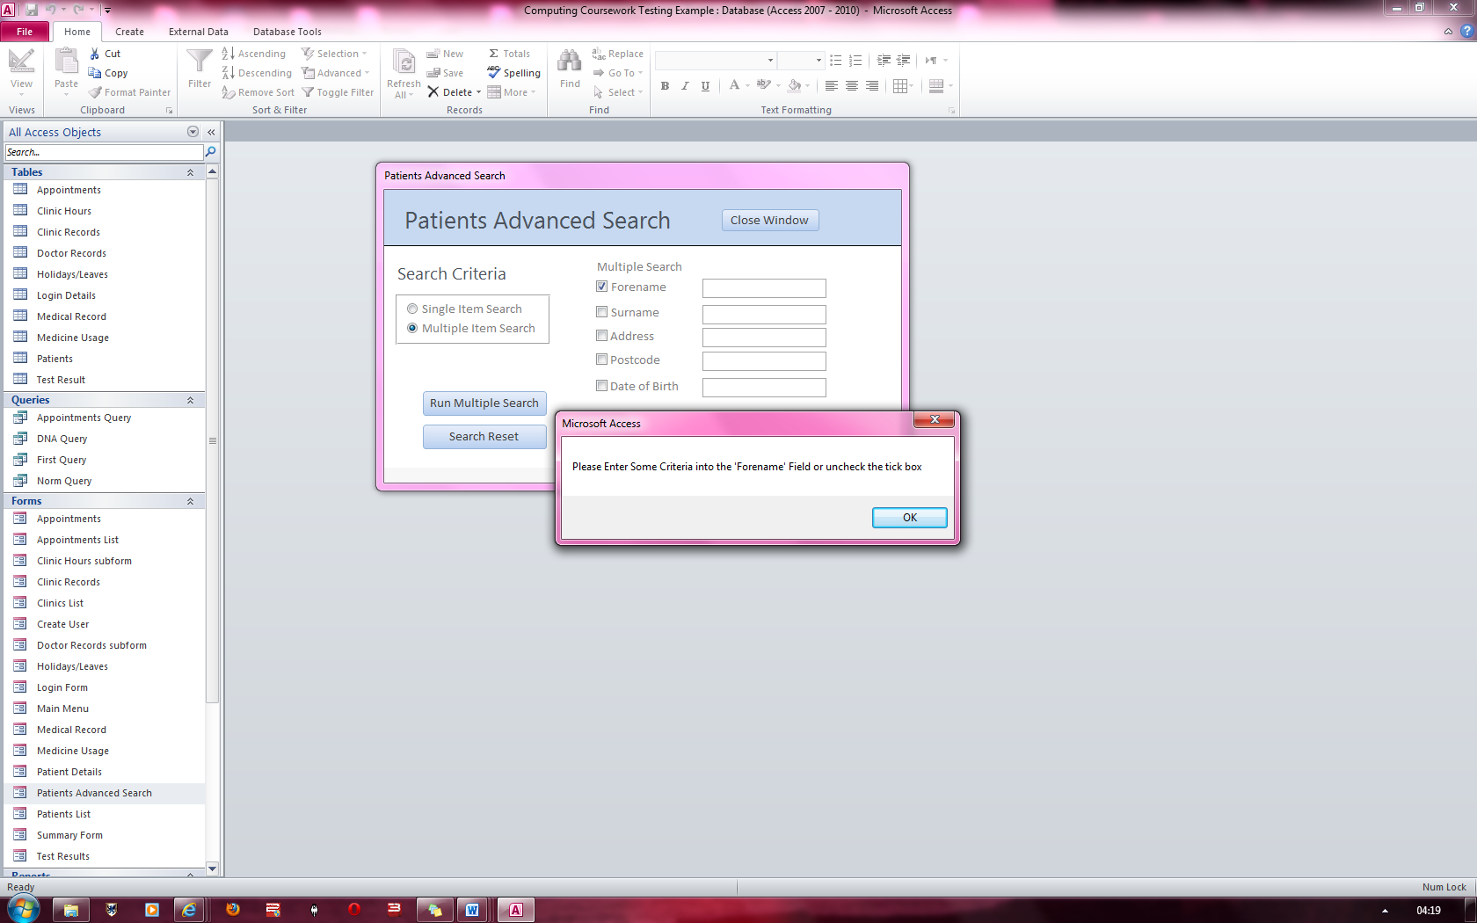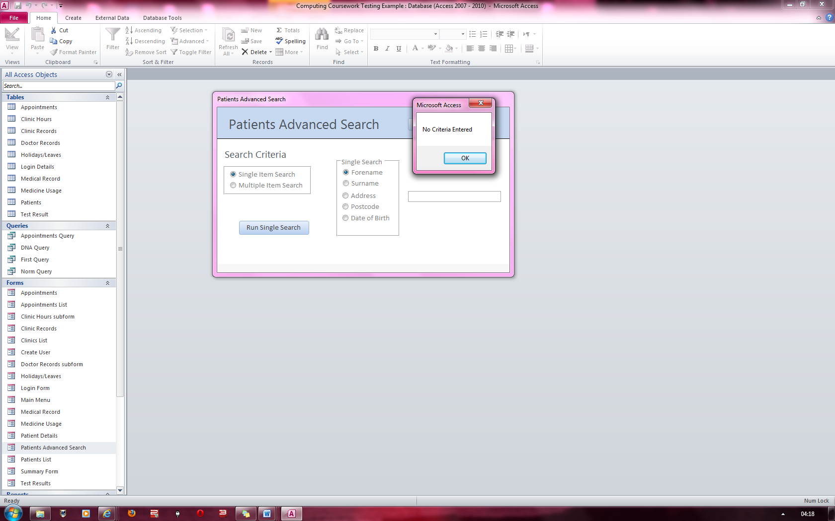

**Fig 53**

**Fig 52**

Error Message stating that the Forename field has been check but no data has been entered and so does not run the search

Error message stating nothing has been entered and does not run the search

### Figure 54 & 55

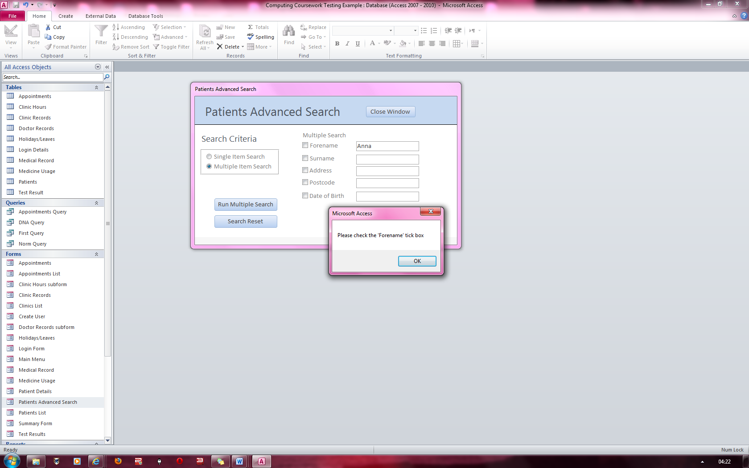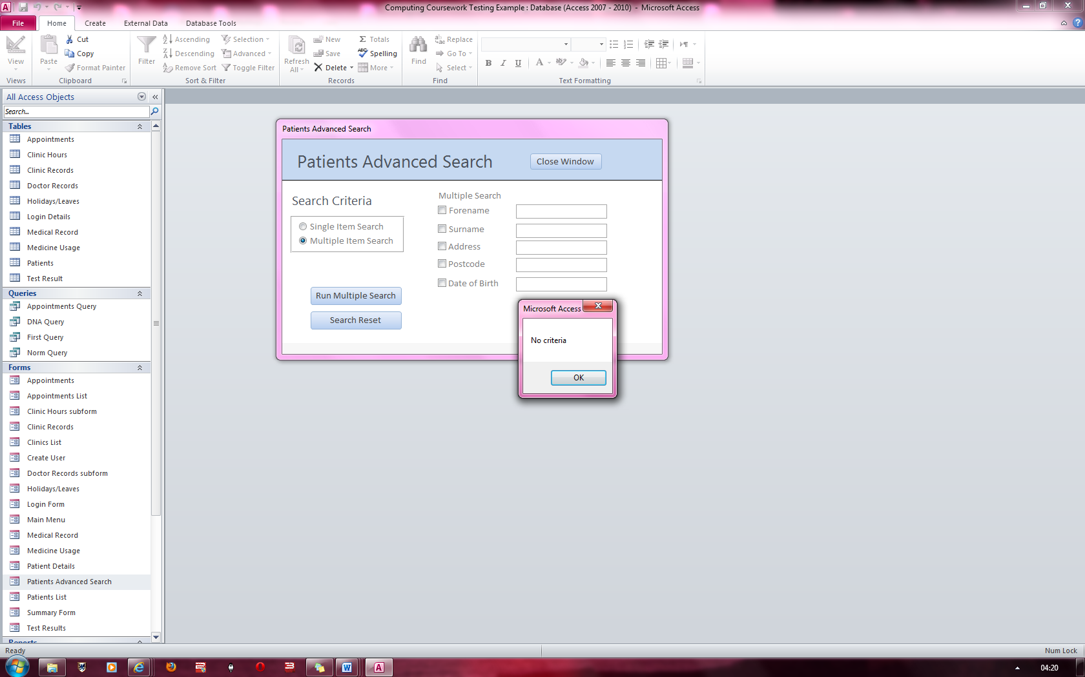

**Fig 55**

**Fig 54**

Error Message stating that the Forename field has data in it but the field has not been checked and so does not run the search

Error message stating nothing has been entered and does not run the search

### Figure 56

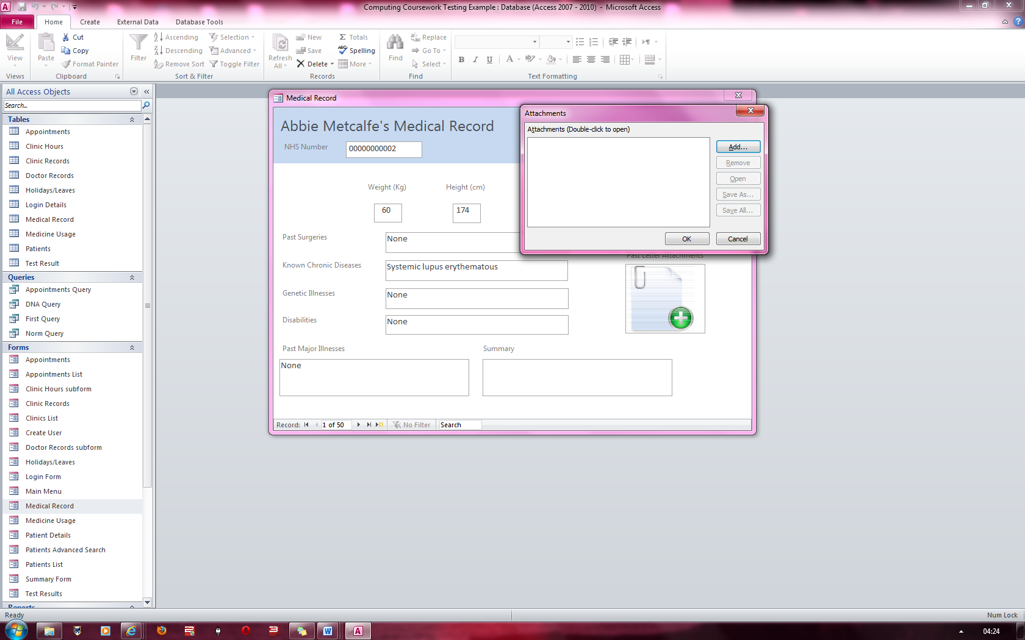

Clicked on add file picture to start up the attachment dialog

### Figure 57

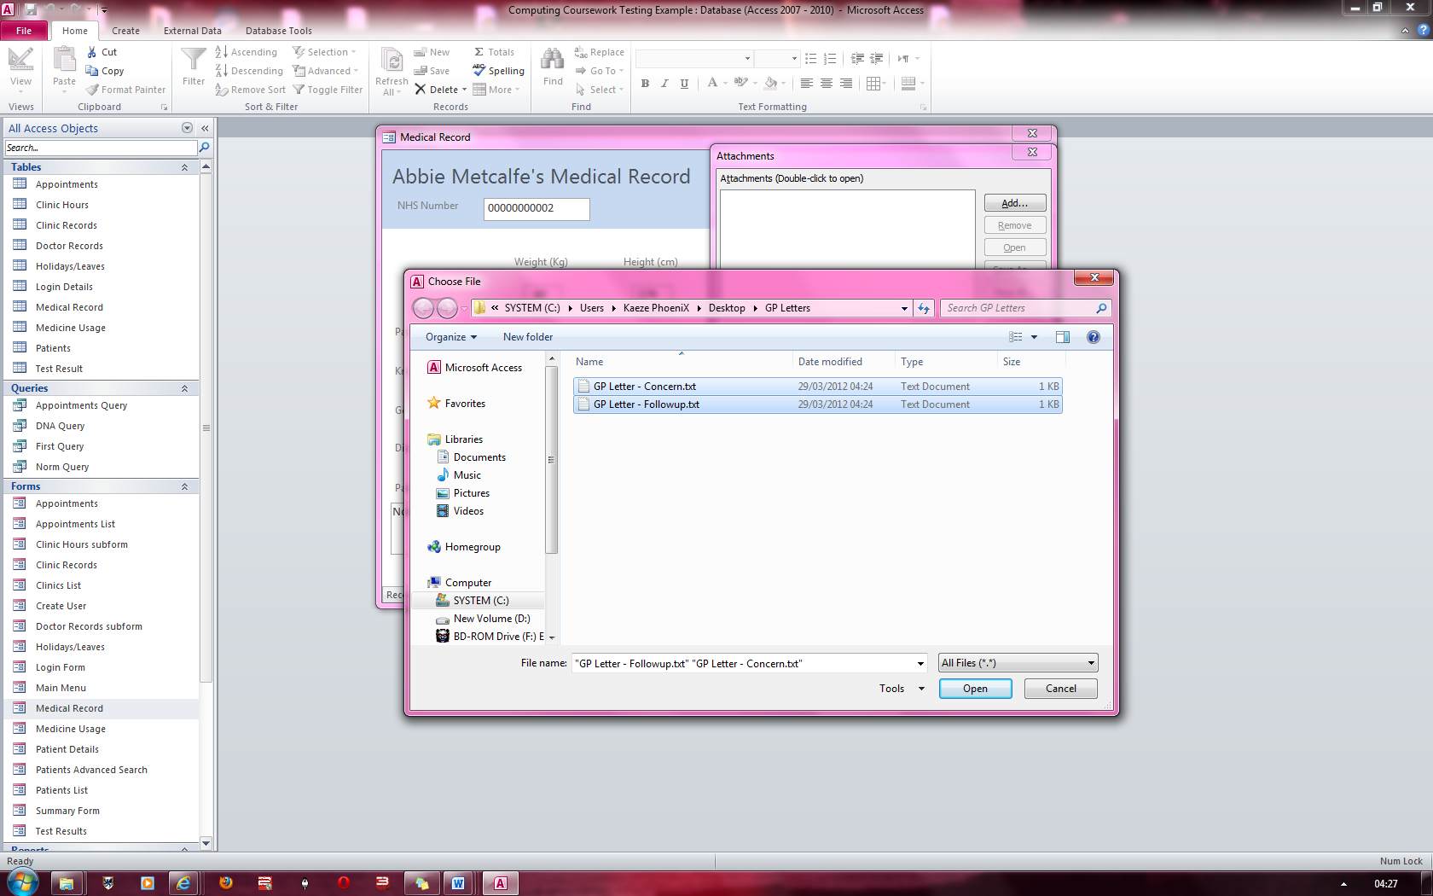

After clicking on Add, a file dialog box appears and I select the two GP letters

### Figure 58

Here the files are clearly attached to the record

### Figure 59

Here I have attached a patient image to the default image icon

### Figure 60

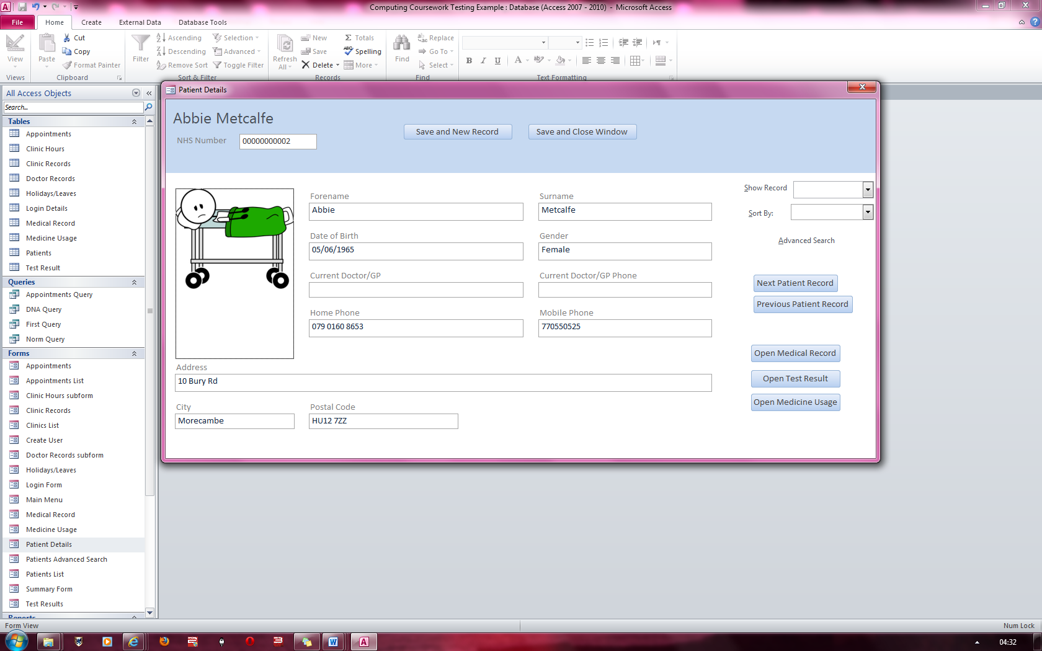

The attached file has been uploaded to the record and is now displayed for the patient’s record

### Figure 61

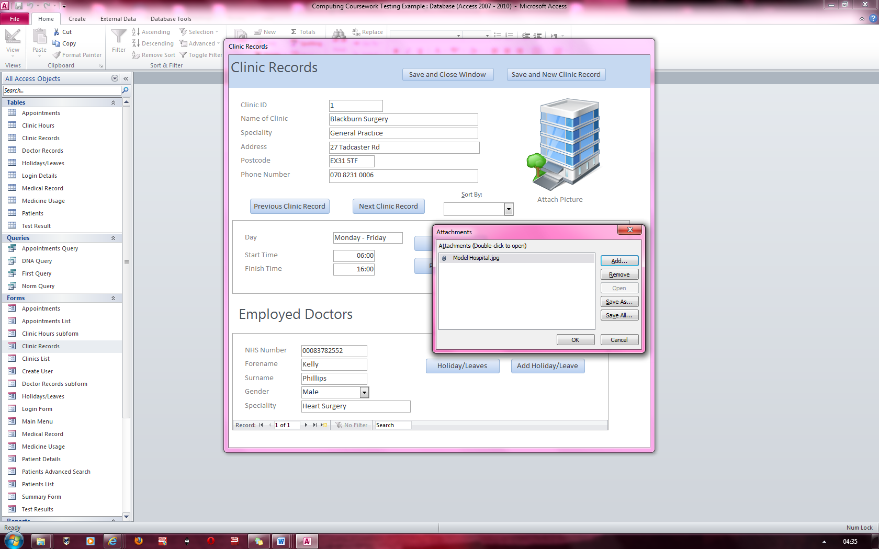

The dialog box opened from where I attached the model hospital image. This will replace the default icon

### Figure 62

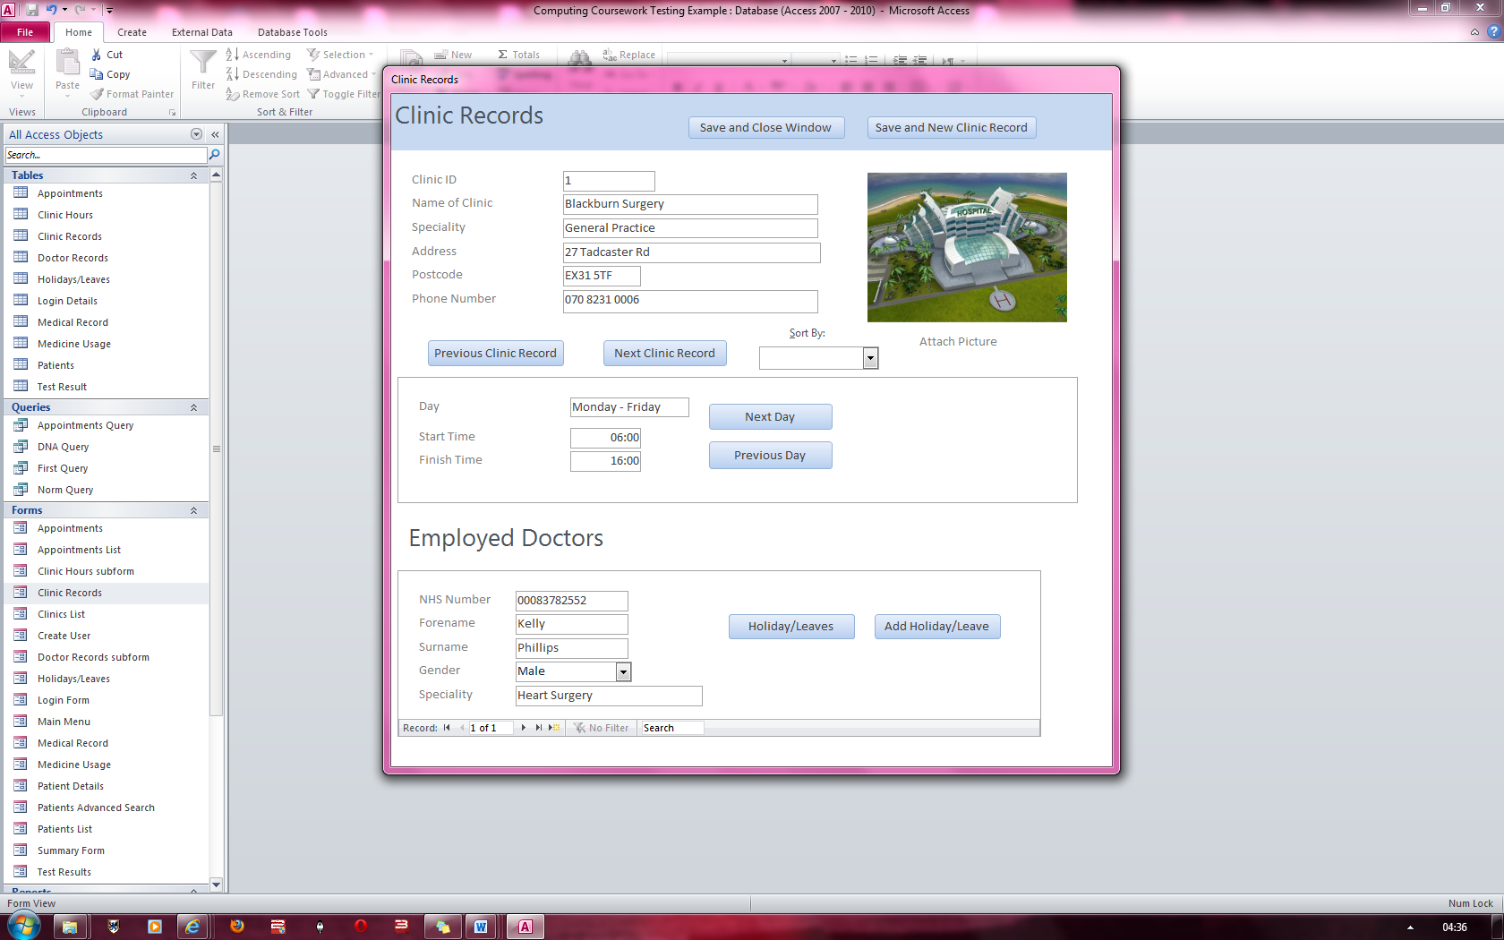

Here the default icon of the image has been replaced and this attachment is now a part of the record

### Figure 63

In this combo box, there are lists of fields I can order the records by in either ascending or descending order. I will be ordering by the forename in descending order. (Note that the records are currently ordered in ascending order of Forename) .If I click on the sort by option again for Forename, the records will again resort into the ascending order.

### Figure 64

Here I have opted to order the record in descending order of Forename. If I had chosen any of the other options, similar result would have occurred for the respective field. I have tested these but chose to only display one image

### Figure 65

In this combo box, there are lists of fields I can order the records by in either ascending or descending order. I will be ordering by the forename in descending order. (Note that the records are currently ordered in ascending order of Clinic ID)

If I click on the sort by option again for clinic ID, the records will again resort into the ascending order.

### Figure 66

Here I have opted to order the record in descending order of Clinic ID. If I had chosen any of the other options, similar result would have occurred for the respective field. I have tested these but chose to only display one image

### Figure 67

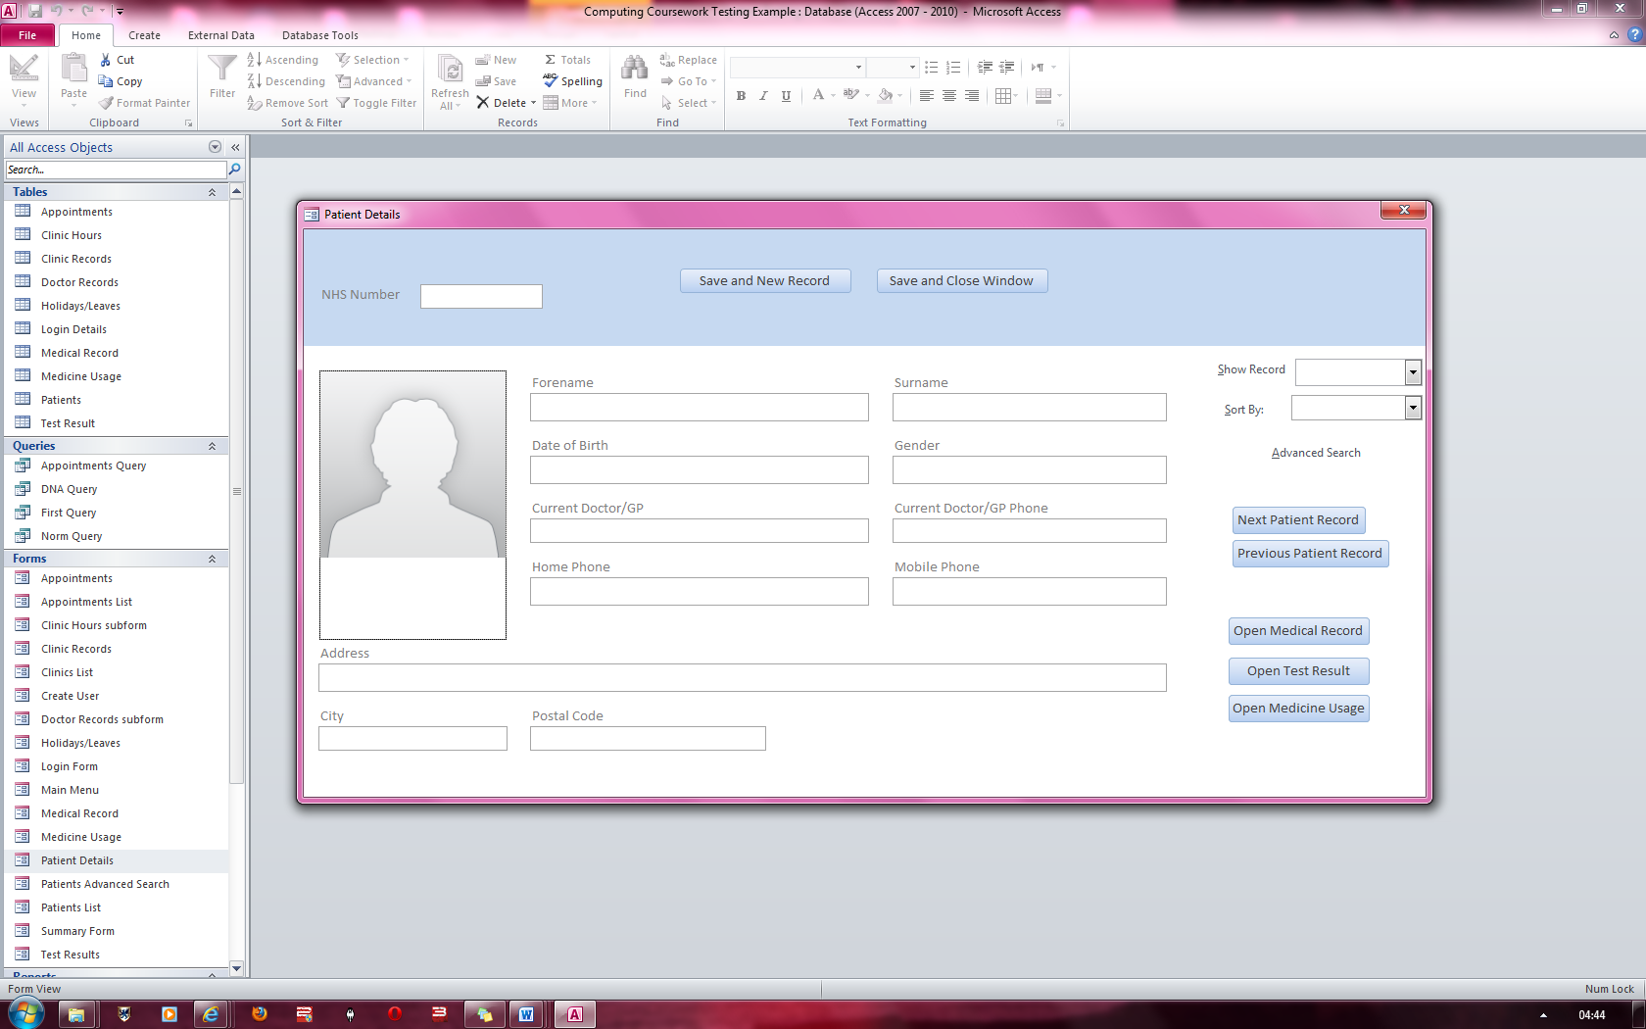

Here is a new empty record ready for data to be entered. All the forms will look very similar to this when adding a new record via pressing the “Save and New Record” button.

### Figure 68

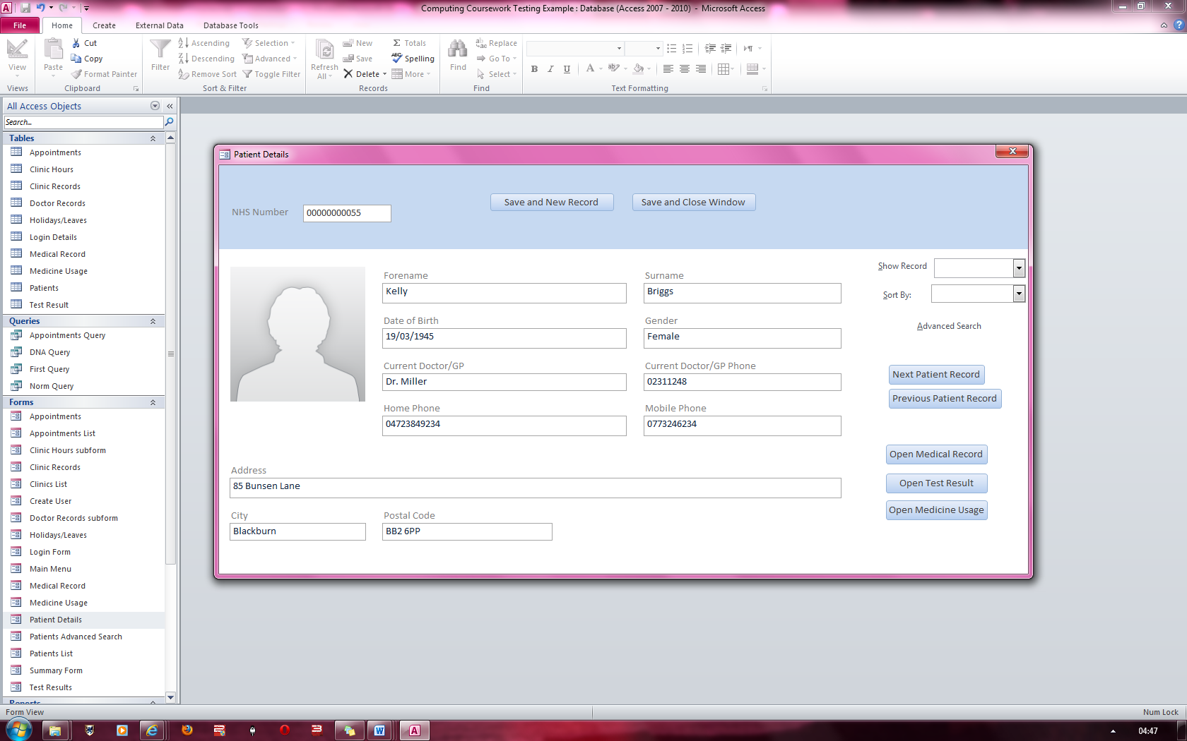

Here I have entered details into the empty record and it will be saved into the patient’s table.

### Figure 69

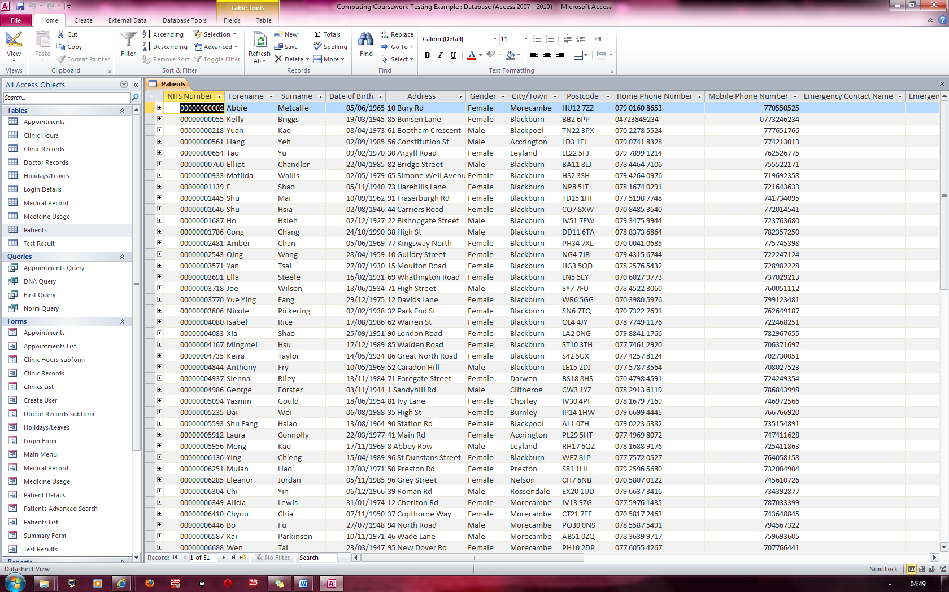

Here I you can see that the record has been correctly. I have tested this function for all my forms and all of them save correctly. Here I have opted to show you just one image

### Figure 70



Here I will edit this record by changing its surname to “Holmes”

### Figure 71

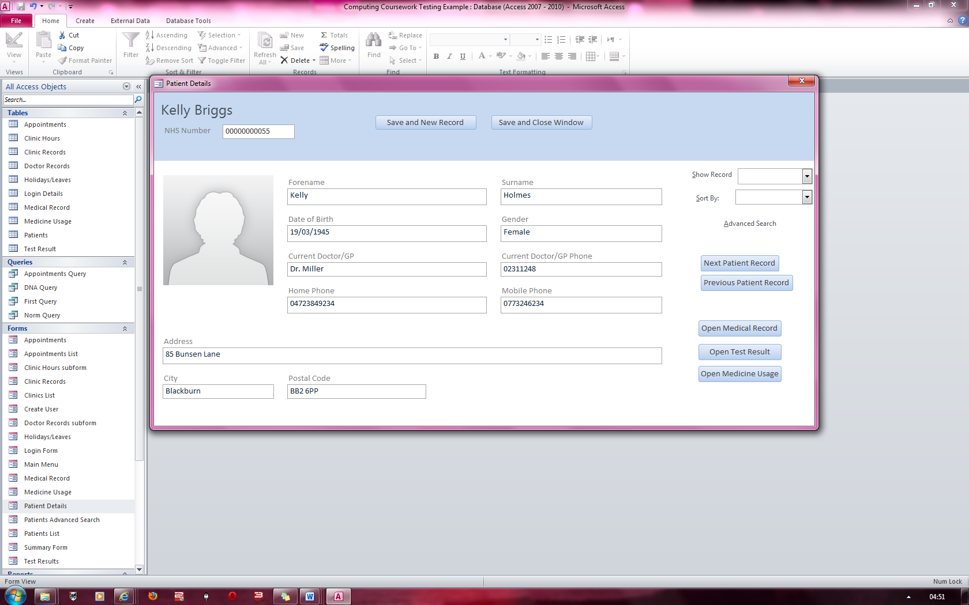

Here I have change the record to “Holmes”

### Figure 72 & 73

Here the record has been amended and saved into the table as shown below.

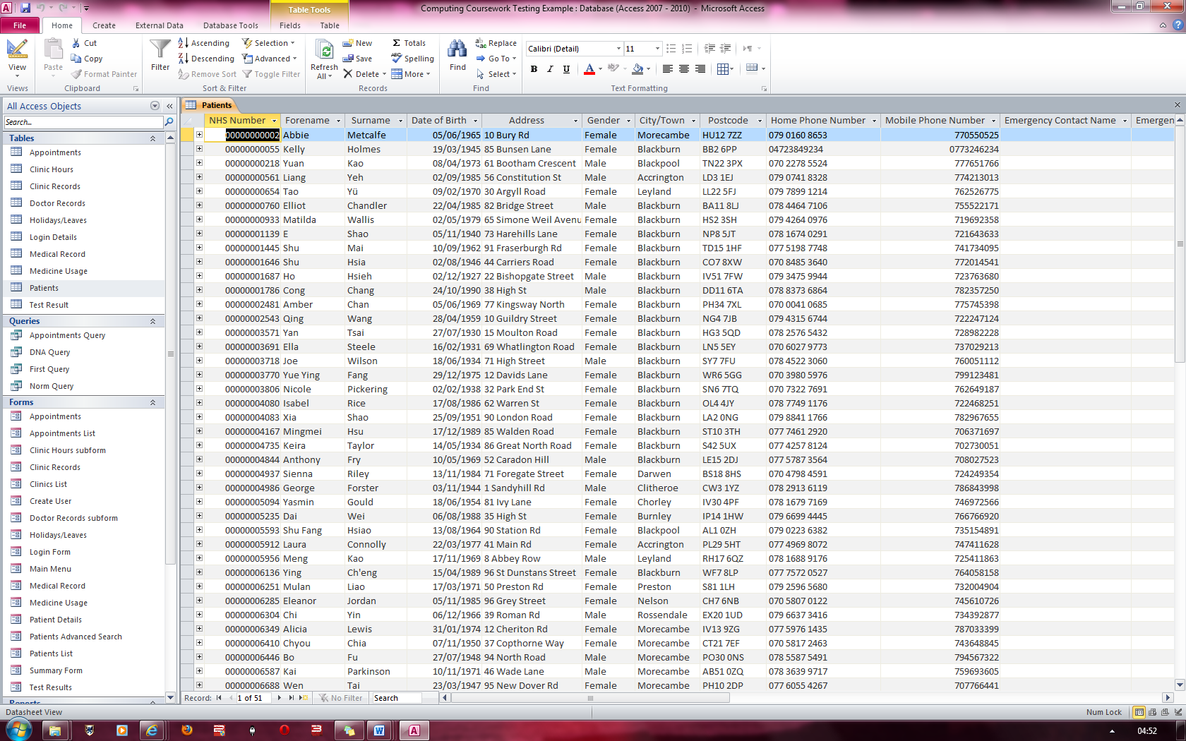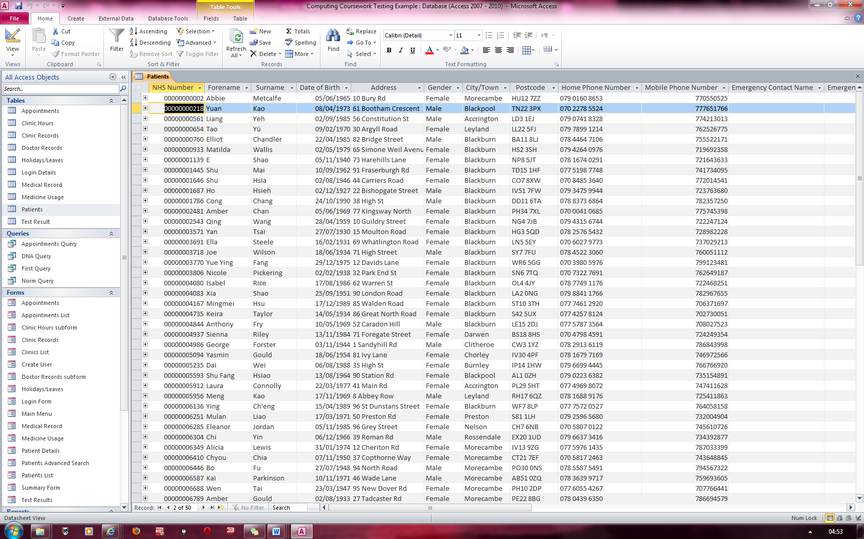

**Fig 74**

**Fig 73**

Here the record has been successfully deleted from the system.

### Figure 74

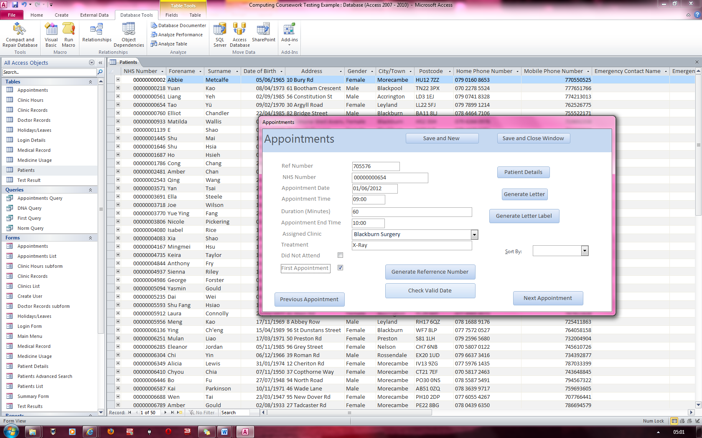

The record display on the left has a valid appointment date meaning that the combination of the appointment date, time and assigned clinic is unique.

The record on the left has an appointment time of 09:00. The duration is 60 minutes and therefore, the appointment End Time should be 10:00.

Therefore, the system has calculated the End Time correctly.

### Figure 75

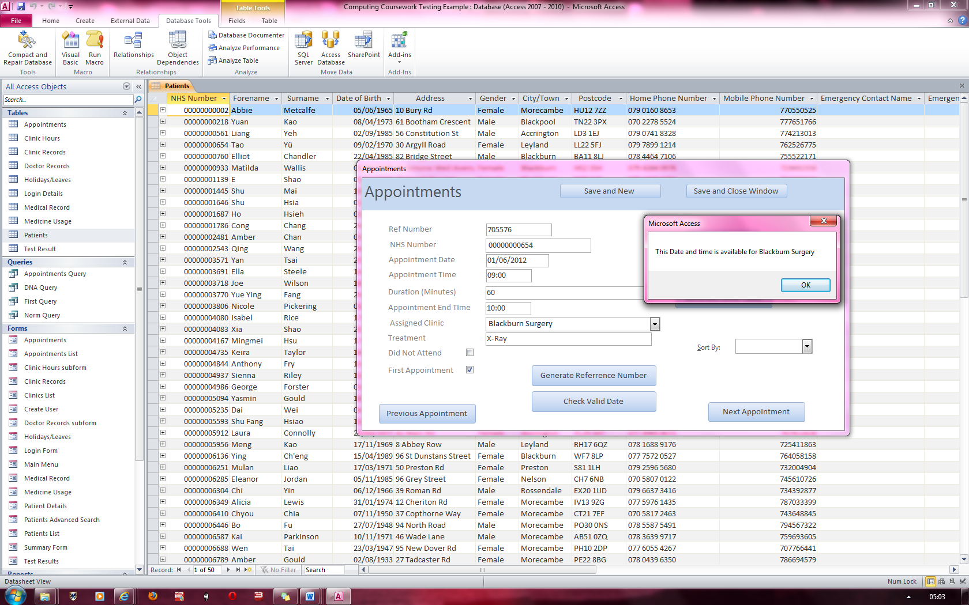

Once Check Valid Date is clicked, it brings up a message stating that the date and time is available to book for at Blackburn Surgery

### Figure 76

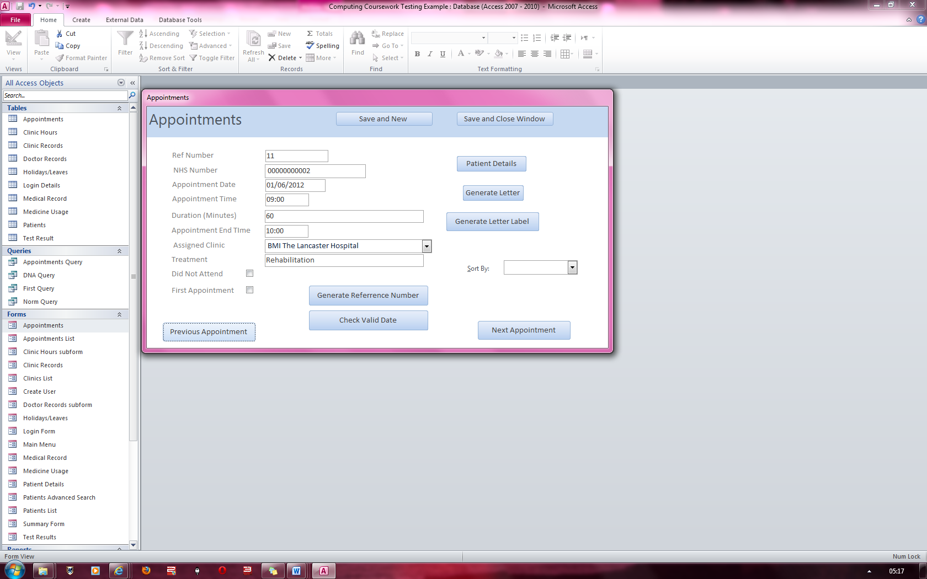

To test if there is an error message when two dates and times collide at a specific surgery, I have set up two appointments which would conflict with each other.

On this screen, the person with NHS number of “2” has an appointment at BMI Lancaster Hospital at 09:00 and it ends at 10:00

Ref number is 11

### Figure 77

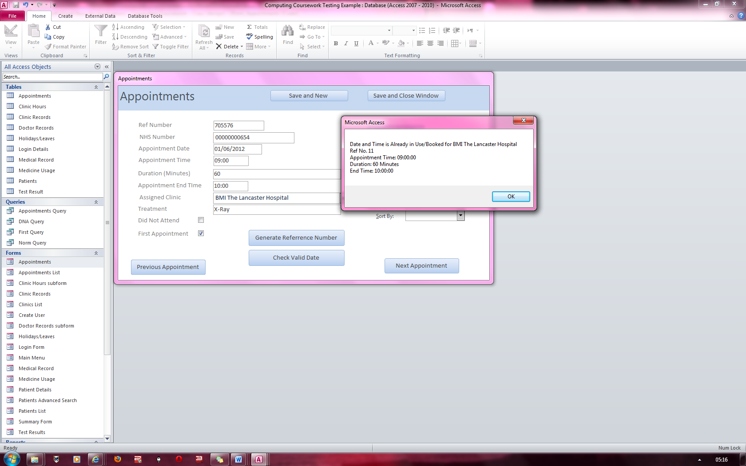

This error message indicates that it has checked if the clinics, dates and times are equal and therefore the dates will conflict

On this screen, the person with NHS number of “654” has an appointment at BMI Lancaster Hospital at 09:00 and it ends at 10:00

The ref number is 705576

### Figure 78

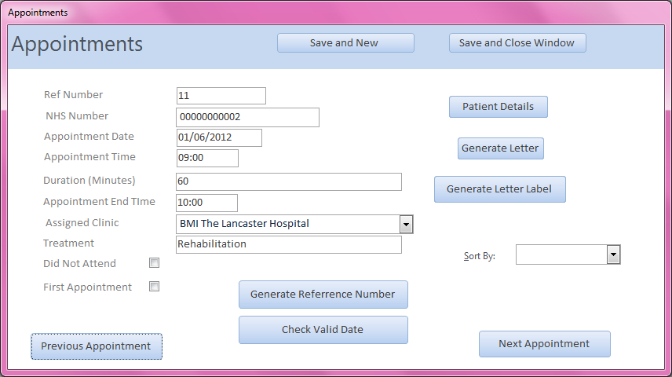

On this screen, the person with NHS number of “2” has an appointment at BMI Lancaster Hospital at 09:00 and it ends at 10:00

Ref number is 11

### Figure 79

### Figure 80

On this screen, the person with NHS number of “6410” has an appointment at Blackburn Surgery at 09:00 and it ends at 10:00

Ref number is 723

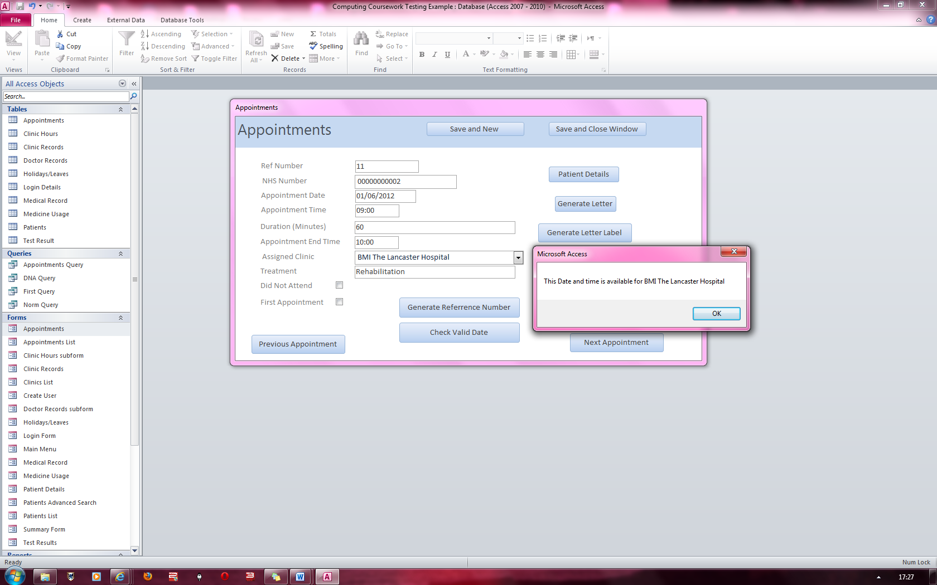

A message has appeared stating that the patient who has NHS Number 2 has an appointment slot available at BMI Lancaster hospital

This proves that the check valid date function relies on the date, time and clinic to test if another appointment has been booked at a specified time, date and clinic.

### Figure 81



On this screen, the person with NHS number of “2” has an appointment at BMI Lancaster Hospital at 09:00 and it ends at 10:00

Ref number is 11

### Figure 82

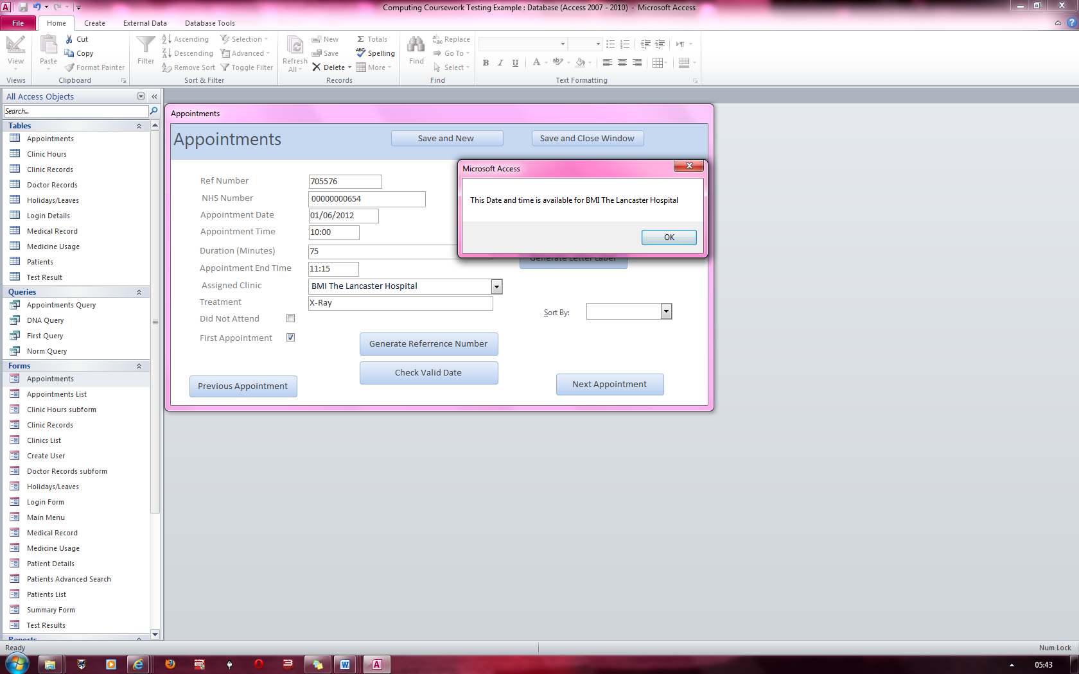

Here, the start time for this appointment begins on the end time of the appointment on the previous screen.

The appointment dates and clinics have been kept the same. Therefore, the valid date function allows you to enter an appointment with a start time at another appointments end time and vice versa.

On this screen, the person with NHS number of “654” has an appointment at BMI Lancaster Hospital at 10:00 and it ends at 11:15

Ref number is 11

### Figure 83

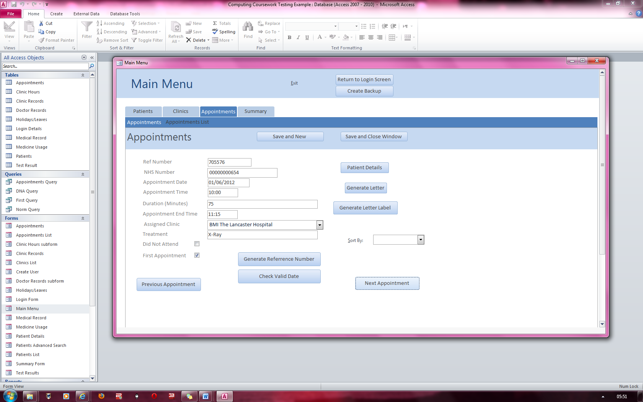

On this screen, the person with NHS number of “654” has an appointment at BMI Lancaster Hospital at 10:00 and it ends at 11:15

He must be treated for an X-ray

This record has first appointment checked

### Figure 84

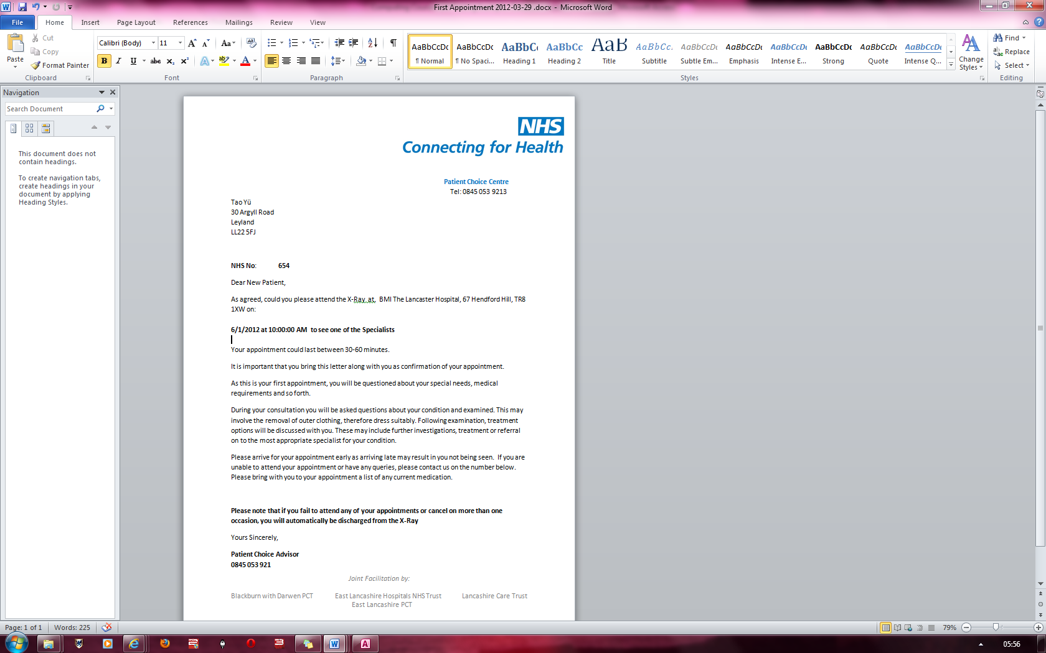

After clicking on generate letter, this letter is produced, which contains the patient’s name and address, start time of appointment and date as well as what they are being treated for.

The letter produced was for a “first appointment” as proven by this line.

“As this is your First Appointment….”

### Figure 85

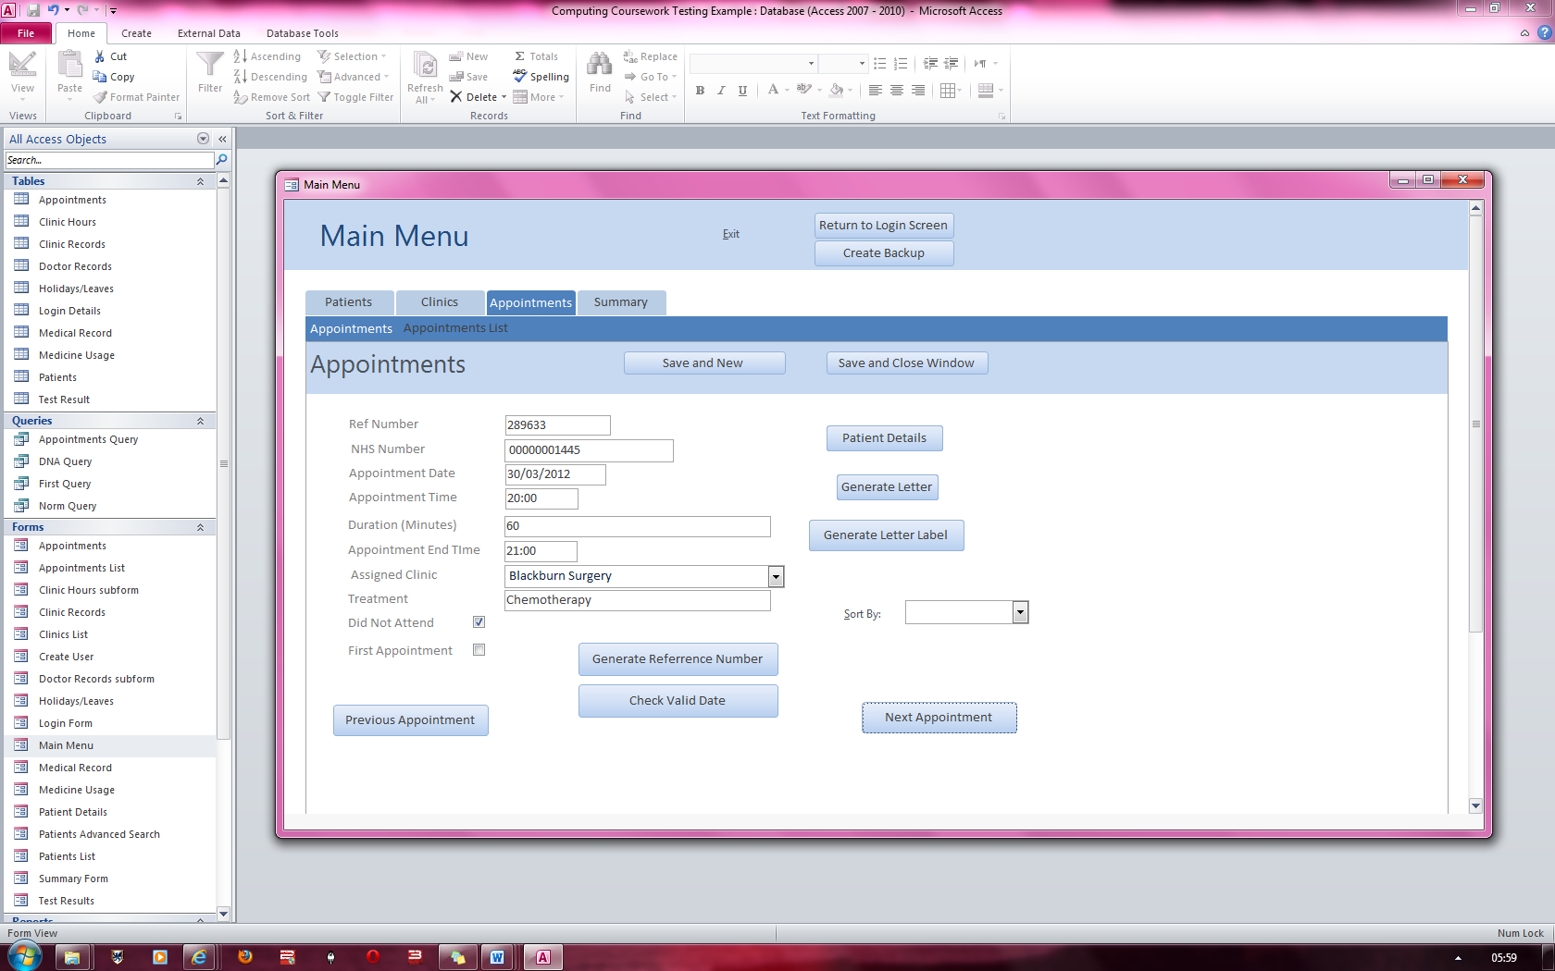

On this screen, the person with NHS number of “1445” has an appointment at Blackburn Surgery at 20:00 and it ends at 21:00

He must be treated for Chemotherapy

This record has Did not Attend checked.

### Figure 86

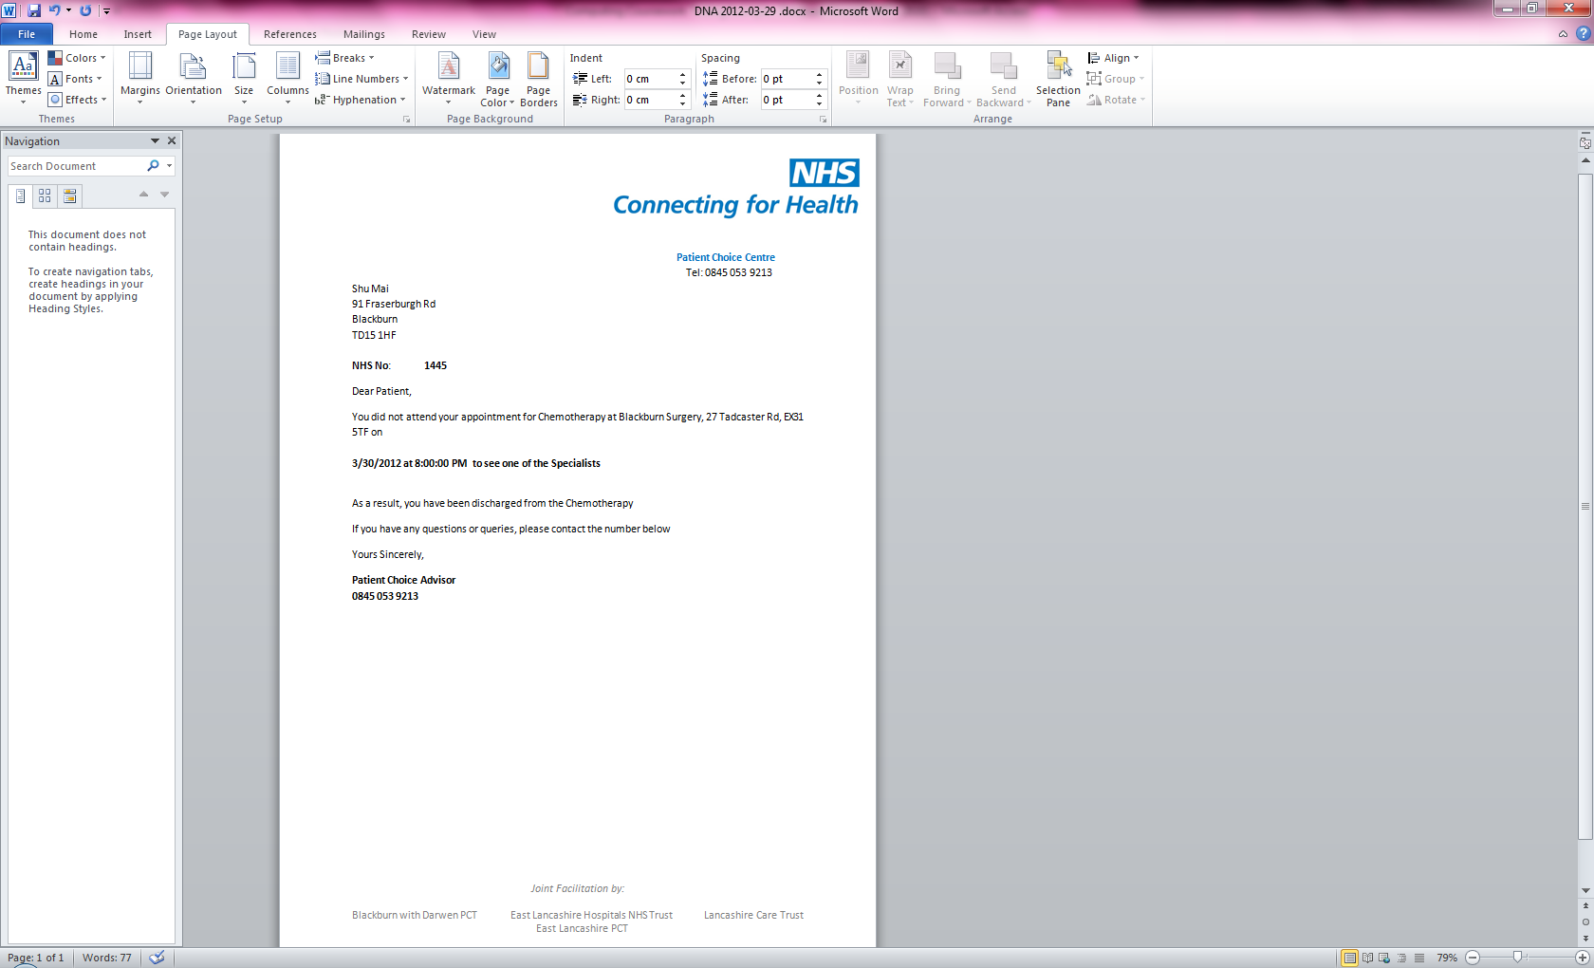

After clicking on generate letter, this letter is produced, which contains the patient’s name and address, start time of appointment and date as well as what they are being treated for.

The letter produced was for a “Did Not Attend” as proven by this line.

“You did not attend your….”

### Figure 87

### Figure 88

On this screen, the person with NHS number of “218” has an appointment at Fullwood Hall Hospital at 14:30 and it ends at 15:15

He is having the Integrated Musculoskeletal service treatment

This record has no checkboxes checked.

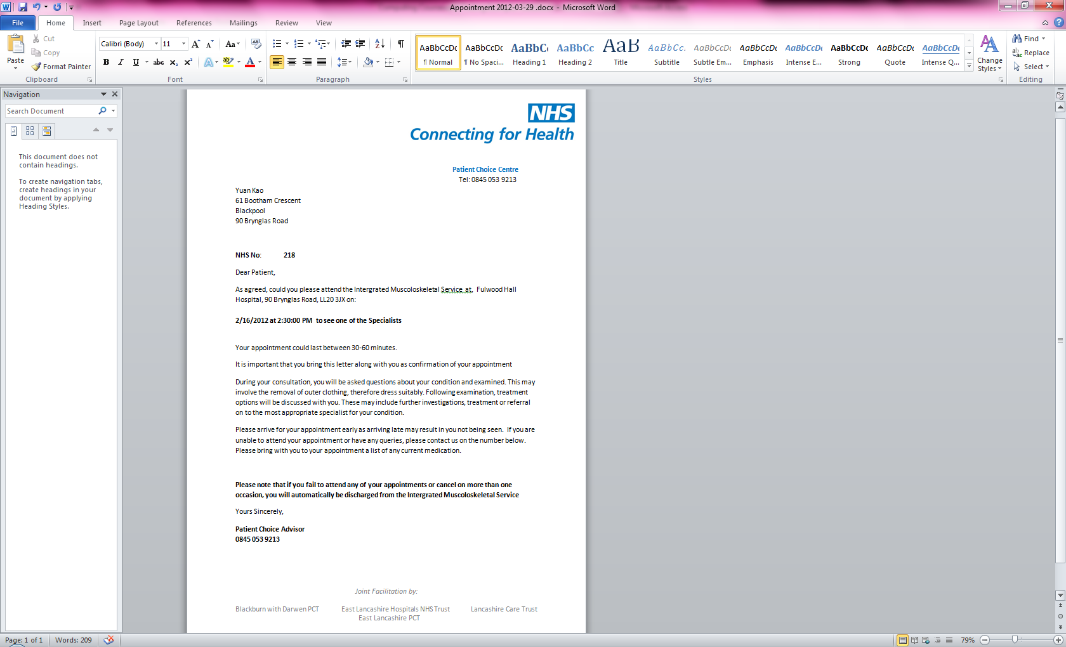

After clicking on generate letter, this letter is produced, which contains the patient’s name and address, start time of appointment and date as well as what they are being treated for.

The letter produced was for a “Normal Appointment” because no line states that it is a letter addressed to a person who is having their first appointment, or if it is addressed to a person who has not attended an appointment

### Figure 89

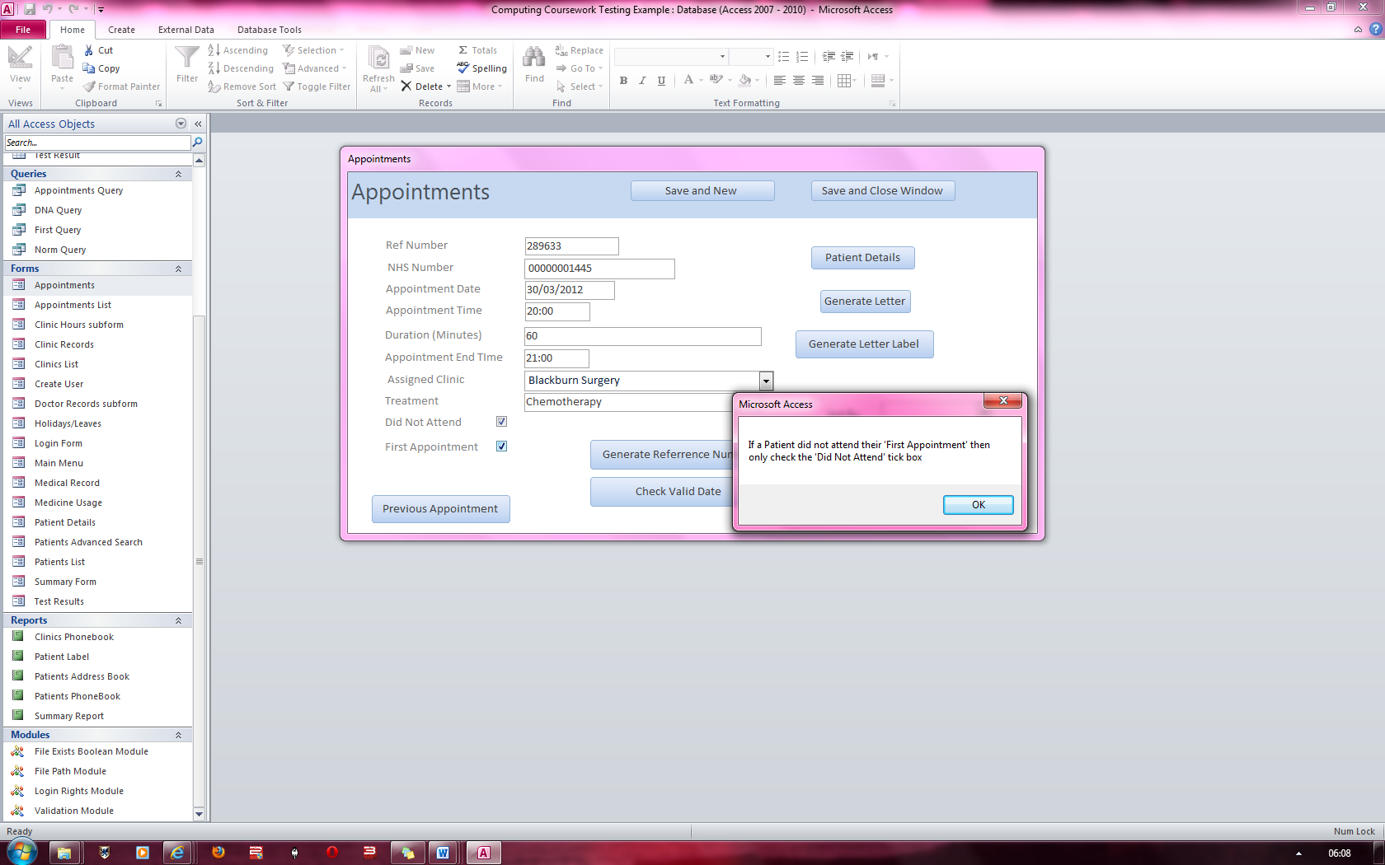

On this screen, both check boxes are checked which should not be possible. Therefore an error message if brought up which unchecks the “Forename” tick box

### Figure 90

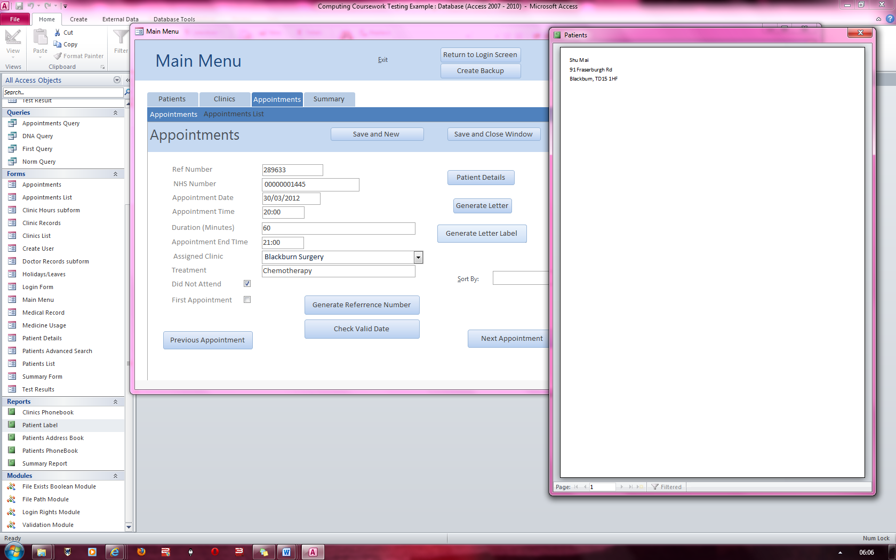

This shows a label being generated for the patient with NHS number 1445.

Proof that this is the correct person assigned to the NHS number is on figures 75 and 76 which show the table of results

### Figure 91 & 92

### Figure 93 & 94

Proof that the Holiday has been added

This shows a Holiday/Leave being entered into the system and being saved for Doctor Kelly NHS Number “8378552” after the button “Add Holiday/Leave” had been pressed.

**Fig 92**

**Fig 91**

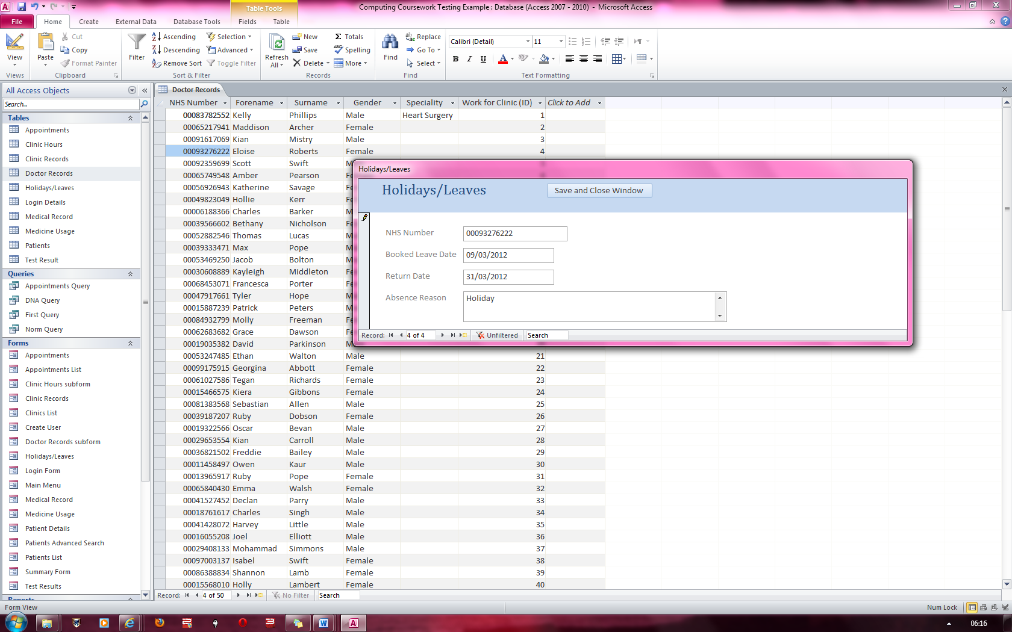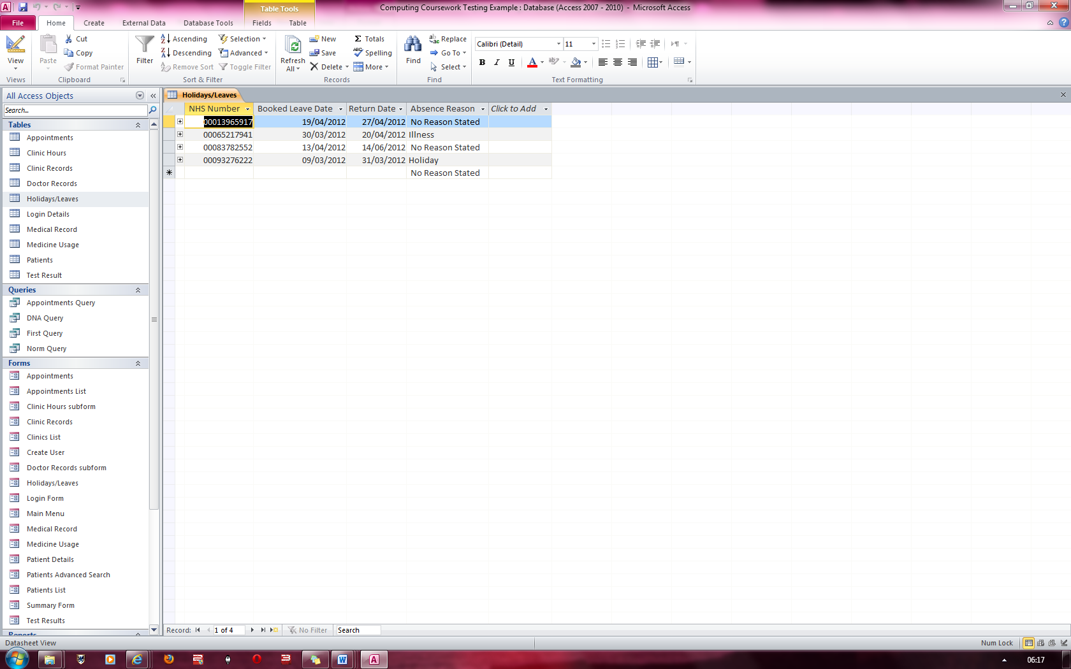

On Error, the record has been added which is a mistake

This shows a Holiday/Leave being entered into the system which has a booked leave date prior to the current date 15/03/2012

**Fig 94**

**Fig 93**

### Figure 95 & 96

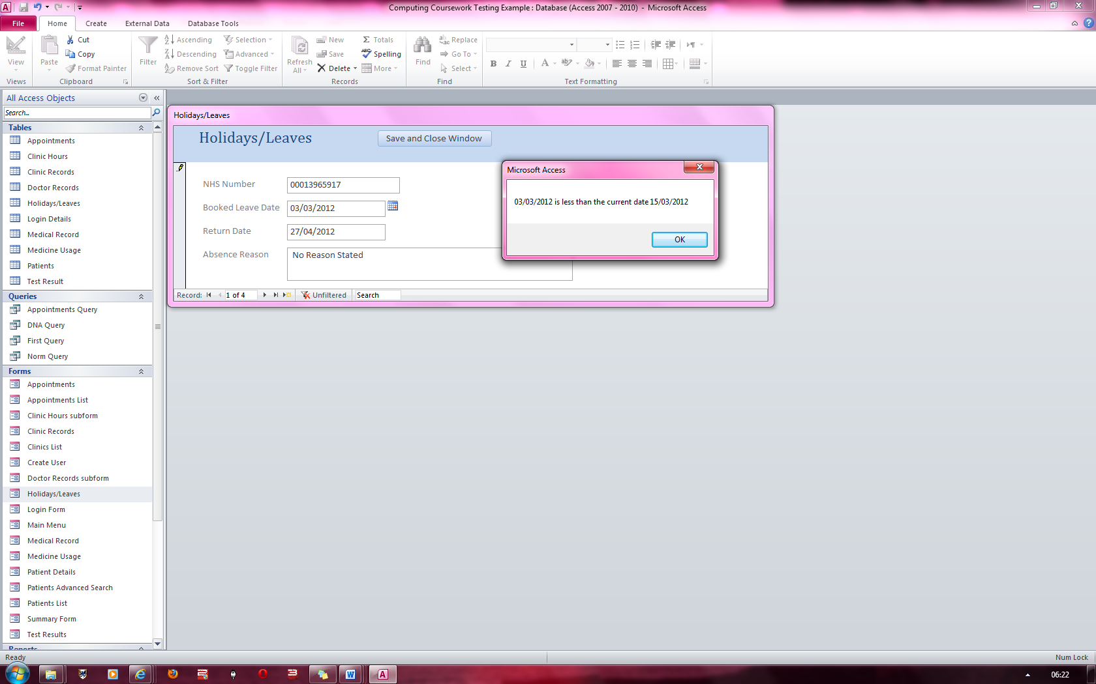

**Fig 95**

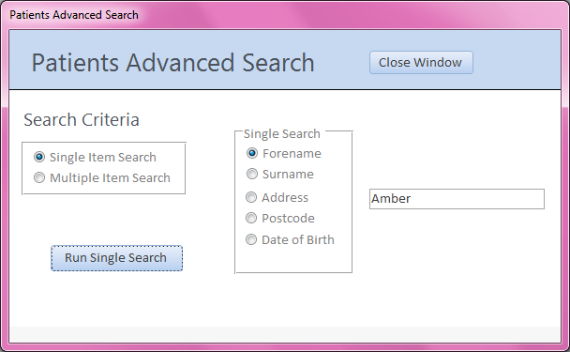

Running a single search with forename set to “Amber”.

The error has been corrected as see here

**Fig 96**

### Figure 97

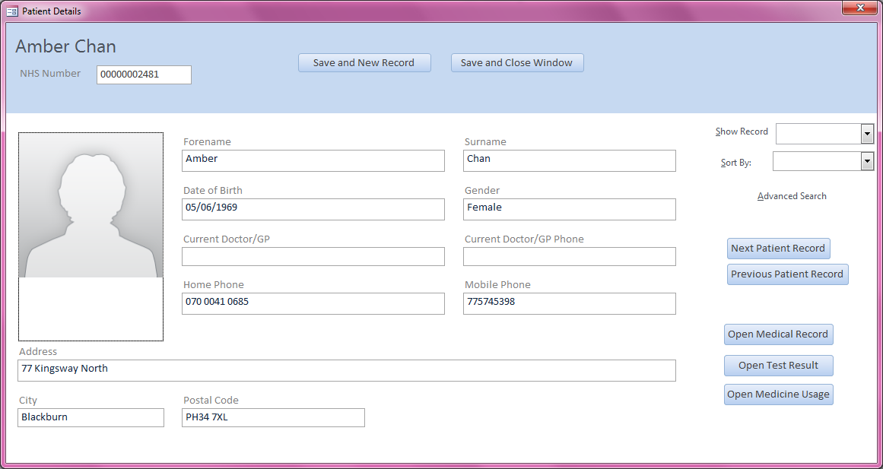

The first person with the name Amber is displayed

### Figure 98

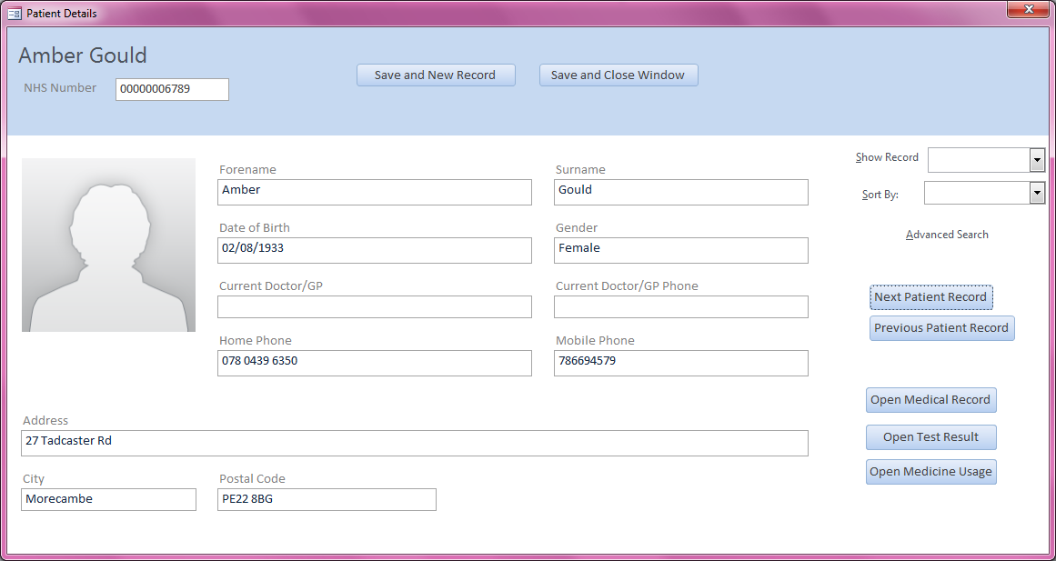

The 2ndperson with the name Amber is displayed when Next patient record is pressed

### Figure 99

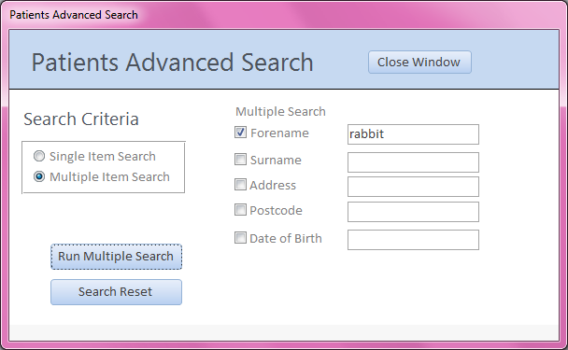

Running a multi search yet only searching for someone with a forename “rabbit”

### Figure 100

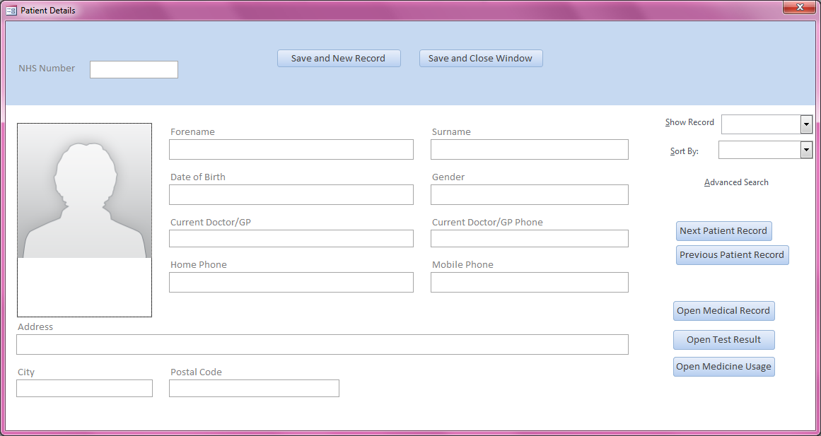

On Error, it brings up the patient details form with all fields blank

### Figure 101

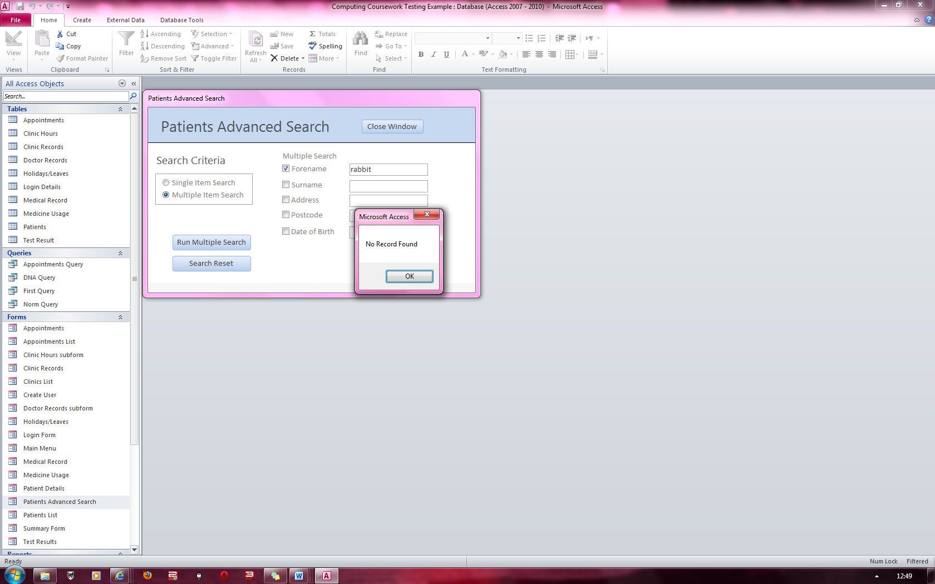

To fix this, I changed the code such that if no record was found with the criteria then an error “No Record Found” would be displayed

### Figure 102

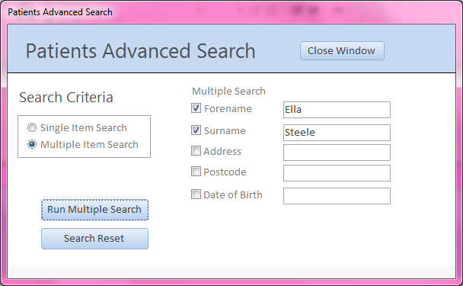

Here is an actual multi search with the forename set to “Ella” and the Surname set to “Steele”

### Figure 103

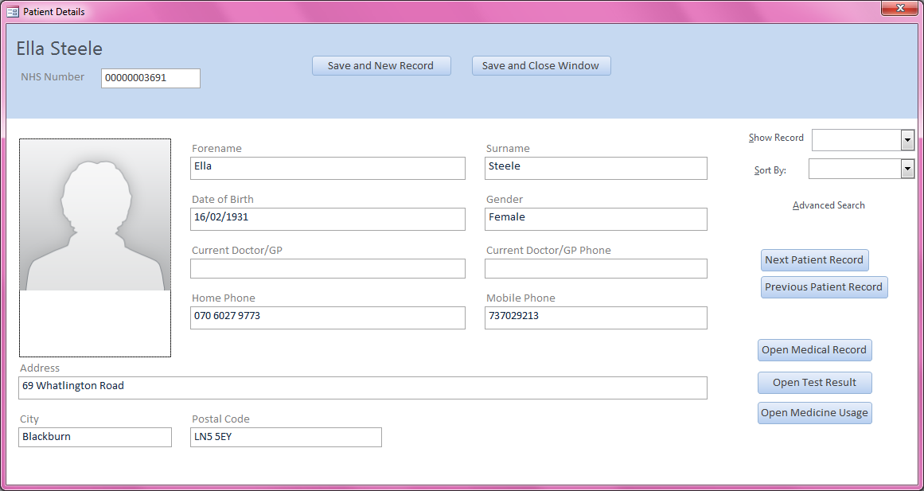

Here the record of Ella Steele is displayed as requested though the search function

### Figure 104

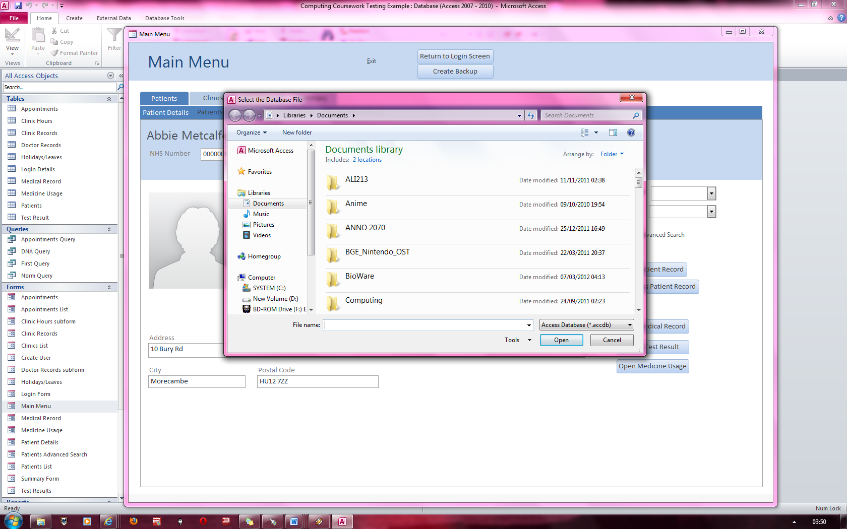

After clicking on the “Create Backup” button, the system sets up a custom file dialog box and displays it.

### Figure 105

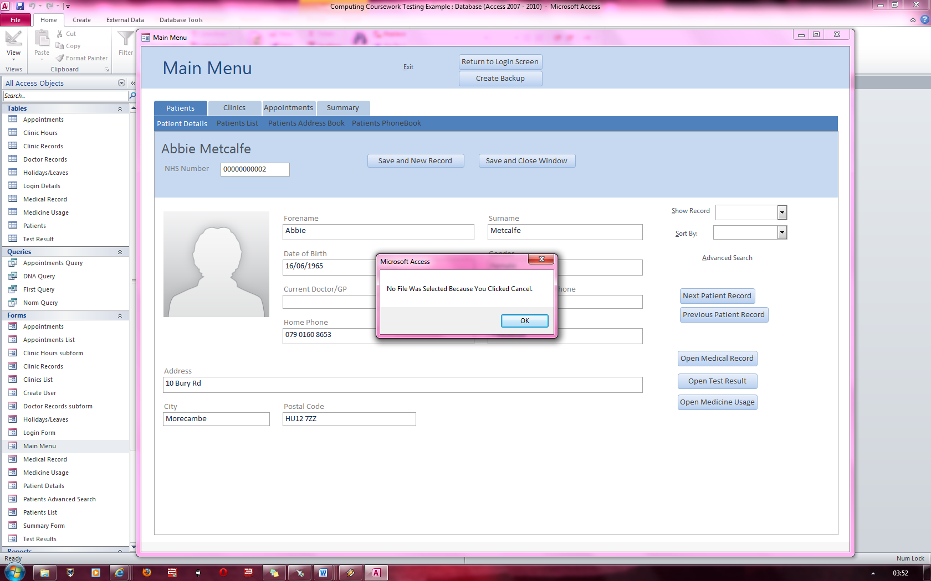

Here I clicked Cancel in the file dialog box which bought up this message

### Figure 106

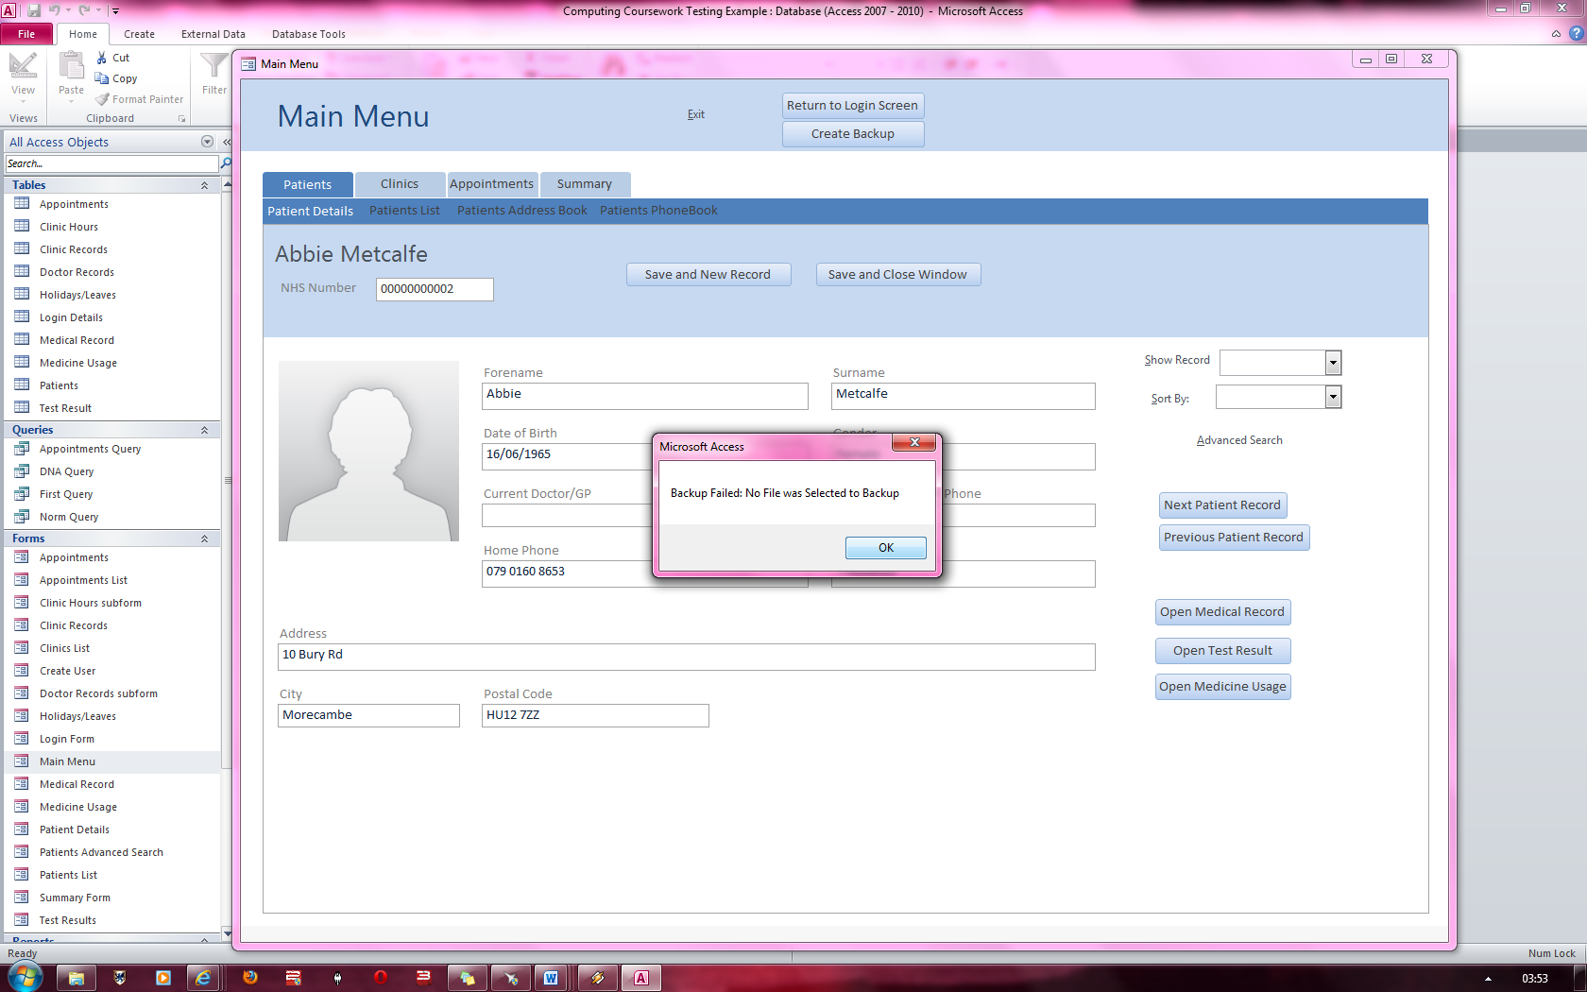

A second message pops up notifying the user that the backup failed and the reason why.

### Figure 107

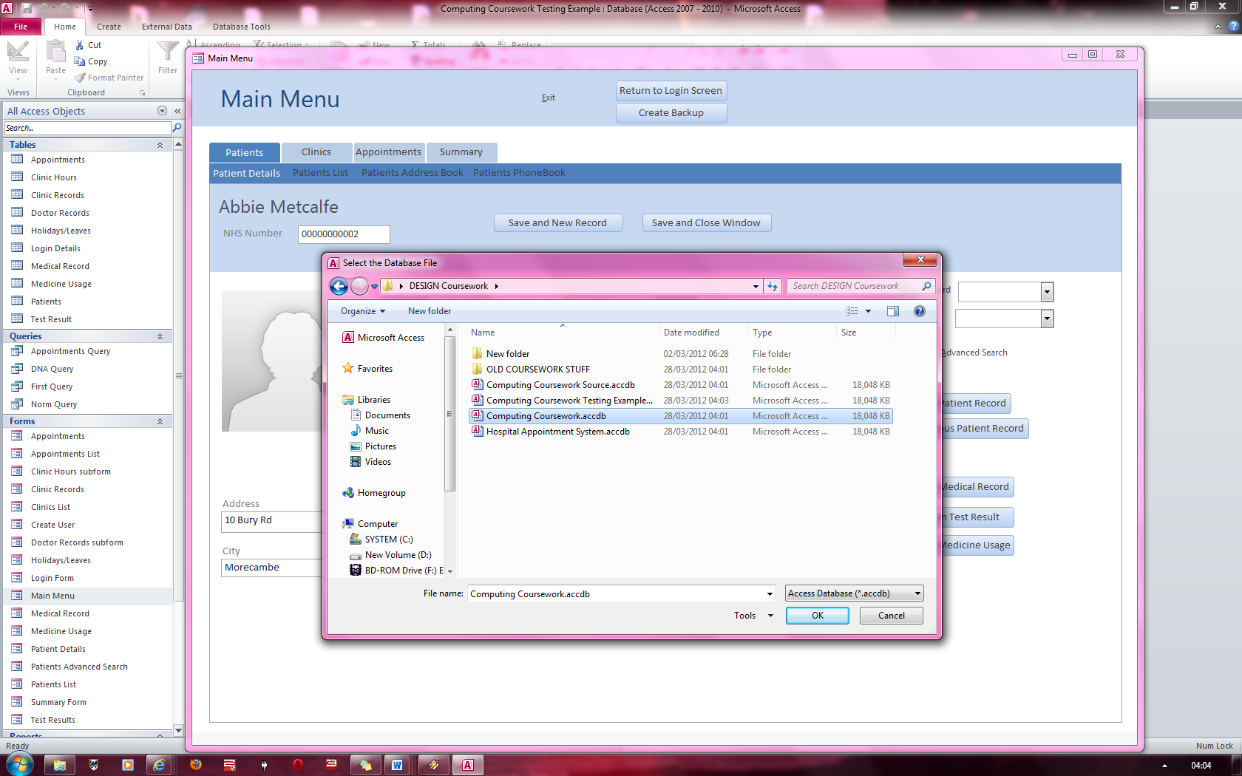

In this case, a file was selected to backup called “Computing Coursework”

### Figure 108

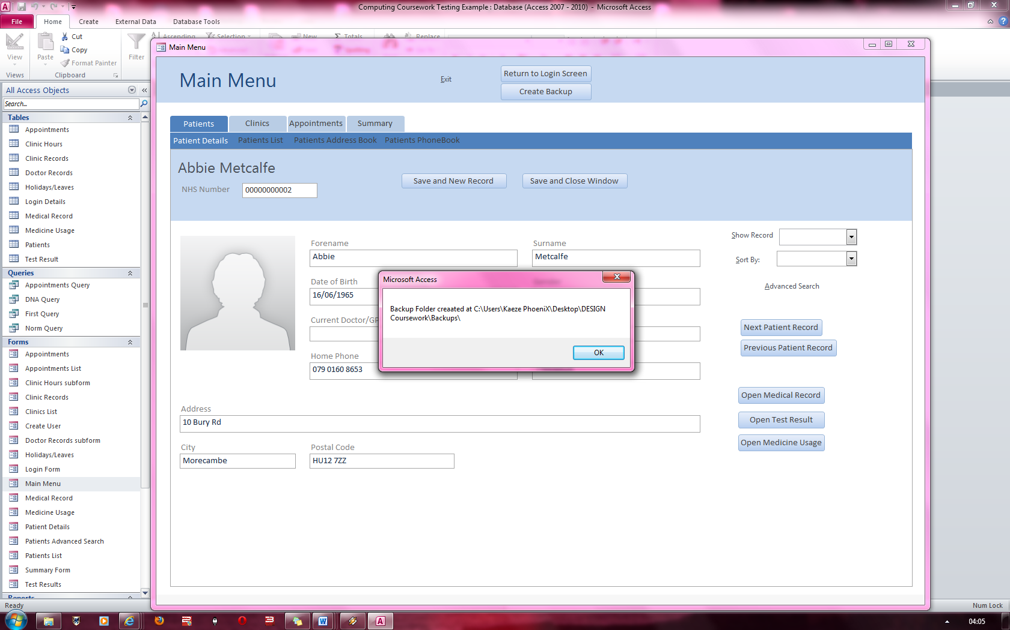

Since no backup folder was found where the directory to back the database up was set, the system manually created one.

### Figure 109

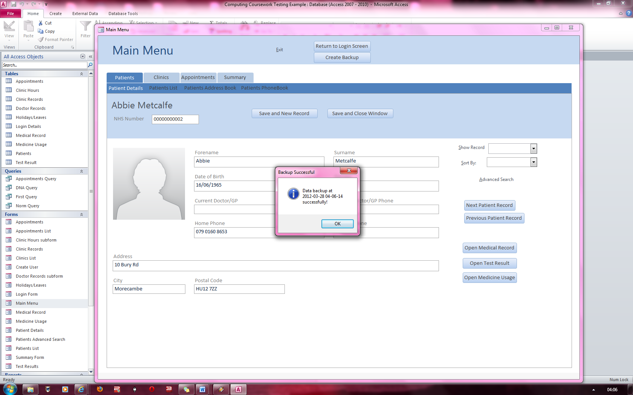

Here the system reports that the backup was successful as well as the date and time it was backed up

### Figure 110 & 111

**Fig 110**

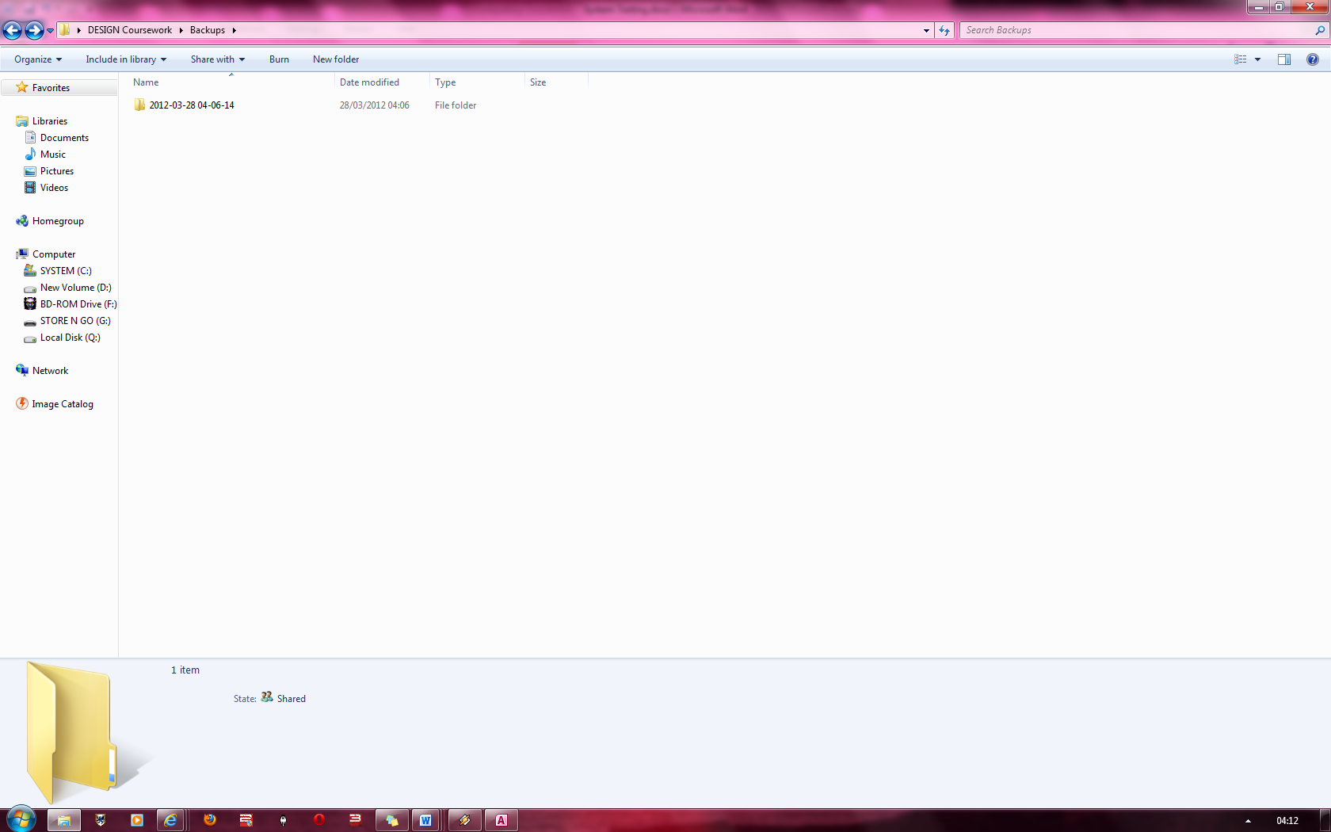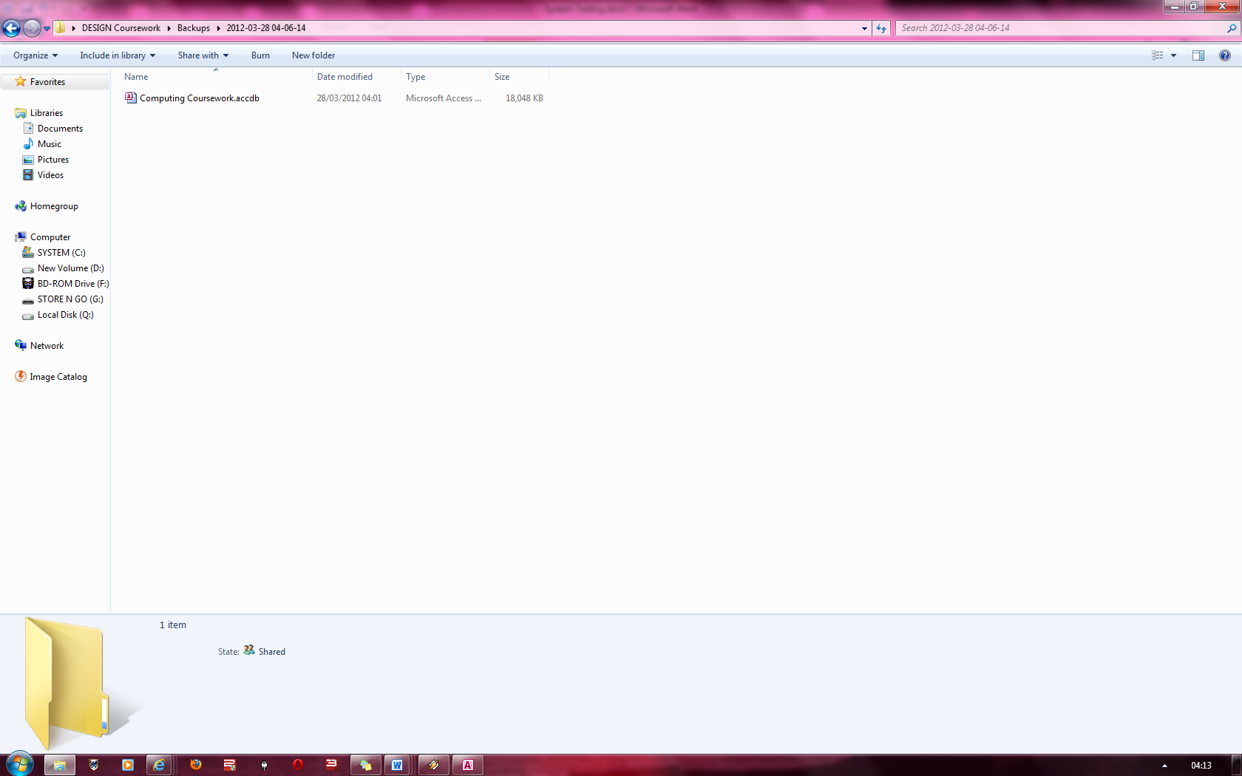

Proof that the backed up database was stored in the right location with the correct file name

Here is the folder that the backed up database was placed in and also seen here is the file path

**Fig 111**

### Figure 112



Computing Coursework was again chosen to be backed up when the file dialog box popped up.

### Figure 113

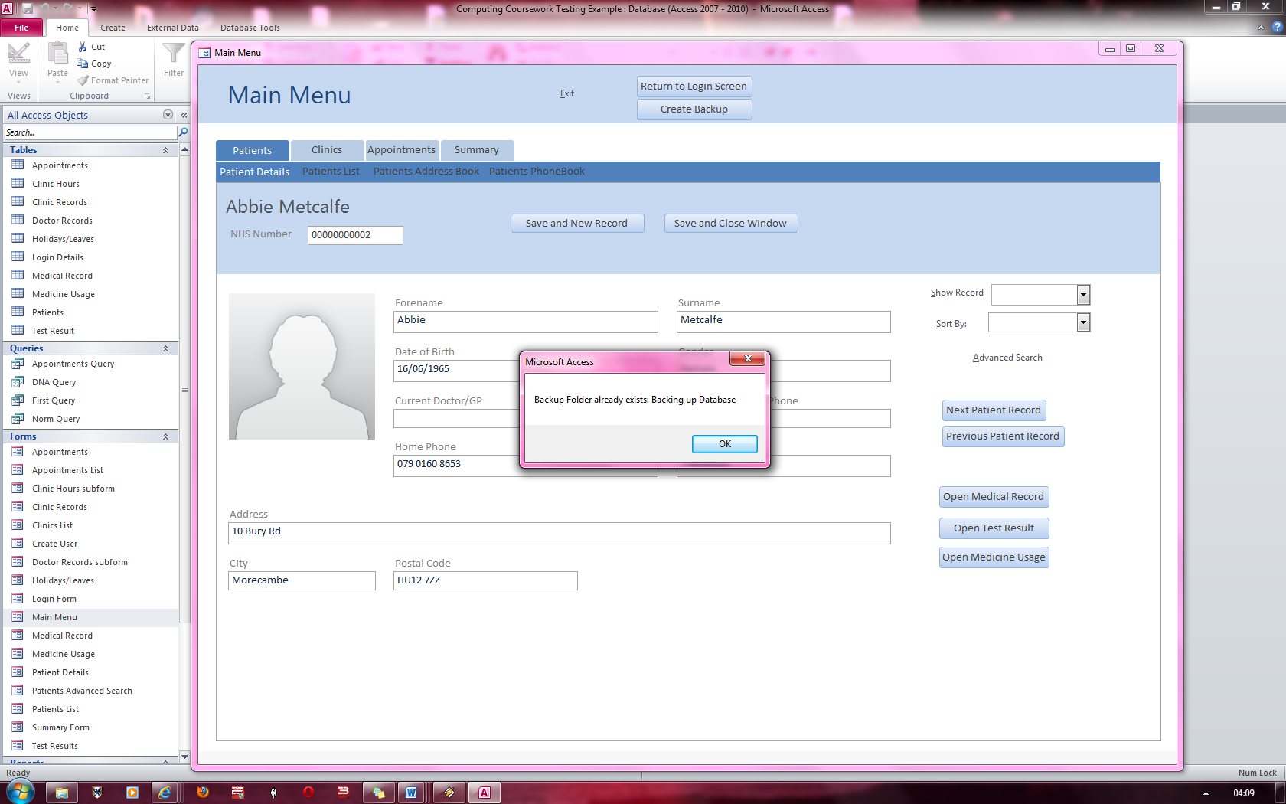

The Message states that the backup folder already exists and therefore it has skipped to the stage of just backing up the folder

### Figure 114 & 115

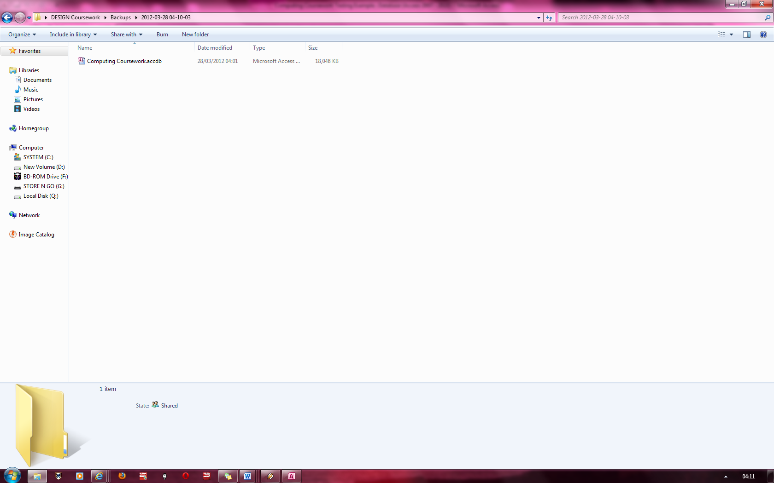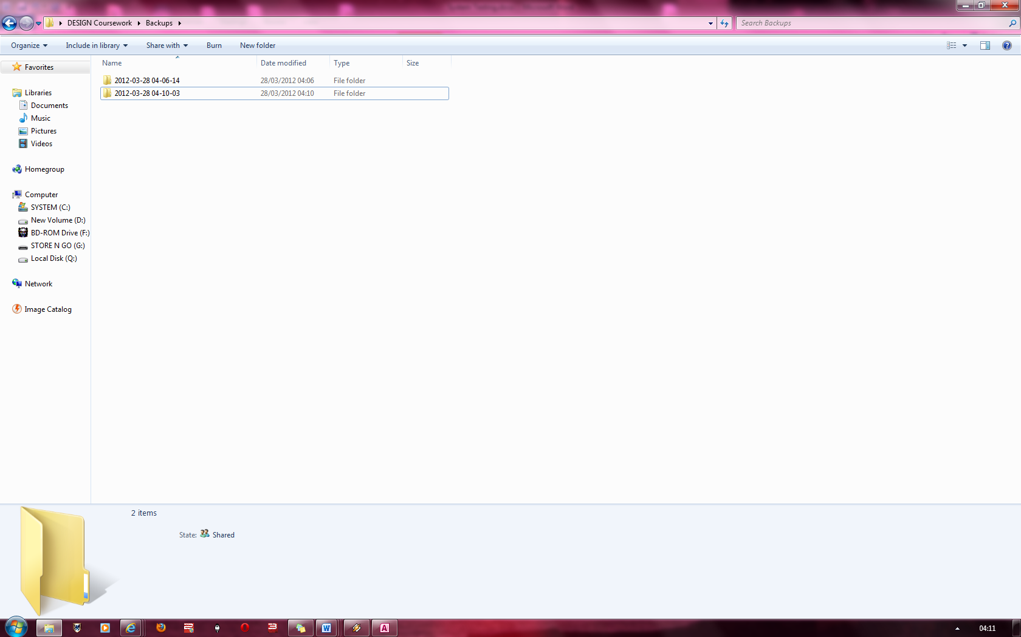

The database was correctly backed up in its intended location.

Here the file was backed up at the right file path again.

**Fig 114**

**Fig 115**

### Figure 116 & 117

### Figure 118

Summary Report appears once “Open Report” is pressed. The data is consistent.

All information here is valid as for testing purposes, only 50 records were made for Clinics, doctors and patients whereas only 7 were made for appointments.

The ratio’s and percentages are also correct.

I have removed a normal appointment to reduce the total amount of appointments to 6.

There are 3 people who have not attended an appointment out of the 6 appointments that are registered in the system. Therefore, the appointment attendance percentage is correct.

### Figure 119

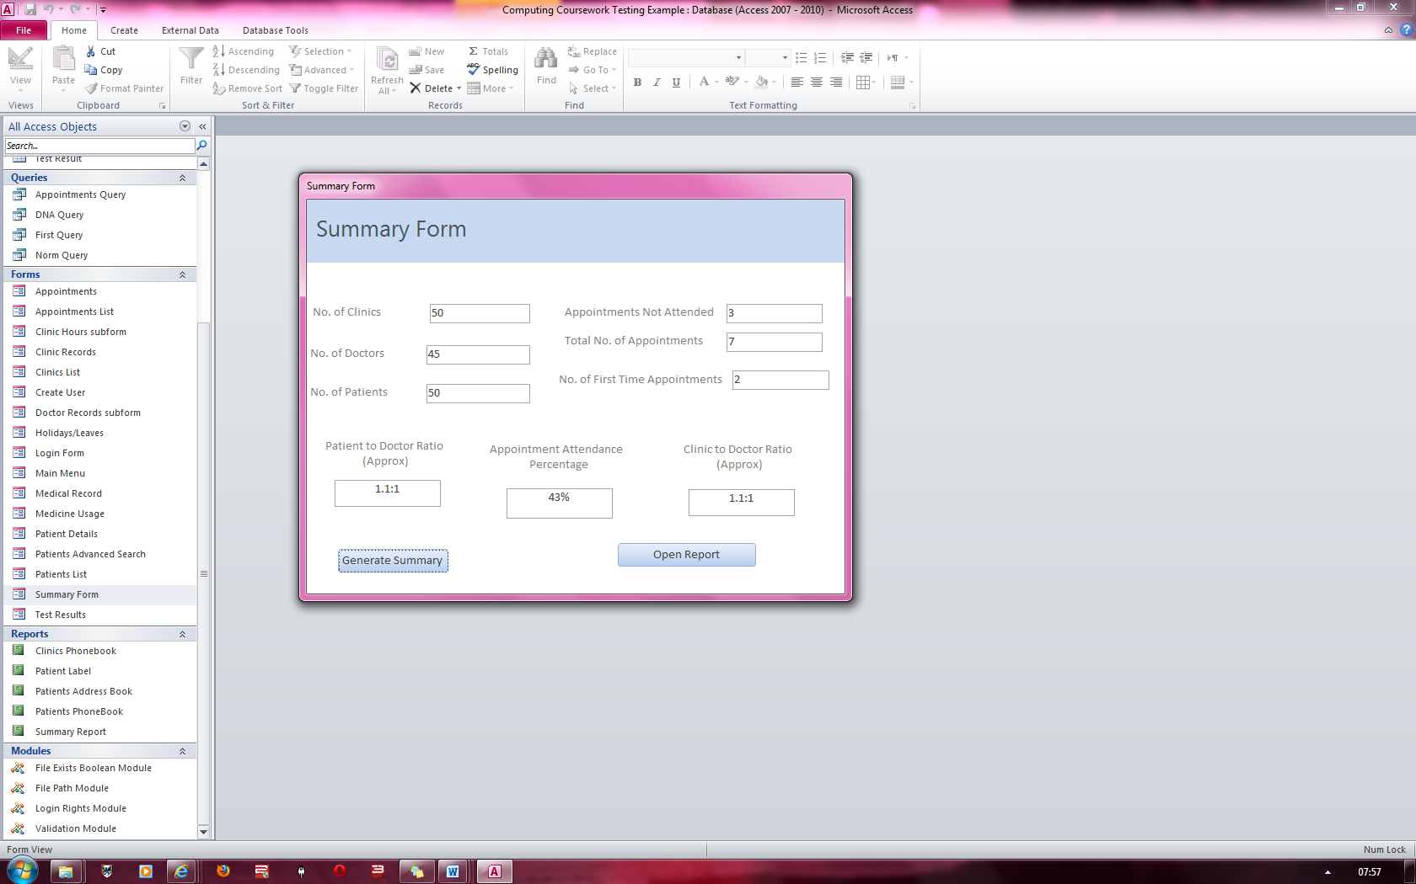

5 doctor records were temporarily removed to test the ratios.

There are 50 patients to 45 doctors and therefore the ratio is 1.1:1. The same goes for the clinic to doctor ratio.

This is consistent with the form’s generated values.

### Figure 120

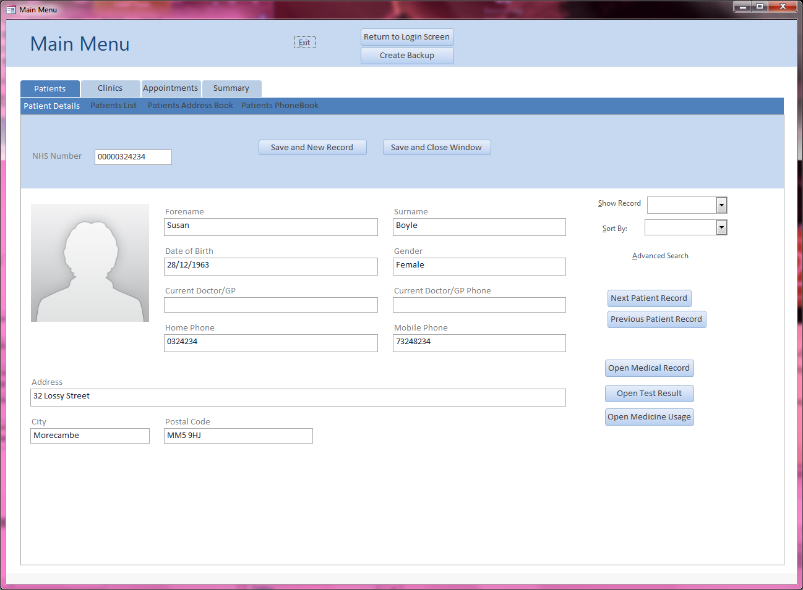

Details specified entered into the system

### Figure 121

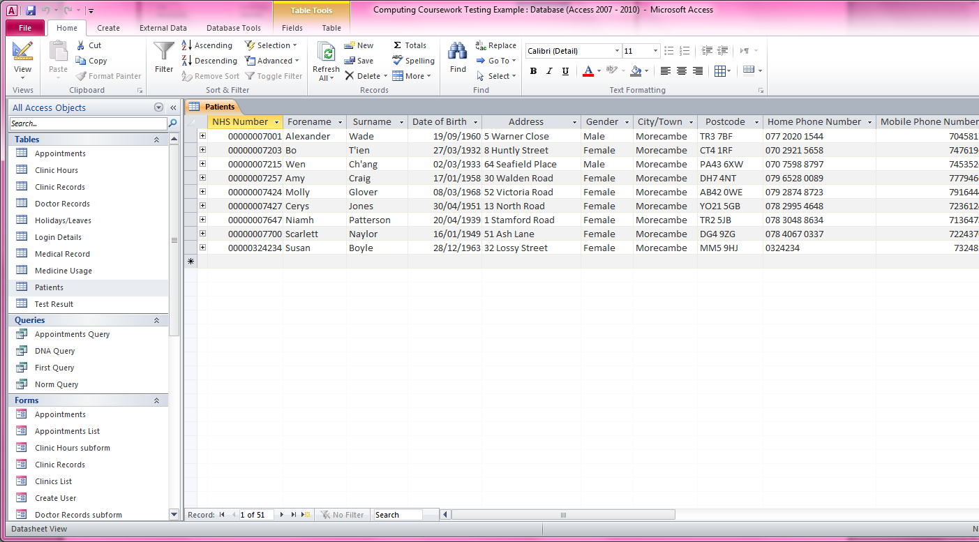

Proof that the record was saved

### Figure 122

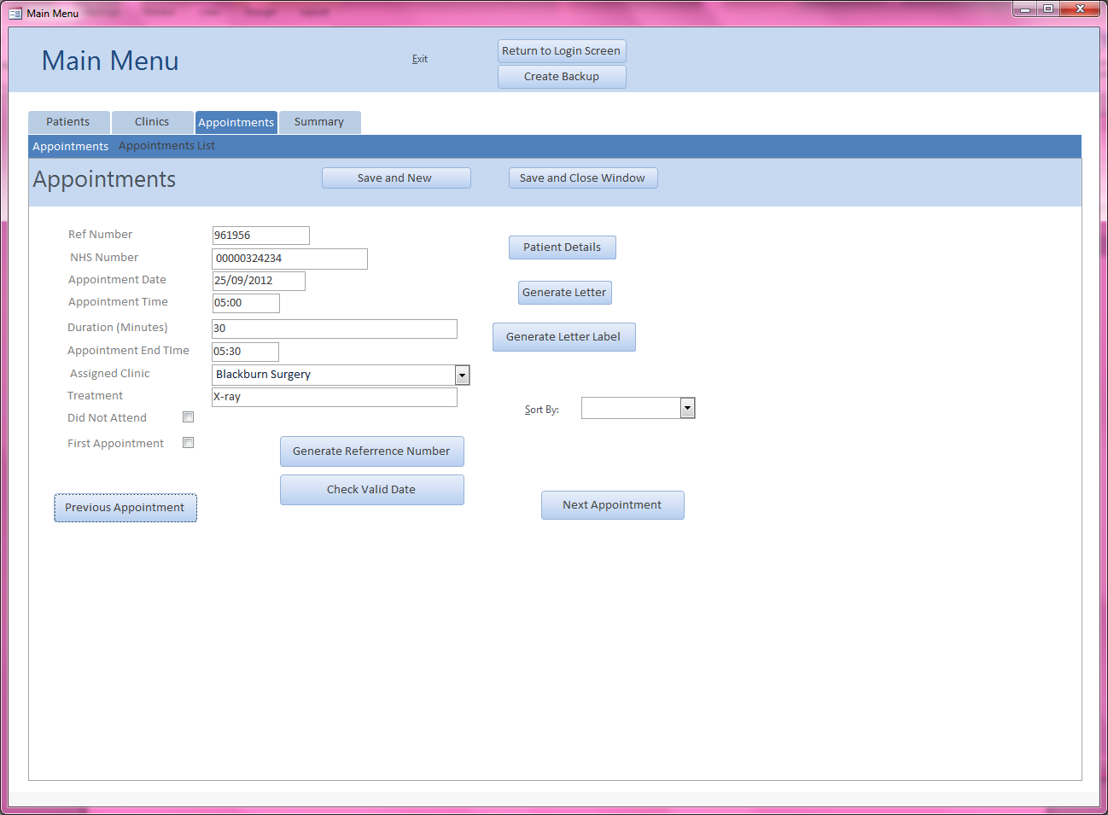

Created the appointment record for Susan Boyle

### Figure 123

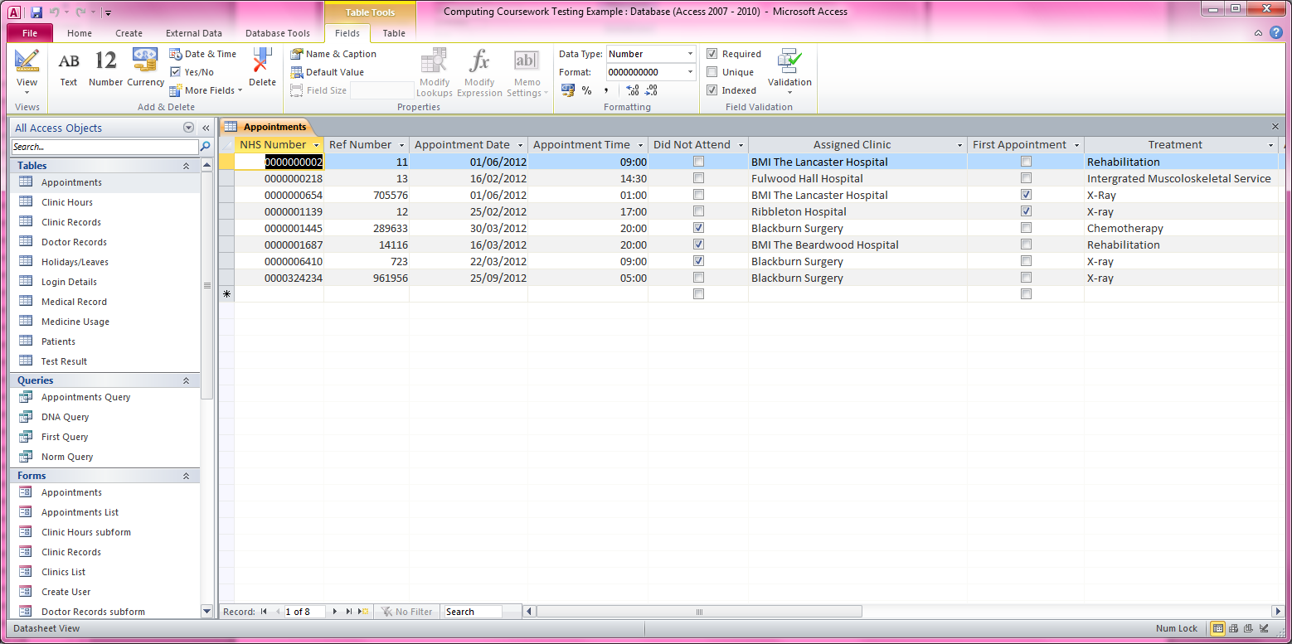

Record saved (NHS number = 0000324234)

### Figure 124 & 125

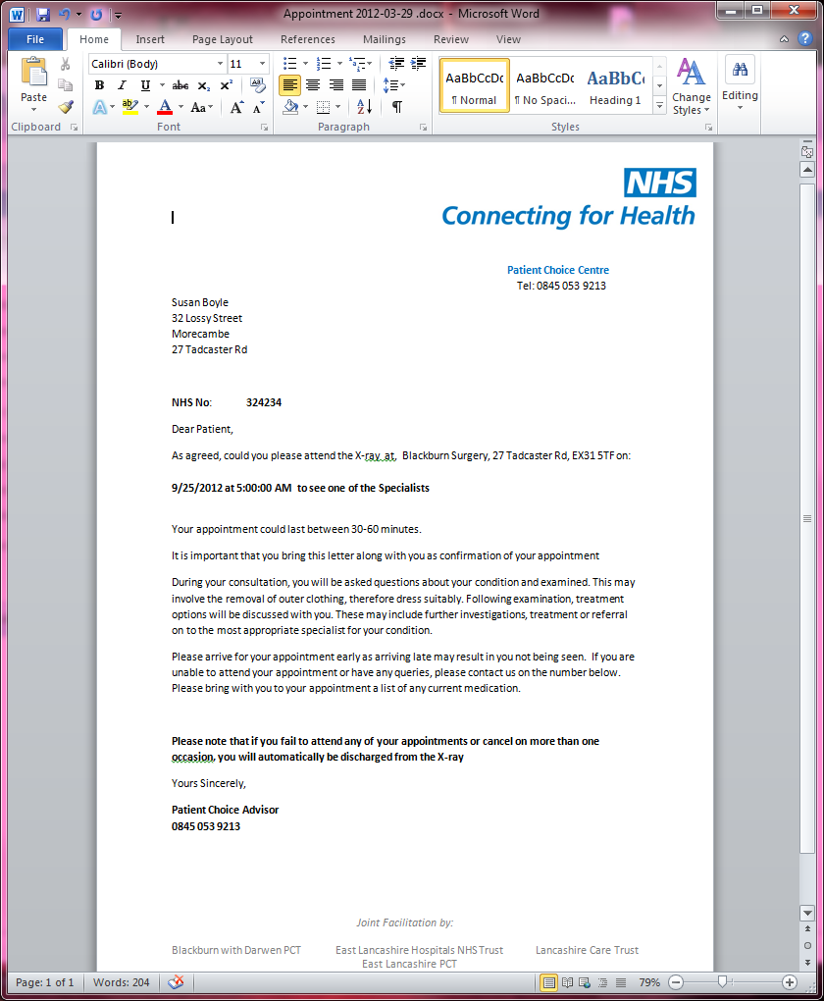

Letter label generated for Susan Boyle with address, city and postcode.

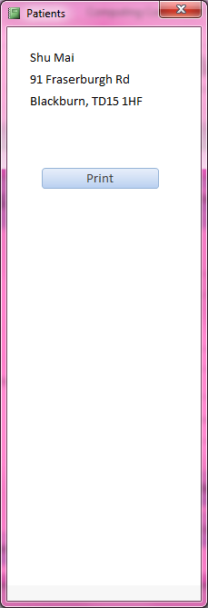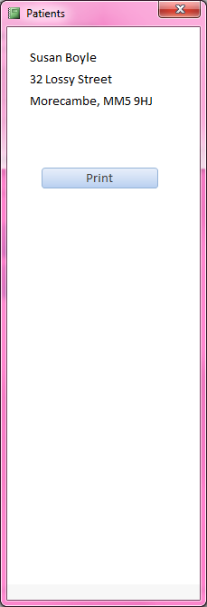

Since no fields were checked, the default “Normal Appointment” letter was generated telling the patient the location of their treatment, the time of the treatment, the date of the treatment and more.

### Figure 126

### Figure 127

Susan Boyle’s patient record is in the Patient’s List

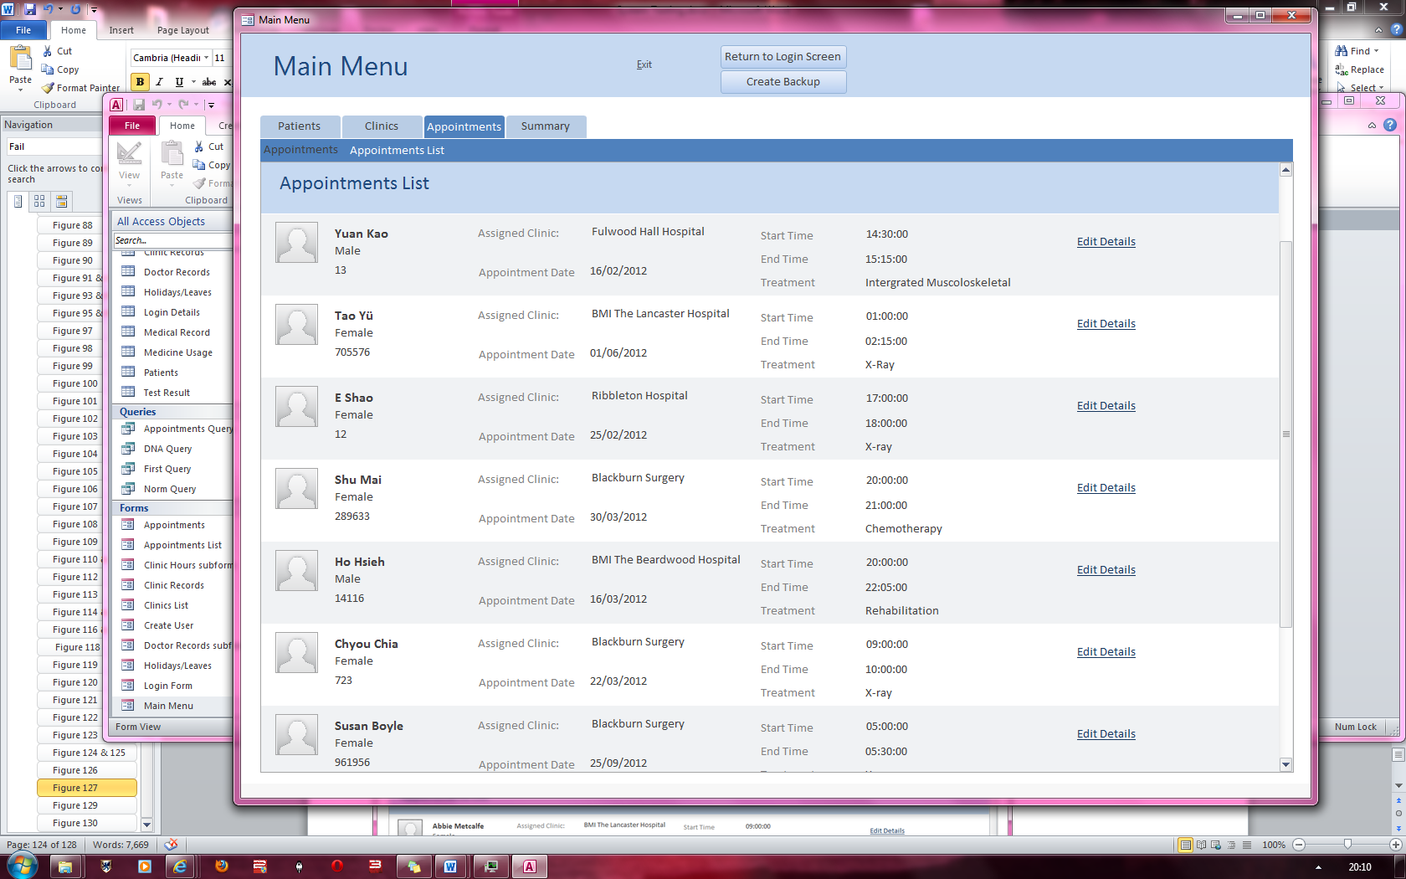

Susan Boyle’s appointment is found in the appointment list

Ref Number = 961956

Figure 12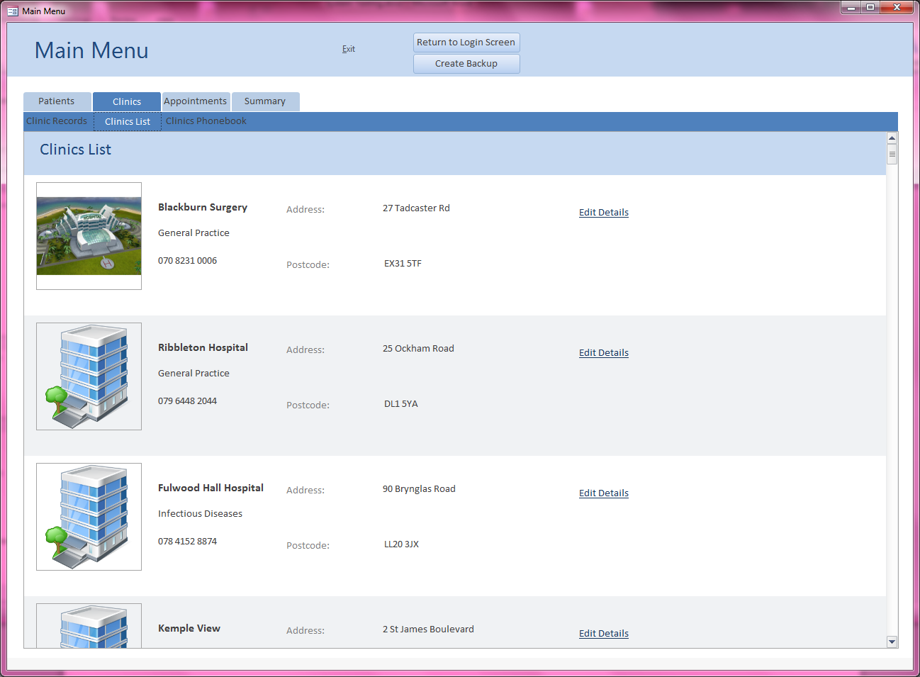8

Blackburn Surgery is in the Clinics List

### Figure 129

### Figure 130

Current Record is on Abbie Metcalfe

Susan Boyle’s record is found in the drop down combo box called “Show Record”

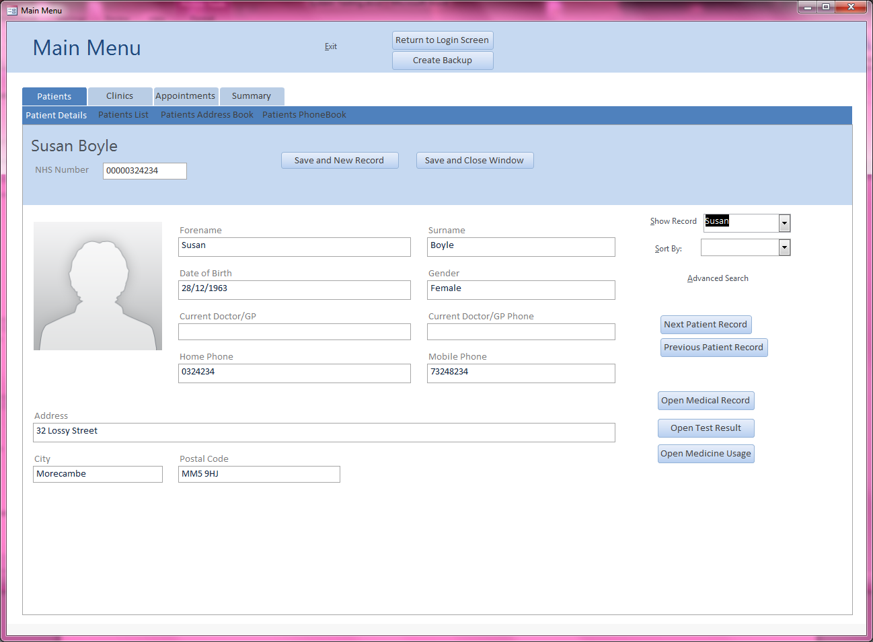

Clicking on the record changes the displayed record to Susan’s

Figure 13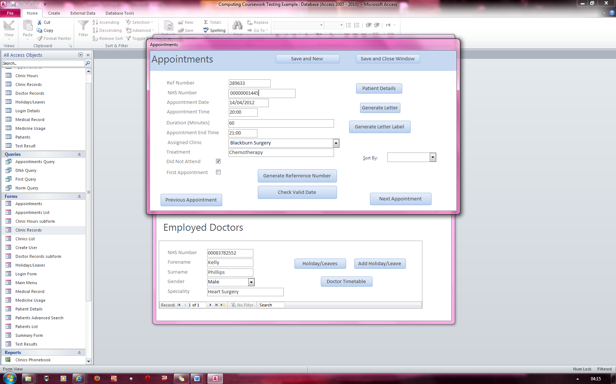1Figure 13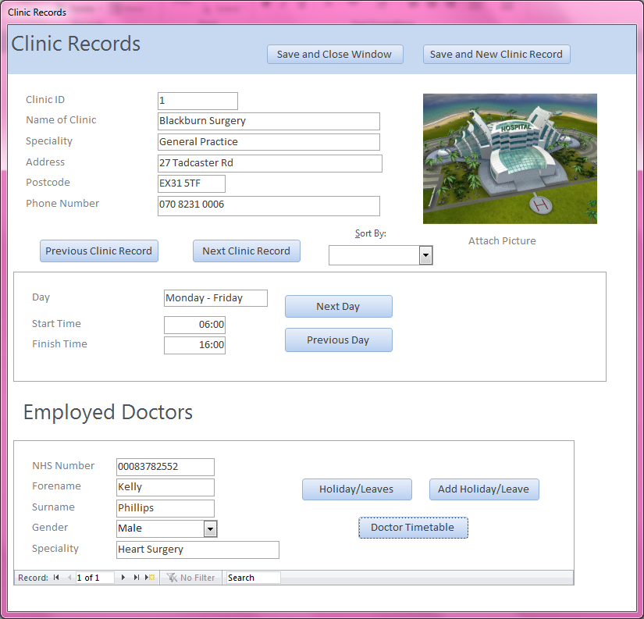2

Doctor Kelly’s timetable

Doctor Kelly works for Blackburn surgery so will only have appointments from Blackburn surgery

Proof that Kelly works for Blackburn Surgery

Figure 13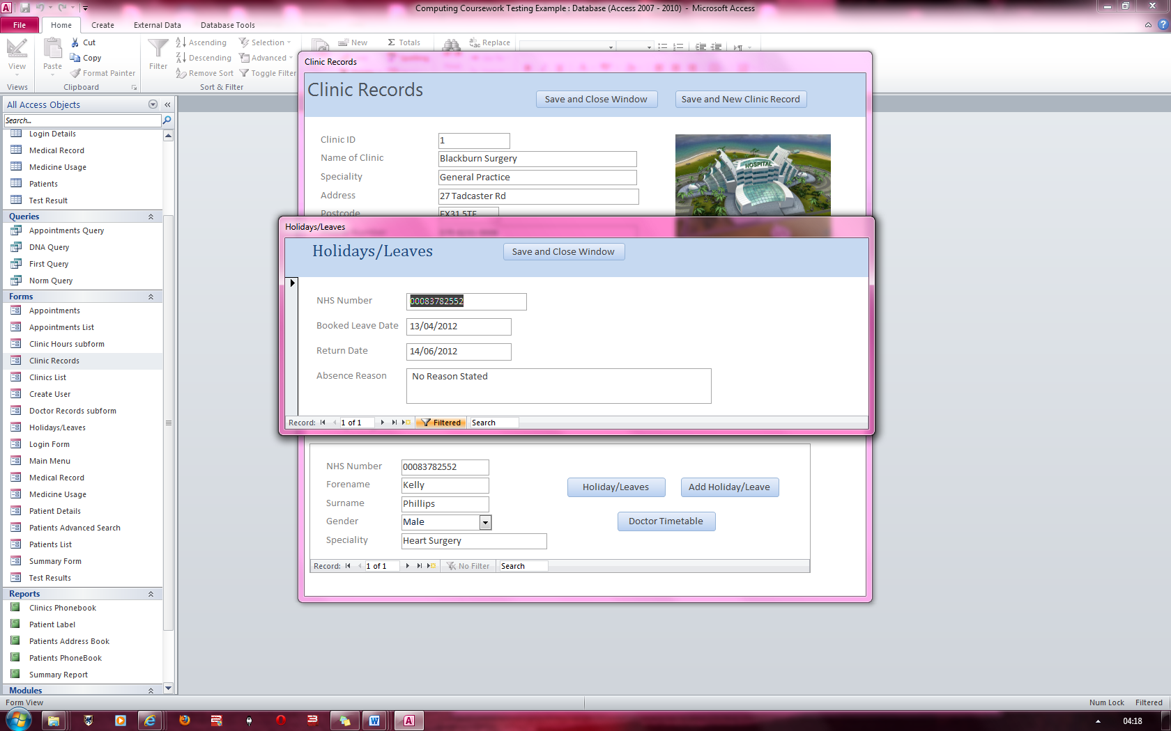3

Kelly’s Holiday leave date is at 13/04/2012 and returns on 14/06/2012

Figure 13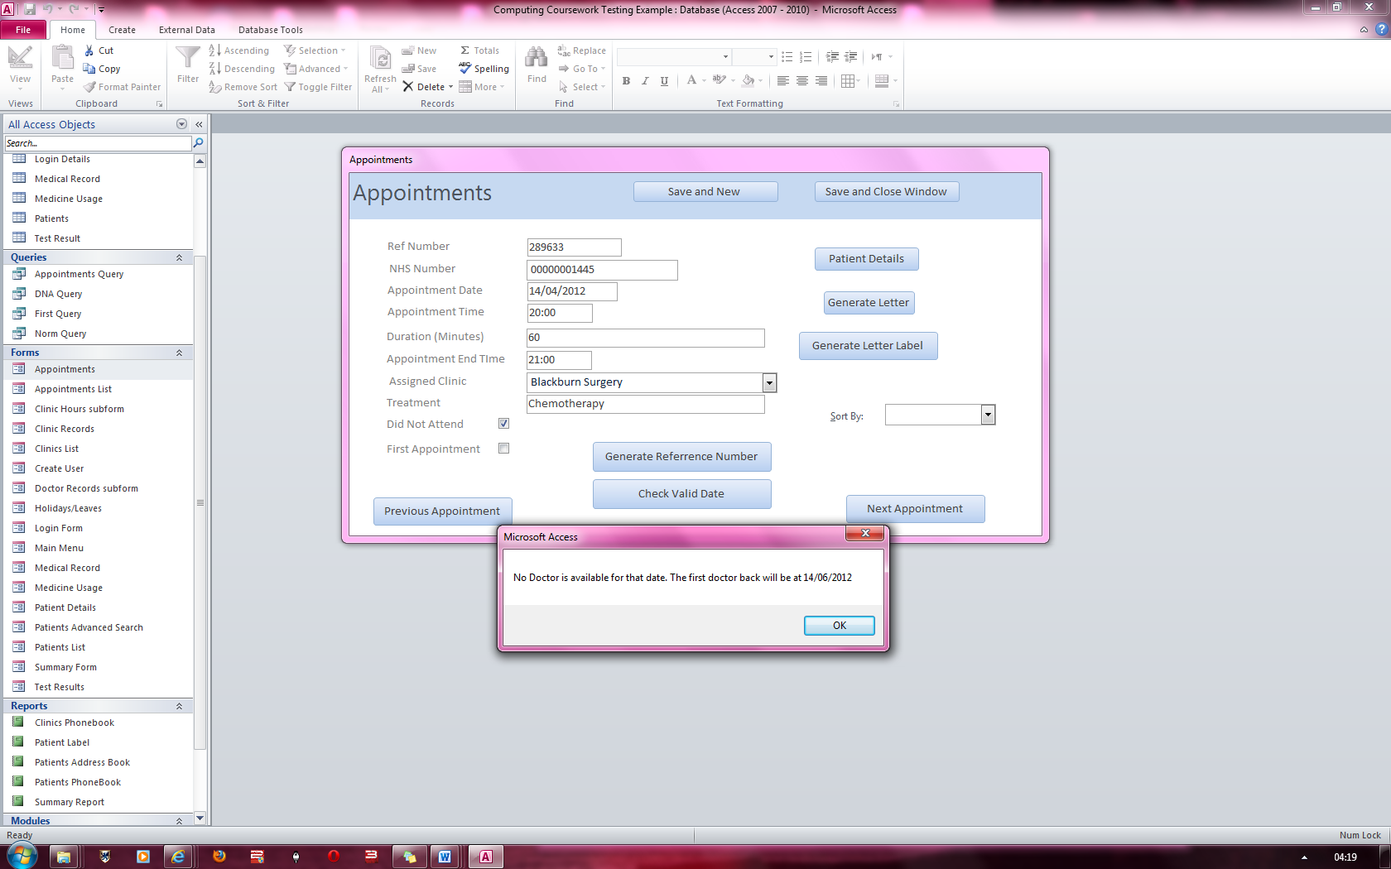4

Blackburn Surgery only had one doctor Kelly. Since Kelly is on holiday until 14/06/2012, the appointment date has to be changed or the clinic does.